

**School of Computing, Engineering and Physical Sciences**

**MSc Information Technology**

**COMP11124 Object Oriented Programming**

**Semester Report**

**Zain Rafique**

**Muhammad Abu bakar**

**Bilal Ahmad**

**Mian Sharib**

Table of Contents

Section 1. Comparisons and Conditionals 1

Exercise 1: Comparison Operators 1

Understanding the Task: 1

Source Code: 1

Explanation 2

Output 2

Exercise 2: Logical Operators 2

Understanding the Task 2

Source Code 3

Explanation 3

Output 4

Exercise 3: if – Conditionals 4

Understanding the Task 4

Source Code 4

Explanation 5

Output 5

Exercise 4: if – else Conditionals 5

Understanding the Task 5

Source Code 5

Explanation 6

Output 6

Exercise 5: if – elif - else Conditionals 6

Understanding the Task 6

Source Code 6

Explanation 7

Output 8

Exercise 6: Compare Temperatures 8

Understanding the Task 8

Source Code 9

Explanation 9

Output 9

Section 2. Python Lists 10

Understanding the Task 10

Exercise 1: Creating a list 10

Exercise 2: Accessing List Elements 11

Exercise 3: Modifying Lists 11

Exercise 4: Summary Task 12

Output 14

Section 2. Python Loops 14

Understanding the Task 14

Exercise 1: While Loop 14

Source Code 14

Output 15

Exercise 2: For Loop 15

Source Code 15

Output 1 15

Output2 16

Exercise 3: Loop Keywords 16

Output 17

Exercise 4: Summary Tasks 18

Section 4. Obtaining User Input 20

Source Code 20

Explanation 21

Output 21

Task: User Input and Conditional Statements 21

Understanding the Task 21

Source Code 21

Explanation 22

Output 22

Task: Temperature Converter 22

Understanding the Task 22

Source Code 23

Explanation 23

Output 24

Section 1. Functions and Scope 25

Exercise 1: Functions in Python 25

Understanding the Task 25

Task: Greet each friend in the list 30

Understanding the Task 30

Source Code 30

Explanation 30

Output 31

Task: Calculate Tax Based on Income and Tax Rate 31

Understanding the Task 31

Source Code 31

Explanation 32

Output 33

Task: Compound Interest Calculator Function 33

Understanding the Task 33

Source Code 34

Explanation 34

Output 35

Exercise 2: Variable Scope 35

Understanding the Task 35

Source Code 36

Explanation 36

Output 37

Section 2: Assertions and Errors 37

Exercise 6: Assertions 37

Understanding the Task 37

Source Code 37

Explanation 37

Output 38

Exercise 7: Identifying and Fixing Common Errors 38

Understanding the Task 38

Section 3. Larger scale python program 43

Task: To-Do list manager: 43

Understanding the Task 43

Source Code 44

Explanation 45

Output 46

Section 1. Python Classes 49

Exercise 1: Creating Classes and Initializing Objects 49

Understanding the Task 49

Source Code 49

Explanation 49

Source Code 50

Explanation 50

Exercise 2: Adding Methods 51

Understanding the Task 51

Source Code 51

Explanation 51

Task: Add logic to methods defined 53

Exercise 3: Testing the Functionality 55

Output 55

Source code 55

Output 56

Source code 56

Output 56

Source code 57

Output 57

Exercise 4: Composition 58

Source Code 58

Explanation 58

_str_ method 58

Task: Change code in the Task Class 59

Understanding the Task 59

Source Code 59

Task: Update list_options() method 59

Section 2. Python Libraries 61

Exercise 1: Adding Dates 61

Understanding the Task 61

Source Code 61

Task: Add the due_date functionality 62

Output 63

Section 3. Modularizing the code 64

Exercise 1: Restructuring 64

Understanding the Task 64

Explanation 64

Output 65

Source code 66

Exercise 2: Main() 66

Understanding the Task 66

Source Code 67

Explanation 67

Task: Move Menu Logic to main() in main.py 68

Understanding the Task 68

Explanation 68

Task: Using task_list object instead of self 69

Understanding the Task 69

Explanation 69

Task: Add Helper function for test tasks 70

Understanding the Task 70

Source Code 70

Explanation 71

Output 72

Section 4. Type Checking and Documenting your Code 72

Exercise 1: Type Checking 72

Understanding the Task 72

Exercise 2: Docstrings and Comments 74

Understanding the Task 74

Explanation 74

Portfolio Exercise 1: Adding Description Attribute to Task 75

Understanding the Task 75

Explanation 75

Portfolio Exercise 2: View overdue tasks 76

Understanding the Task 76

Explanation 76

Output 78

Section 1. Inheritance 79

Exercise 1: Simple Inheritance 79

Understanding the Task 79

Explanation 79

Exercise 2: Super () function 81

Output 82

Task: Create ElectricCar and the PetrolCar class. 82

Task: Adding max range parameter 83

Exercise 2: kwargs** 83

Understanding the Task 84

Explanation 84

Source Code 84

Output 85

Task: Adding seats attribute 85

Test 85

Output 85

Task: Creating Multilevel Inheritance 85

Understanding the Task 85

Explanation 86

Section 3. Multiple Inheritance 87

Understanding the Task 87

Explanation 87

Output 88

Section 4. Polymorphism 89

Understanding the Task 89

Explanation 89

Source Code 90

Explanation 90

Output 90

Section 6. ToDo 90

Task: Add Recurring Task functionality 90

Understanding the Task 90

Explanation 91

Explanation 93

Output 94

Task: Add Recurring Task in Propagate Task List 94

Understanding the Task 94

Source Code 95

Explanation 95

Output 95

Explanation 96

Task: Mark Recurring Task Completed 96

Understanding the Task 96

Source Code 97

Explanation 97

Output 98

Exercise 4 – Encapsulation 98

Understanding the Task 98

Source Code 99

Example Usage 99

Explanation 99

Portfolio Exercise 3: Add User and Owner Functionalities 100

Source Code 100

Understanding the Task (UIT) 101

Explanation 101

Output 101

Portfolio Exercise 4 102

Understanding the Task (UIT) 102

Source Code 102

Usage Example 103

Output 103

Section 1. Debugging 104

Exercise 1: Finding the Problem 104

Problem Statement: 104

Understanding the Issue 105

Type of Error: Logical Error 105

What I Learned About Debugging 105

Task: Fixing the Problem 105

Output 106

Exercise 3: Stepping Through the Code 106

Exercise 4: Watching Variables or Expressions 107

Section 2. Properties using the @property decorator 108

Understanding the Task 108

Source Code 109

Explanation 109

Why Is This Useful? 109

Output 110

Section 3. Implementing Persistence 110

Exercise 1: DAO 111

Understanding the Task 111

Source Code 112

Explanation 112

Output 113

Exercise 2: CSV Persistence 114

Serialization 114

Task A: Complete get_all_tasks() functionality 114

Understanding the Task 114

Source Code 115

Explanation 116

CSV file 117

Task B: Complete save_all_tasks() functionality 119

Understanding the Task 119

Source Code 120

Explanation 121

Output 122

Summary 124

Task C: Update single record in the file 124

Understanding the Task 124

Source Code 125

Explanation 125

Explanation 129

Exercise 3: Serialization using Pickle 129

Understanding the Task 130

Source Code 131

Explanation 131

Output 132

Section 1. SOLID Principles 134

Exercise 1. Single Responsibility Principle 134

Understanding the Task 134

Source Code 135

Explanation 136

Benefits of SRP in My ToDoApp 136

Exercise 2. Open/Closed Principle 137

Understanding the Task 137

Explanation 137

Benefits of Using OCP 138

Exercise 3: Liskov Substitution Principle (LSP) 138

Understanding the Task 138

Explanation: 138

Benefits: 138

Exercise 4: Interface Segregation Principle (ISP) 139

Understanding the Task 139

Explanation 139

Benefits 139

Exercise 5: Dependency Inversion Principle (DIP) 139

Understanding the Task 139

Explanation 140

Benefits 140

Section 2. Exception Handling 140

Task: ToDoApp Modification by adding exception handling 140

Understanding the Task 140

Benefits of Exception Handling 143

Section 3. Improving ToDoApp according to SOLID Principles 144

Task: Modification of main module to separate the user interface from the business logic 144

Understanding the Task 144

Explanation 145

Benefits of This Restructure 145

Source Code 146

Section 1. Data Structures 164

Exercise 1: Tuples 164

Understanding the Task: 164

Source Code 165

Explanation: 165

Output 165

Exercise 2: Sets 165

Understanding the Task: 165

Source Code 166

Explanation: 166

Output 166

Exercise 3: Dictionaries 166

Understanding the Task: 166

Source Code 167

Explanation: 167

Output 167

Task: Swap a and b using tuple 168

Source Code 168

Explanation 168

Output 168

Task: Comparing two sets to find common values 169

Source Code 169

Explanation: 169

Output 169

Task: Histogram 170

Source Code 170

Explanation: 170

Output 171

Section 2. Abstract Classes 171

Task: Dice class and abstract method in it 171

Source Code 171

Explanation 171

Task: Six Sided Dice 172

Understanding the Task 172

Source Code 172

Explanation 173

Rolling the Dice 1000 Times: 173

Task: Ten-Sided Dice 173

Understanding the Task 173

Source Code and Explanation 174

Output 174

Task: Implement Abstraction in ToDoApp 175

Understanding the Task 175

Source Code 175

Using Abstract class 175

Using Abstract class 176

Portfolio Exercise 5: Priority Task 177

Understanding the Task 177

Source Code 178

Explanation 178

Portfolio Exercise: Integrate Priority Task in ToDoApp 179

Understanding the Task 179

Source Code 179

Output 181

CSV 183

Week 2

# Section 1. Comparisons and Conditionals

## Exercise 1: Comparison Operators

### Understanding the Task:

In this exercise, I was asked to explore and practice **comparison operators**. I was expected to check how values or variables compare using operators like **==, !=, >, <, >=, and <=.** The primary objective was to understand how these comparisons return either True or False.

### Source Code:

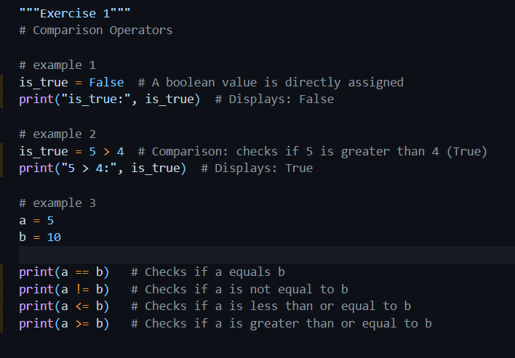

### Explanation

This exercise covers comparison operators such as ==, !=, <, >, <=, >=. In this exercise, I learned how Python comparison operators work. I first set a variable to False just to check how Boolean values work. Then I checked if 5 is greater than 4. I found out it answered True because the statement was correct. After that, I created two variables a and b which I set to 5 and 10 respectively. I checked them using comparison operators like ==, !=, <=, and >=. This helped me learn about testing equality between two values, inequality, or determining how one value compares to the other.

The comparisons are:

* a == b: Is a equal to b? (No → False)
* a != b: Is a not equal to b? (Yes → True)
* a <= b: Is a less than or equal to b? (Yes → True)
* a >= b: Is a greater than or equal to b? (No → False)

### Output

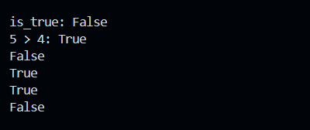

## Exercise 2: Logical Operators

### Understanding the Task

In this exercise, I was supposed to work with **logical operators** such as **and**, **or**, and **not**. I had to check how they behave when used with different conditions and operators and see what kind of Boolean result they give, either True or False. The objective was to understand how we can combine multiple logical conditions all at once.

### Source Code

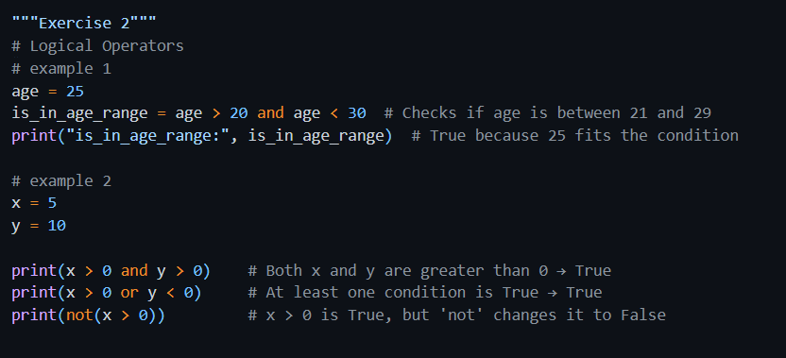

### Explanation

Here, I got to know how to combine multiple conditions using logical operators. I started by checking if a person's age was between 20 and 30 using the **and** operator. The output of this was True because both sides of the condition were correct. Then I checked and tested other expressions using and, or, and not with two numbers. I observed that the output of the and operater is only True when both the conditions are True while or only needs one condition to be true. The **not** operator reversed the result. By working on these examples, I learned how various conditions can be combined and then used.

* I check if any age variable value is between 21 and 29 by using and. Both sides must be true.
* x and y are numbers. We test combinations of conditions:
  + x > 0 and y > 0: Are both positive? → Yes.
  + x > 0 or y < 0: Is either positive or y negative? → Yes (since x > 0 is True).
  + not(x > 0): This means “is it NOT true that x is greater than 0?” → No, x is 5, so x > 0 is True, and not(True) is False.

### Output

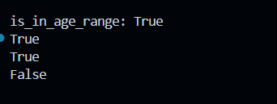

## Exercise 3: if – Conditionals

### Understanding the Task

In this task exercise, I learned the basic use of if conditional statements in Python. I checked if a certain condition is true and then update any variable or display a message accordingly. The main goal of this thing was to learn how decisions are made in a programs, based on conditions.

### Source Code

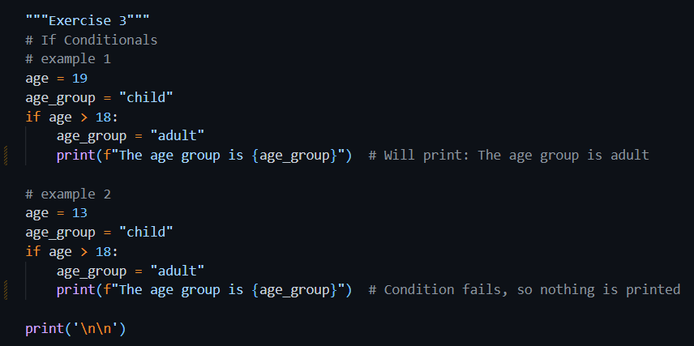

### Explanation

In this part, I used an if conditional to check age group. First, I assumed the person was a child but then checked age > 18 to see if they were an adult. If they were, I updated the variable and printed it. When I tested it with age 19, it printed "adult". But with age 13, nothing was printed because the condition wasn’t true. I learned that if statements only run their block when the condition is true, otherwise, they skip it.

### Output

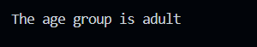

## Exercise 4: if – else Conditionals

### Understanding the Task

### This task was about using the if-else conditionals. I had to code where the program chooses between two possible actions, one if a condition is true, and another if it's false.

### Source Code

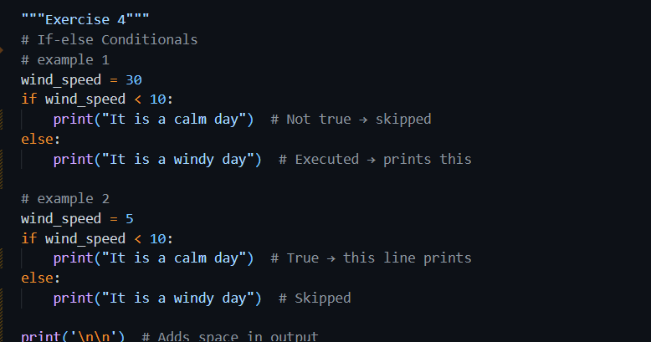

### Explanation

* In the first example, wind_speed was 30, which is not less than 10, so it printed "It is a windy day".
* In the second example, windspeed was 5, which is less than 10, so it printed "It is a calm day".

### Output

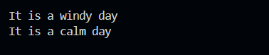

## Exercise 5: if – elif - else Conditionals

### Understanding the Task

### In this exercise, I learned and practiced using if-elif-else blocks to check and handle multiple conditions in a clean way. This helped in making better decision-based logic where the program chooses the right option from multiple possibilities.

### Source Code

#### Example 1

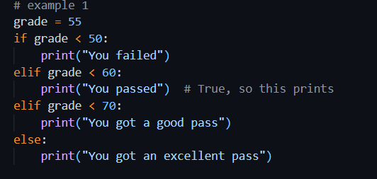

#### Example 2

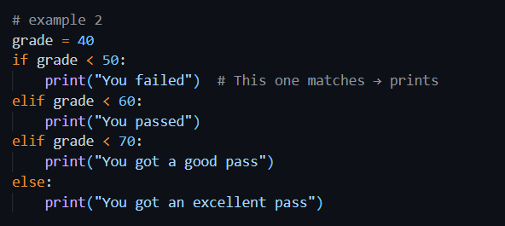

#### Example 3

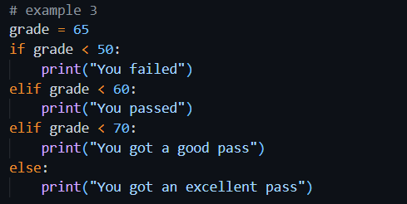

#### Example 4

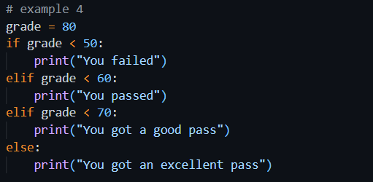

### Explanation

* Four different grades were tested.
* The code checked each grade and printed a message:
  + Below 50 → “You failed”
  + Between 50–59 → “You passed”
  + Between 60–69 → “You got a good pass”
  + 70 and above → “You got an excellent pass”
* Each elif allows checking in sequence, and only one block runs depending on the value.

### Output

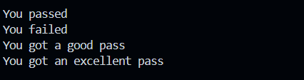

## Exercise 6: Compare Temperatures

### Understanding the Task

This task is about comparing two temperature values. This is to see if both temperatures are the same or different. I had to store two temperature values in separate variables and then use an if-else condition to compare them. If both temperatures values in variables were equal, the program should print a message saying they are the same. Otherwise, it should be printed that the temperatures are different.  
The purpose of this task was to help me learn using comparison operators (==) and conditional statements to make decisions based on real-world values. It has also helped me learn how to clearly format and print meaningful output messages based on the result of the comparison.

### Source Code

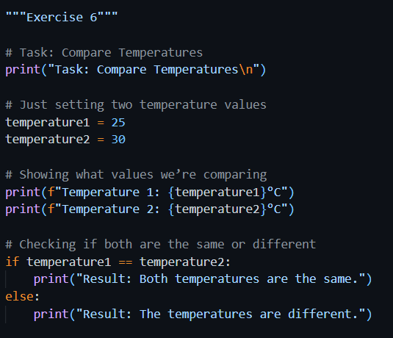

### Explanation

* The two temperatures were set to 25 and 30.
* The program displayed both values.
* Then it compared them: since 25 ≠ 30, it printed “The temperatures are different”.

### Output

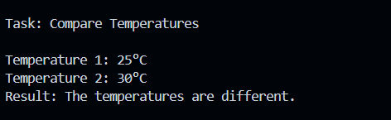

# Section 2. Python Lists

### Understanding the Task

I was asked to practice how Python lists work. Specifically:

* I had to **create a list** of cities.
* Then I **accessed specific elements** in the list using indexes and slicing.
* After that, I **modified the list** by changing one value and adding another.
* Finally, I had to **create, access, and manipulate another list** of colors, check its length, and use conditions and slicing to work with it.

These tasks helped me understand how flexible, usable and powerful Python lists are.

## Exercise 1: Creating a list

* I created different types of lists to explore how Python handles numbers, text, empty lists, and mixed types.
* I also created a list named city_list with "Glasgow", "London", and "Edinburgh" as requested.

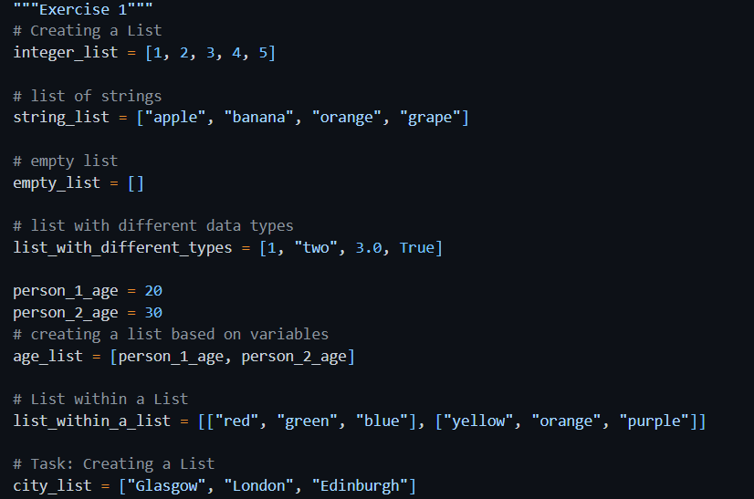

## Exercise 2: Accessing List Elements

* I learned that I could get a specific item by its position using an index.
* I used slicing to get a portion of the list.
* I also printed the **third item** and the **last two items** from city_list using slicing.

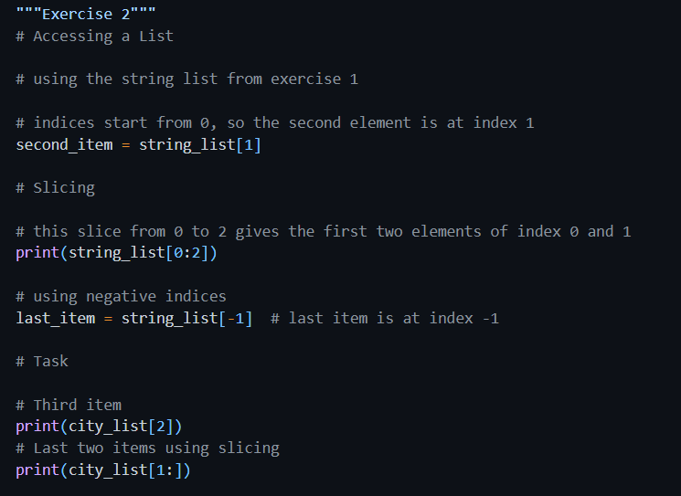

## Exercise 3: Modifying Lists

* I replaced the first item in string_list from “apple” to "pear".
* I added a new item to the end of the list using .append().
* I also updated the city_list by adding "Manchester" and changing "London" to "Birmingham".

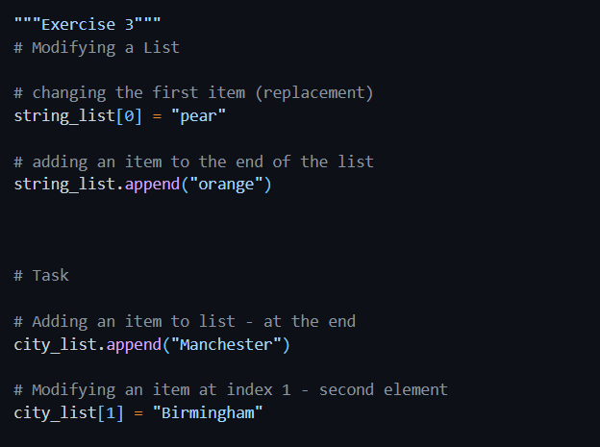

## Exercise 4: Summary Task

I created a list called colours and printed it.

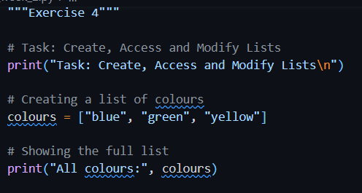

I accessed the second color and printed it.

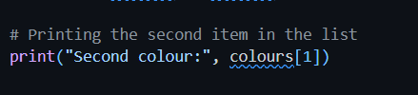

I changed the first color, counted how many colors were in the list using len(), and printed that.

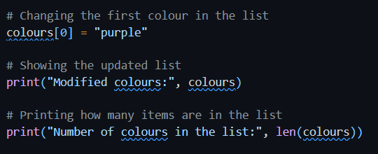

I checked whether "red" was in the list and printed a message accordingly.

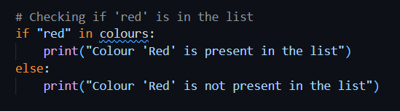

I used slicing to make a new list with just the second and third colors.

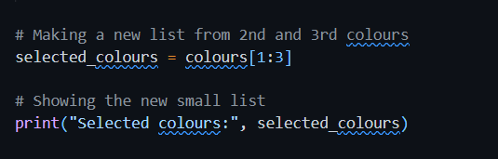

### Output

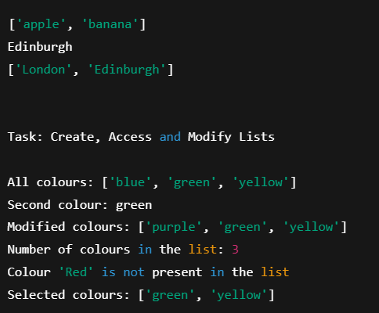

# Section 2. Python Loops

### Understanding the Task

## In this exercise, I understood how to utilize loops in Python. The purpose of this it to repeat tasks automatically untill the condition is met. I worked with both while loops and for loops. I also understood the concept of controlling the flow of loops using special keywords like break (to stop the loop immediately) and continue (to skip that part of loop). After that, I implemented my learning to some small programs like printing even numbers, summing up squares of numbers, and creating a countdown. These tasks helped me build a strong foundation in writing loops effectively.

## Exercise 1: While Loop

### Source Code

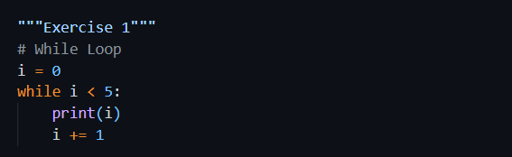

* I used a while loop to print numbers from 0 to 4.
* The loop kept running as long as the value of ‘i’ variable was less than 5.
* Each time, I printed i and increased it by 1.

### Output

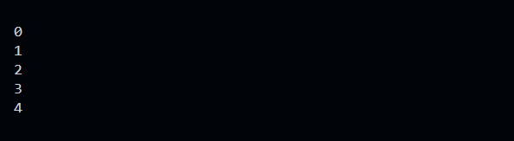

## Exercise 2: For Loop

### Source Code

#### Example 1

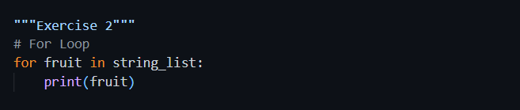

#### Example 2

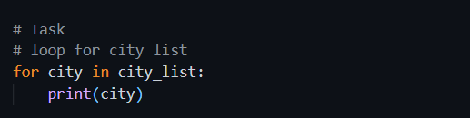

* I used a for loop to print items from two different lists: string_list and city_list.
* It went through each element of list one by one and printed them

### Output 1

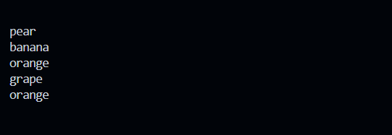

### Output2

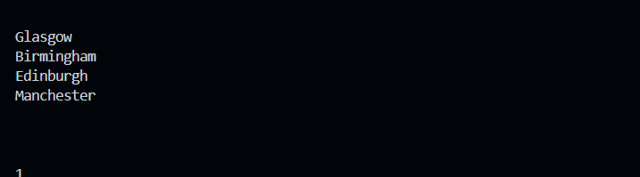

## Exercise 3: Loop Keywords

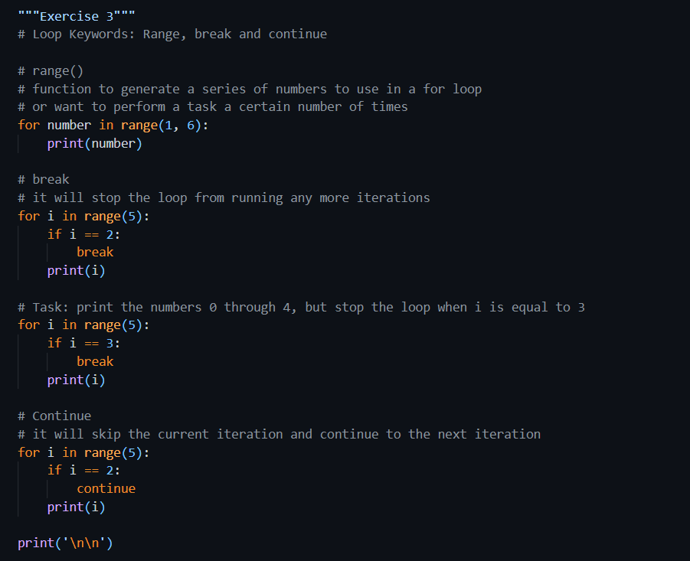

* I used range(1, 6) to print numbers from 1 to 5.
* Then I used break keyword to stop the loop when i became 2.
* I also wrote a custom task to stop when i == 3.
* Lastly, I used continue keyword to skip printing the number 2 but printed everything else.

### Output

#### Range ()

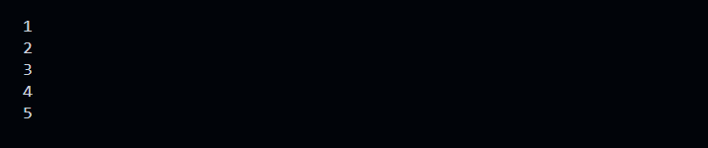

#### break

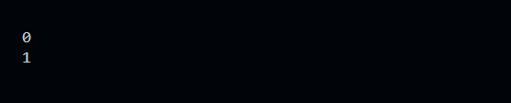

#### print the numbers 0 through 4, but stop the loop when i is equal to 3

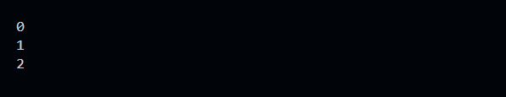

#### continue

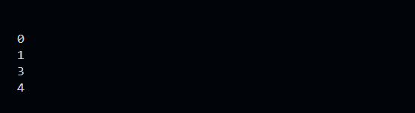

## Exercise 4: Summary Tasks

#### Even Numbers

##### Source Code

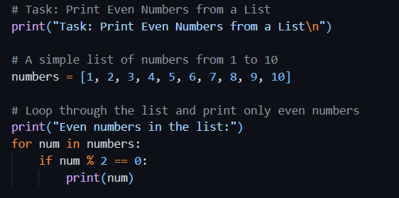

* I created a list from 1 to 10.
* I used the modulo operator % to check if a number was even.
* If yes, I printed it.

##### Output

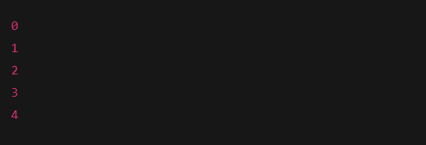

#### Sum of Squares

##### Source Code

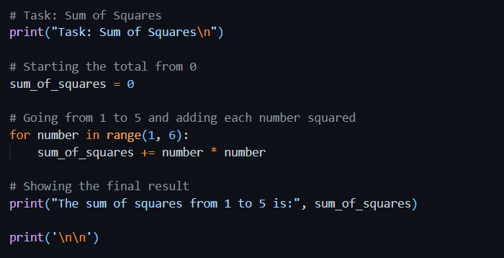

* I used a loop to go from 1 to 5.
* I squared each number and added it to a total.
* I printed the final sum, which came out as 55.

##### Output

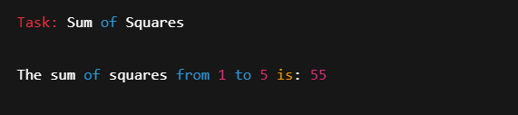

#### Countdown

Source Code

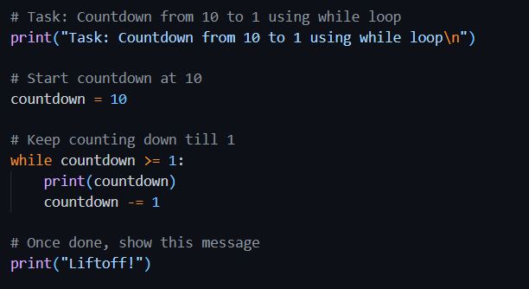

* I used a while loop that started from 10.
* It printed each number down to 1.
* Then, it printed “Liftoff!” to end the countdown.

##### Output

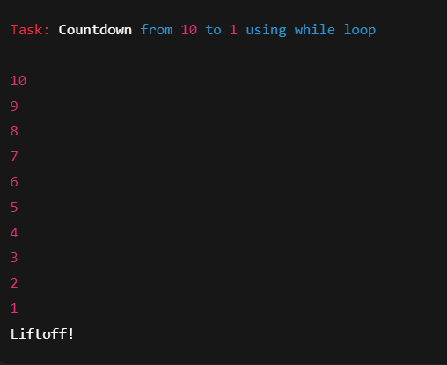

# Section 4. Obtaining User Input

### Source Code

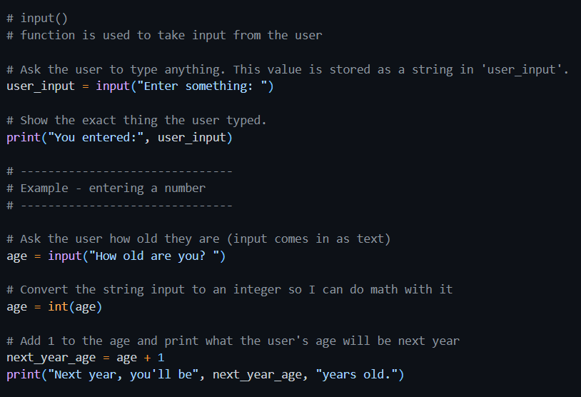

### Explanation

### I used input() method (built in) to ask the user to type something.

### Whatever they typed got stored in a variable and then used in some logic in program.

### This helped me see how input works in real time.

### I asked the user to enter his age.

### Since input is always a string by default, I used int() method to convert string into a number.

### Then, I added 1 to it and then calculated what will be his age next year.

### This showed me how to turn text into numbers and use it in calculations.

### Output

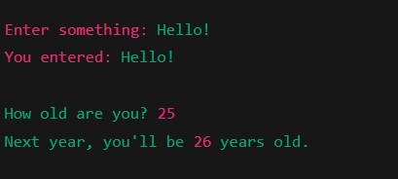

## Task: User Input and Conditional Statements

### Understanding the Task

In this section, I learned how to get input from the user using the input() function. I practiced asking the user to type something, storing that input in a variable, and then doing something with it, like printing it or using it in a condition. I also learned how to convert string input into numbers so that I can do math with it. Finally, I created a small program to check someone’s age group based on what they enter.

### Source Code

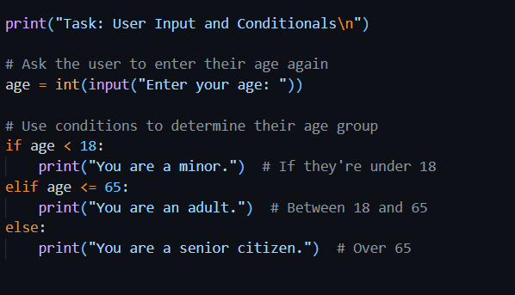

### Explanation

* I asked the user to enter their age again.
* Based on the value, I used conditions to print whether the person is a minor, adult, or senior citizen.
* This helped me combine input with decision-making logic.

### Output

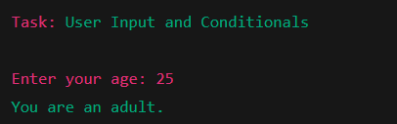

## Task: Temperature Converter

### Understanding the Task

* I ask the user which temperature unit they want to convert from (C, F, or K).
* If the input is valid, I ask for the temperature value.
* I then convert the value into the other two temperature scales using the correct formula:
  + **C to F and K**
  + **F to C and K**
  + **K to C and F**
* If the user enters an invalid unit, the program tells them and asks again.
* Once the conversion is done, the program ends.

### Source Code

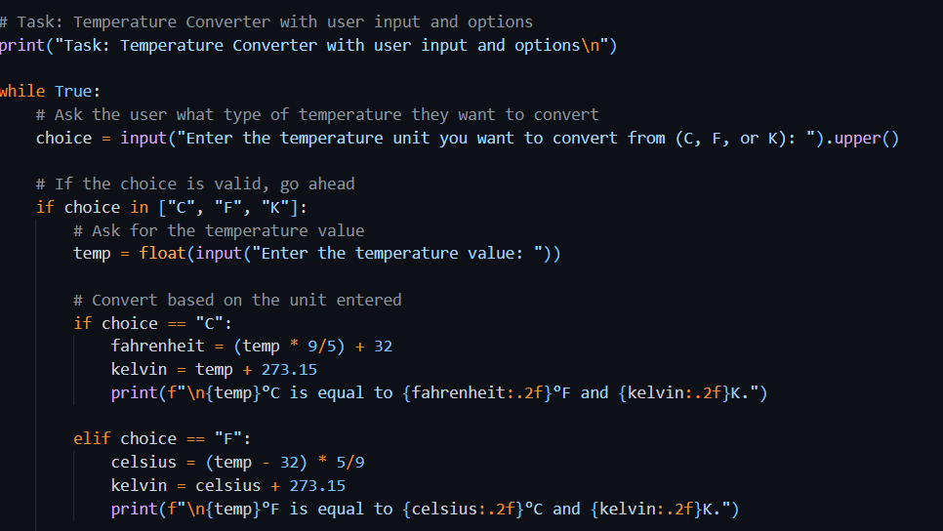

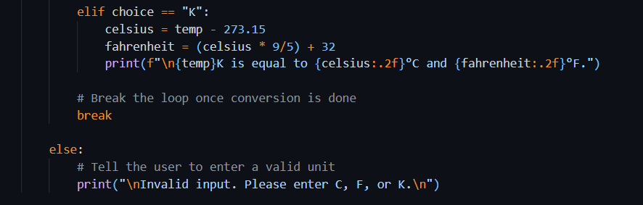

### Explanation

In this program, temperature is being converted between different scales of temperature, I asked the user to input which unit they want to convert from, Celsius, Fahrenheit, or Kelvin. Once the user chose a valid option, I then asked for the temperature value.

When user enters a value as an input, Math formulas are being used to convert temp from one unit to other. For example, if the input was in Celsius unit, I converted it to Fahrenheit and Kelvin.

I used a loop in program to keep asking the user to input until the user entered a valid unit, and used conditionals to decide which conversion formula to use. At the end, the results temperatures in remaining two units were displayed on screen in a clean format.

This program helped me practice getting user input, working with loops, using conditionals, and performing basic calculations.

### Output

#### Case 1: User Enters C

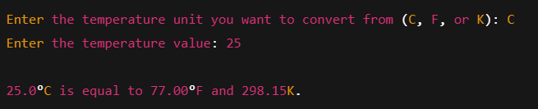

#### Case 2: User Enters Invalid Input First, then Valid

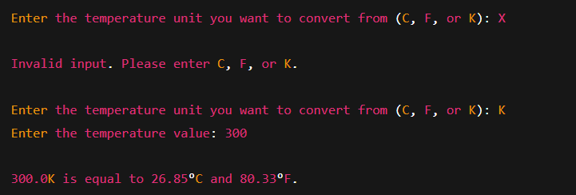

Week 3

# Section 1. Functions and Scope

## Exercise 1: Functions in Python

### Understanding the Task

I In this task, I learned how functions in Python work and how reusability and organization of code are enabled with their uses. I brushed upon different aspects, like defining a simple function, passing parameters to it, and using keyword arguments. I practiced default parameters and learned the return values inside functions. Each small subtopic further enlightened me about how functions would behave in varied scenarios and how we could manage input and output even more effectively. It has also given me quite a solid bearing in the application of clean-function coding practices.

Creating Functions

##### Source Code

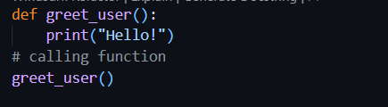

##### Explanation

Here, I created a simple function called greet_user() that prints a greeting. I called the function after defining it to run the print statement. This shows how basic functions are defined and called in Python.

##### Output

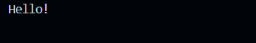

#### Function Parameters

##### Source Code 1

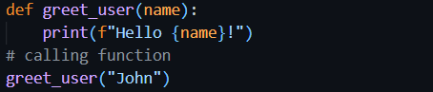

##### Output 1

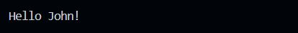

##### Source Code 2

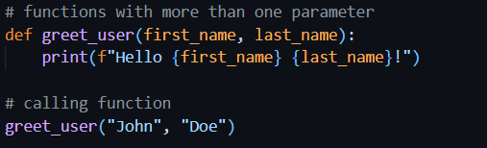

##### Output 2

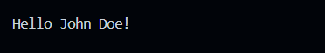

##### Explanation

This version of the function takes a parameter called name. When I call greet_user("John"), it prints "Hello John!". This shows how to pass input (variables) into a function and use it inside.

#### Keyword Arguments

##### Source Code

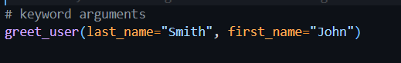

##### Explanation

In this example, I called the same function using keyword arguments. I passed values by naming the parameters directly. This allows the arguments to be passed on in any order, which makes the code more readable.

##### Output

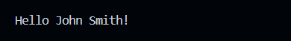

#### Default Values

##### Source Code

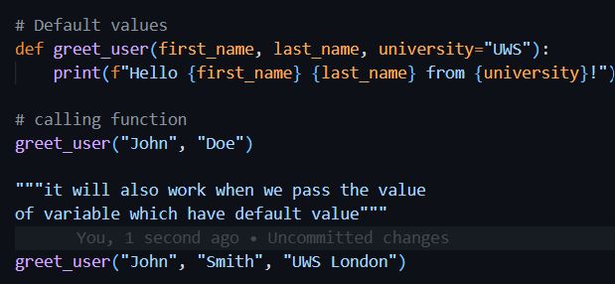

##### Explanation

There is a default value for the university parameter. If I don't pass the value, it takes "UWS" by default, but I could always pass a custom value to it like "UWS London." This is useful for parameters that, by default, tend to have a common value.

##### Output

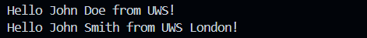

#### Return

##### Source Code

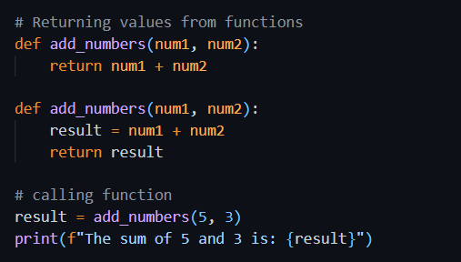

##### Output

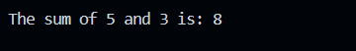

##### Source Code

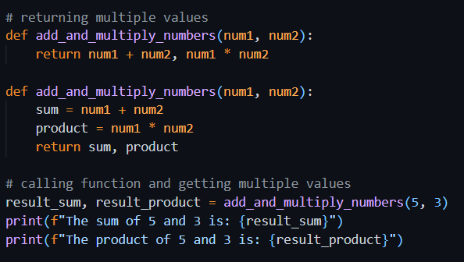

##### Output

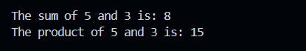

##### Explanation

In this part, I made a function called add_numbers(), which takes two numbers and returns their sum as the output. Instead of printing the result inside the function, it sends the result back using the return keyword. I put that value in a variable named result and simply printed it. This makes the function flexible since I can use the result anywhere else in the program too.

## Task: Greet each friend in the list

### Understanding the Task

For this task, I had to create a function that takes a list of friends' names and greets each one by printing a message. The ultimate goal was to apply a for loop to go through a list and greet each item in it.

### Source Code

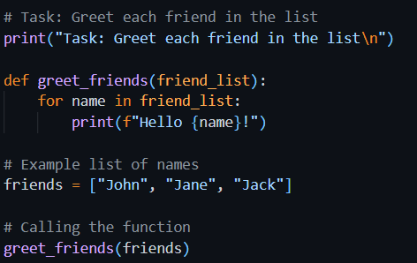

### Explanation

I defined a function greet_friends() that accepts one parameter, a list of names. Within this function, a for loop iterates through the list to print "Hello" followed by each respective name of friend. When I called the function with a list such as ["John", "Jane", "Jack"], this caused printing a greeting message for each one of them; which is a good example of the combination of functions and loops.

### Output

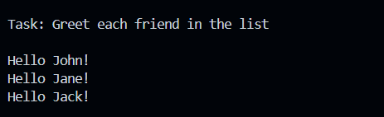

## Task: Calculate Tax Based on Income and Tax Rate

### Understanding the Task

This task was to write a program to calculate tax based on the income entered and tax rate. It started with testing that the function would work with fixed values, then prompted for user input on income and tax rate for as many times as desired. The goal was to apply functions, input/output, loops, and basic arithmetic.

### Source Code

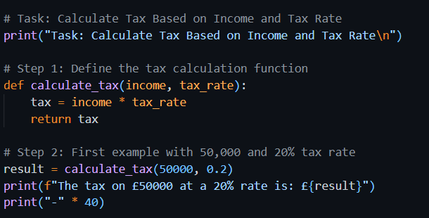

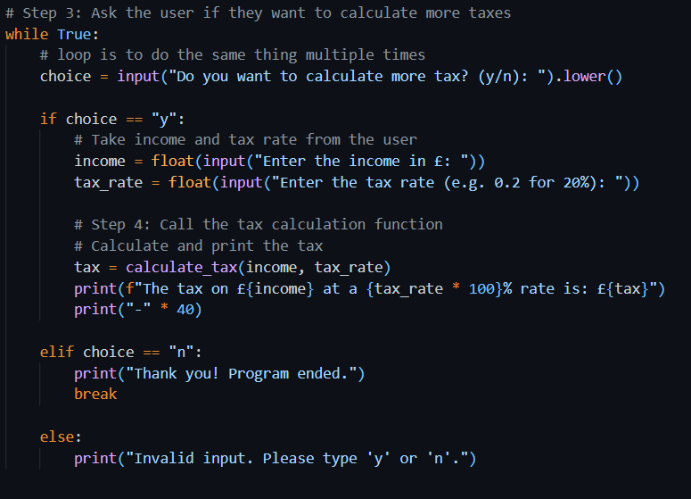

### Explanation

* First, I created a function called calculate_tax that multiplies income by tax rate and returns the result.
* I tested the function with £50,000 income and a 20% tax rate, and it correctly returned the tax.
* Then I used a while loop to allow the user to calculate tax as many times as they want.
* If the user enters 'y', it asks for income and tax rate, then prints the calculated tax using the same function.
* If the user types 'n', the program ends with a thank-you message.
* It also handles invalid inputs like any character other than 'y' or 'n'.

### Output

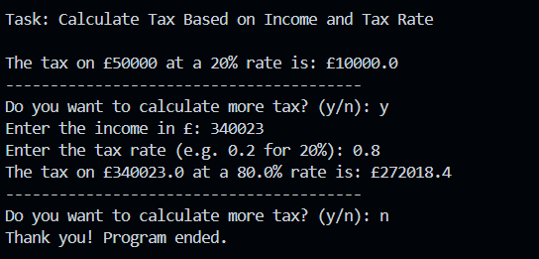

## Task: Compound Interest Calculator Function

### Understanding the Task

In this task, I was required to make a function called compound_interest() which calculates how much the investment grows each year under compound interest. An initial amount, the number of years, and the interest rate would be passed to the function as parameters. It prints the total value for every year; it then returns the amount for the last year as an integer. This included checks to confirm whether the inputs are valid, such as for instance making sure that the interest rate is between 0 and 1 and the duration is positive. Hence it gave me extra practice in the use of function, loops, and input validation.

### Source Code

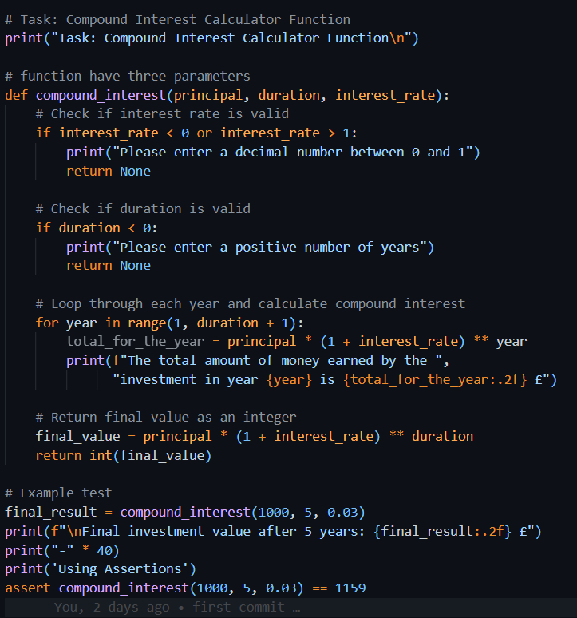

### Explanation

* The function compound_interest takes three parameters: principal, duration, and interest_rate.
* It first checks for the interest rate between 0 and 1 and duration to be positive, or else it shows an error and exits early.
* Then it uses a for loop to calculate and print the total amount at the end of each year by the compound interest formula:  
  (principal×(1+rate)year)(principal × (1 + rate) ^ year)(principal×(1+rate)year)
* Finally, it returns the total value at the end of the given duration, rounded to an integer.
* I tested the function with an initial investment of £1000 for 5 years with an interest rate of 3%, and it correctly printed the values for each year and returned the final result.

### Output

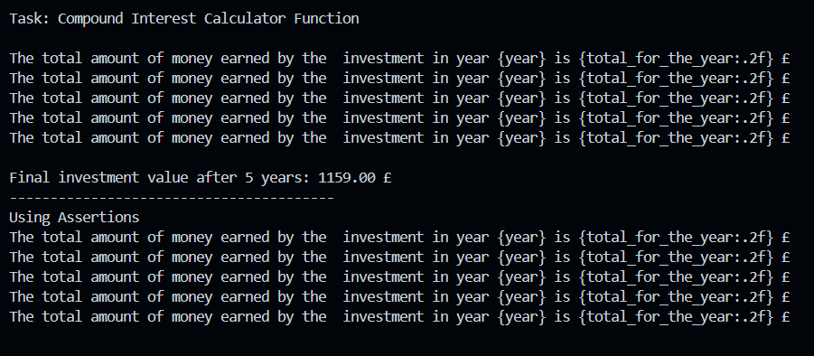

## Exercise 2: Variable Scope

### Understanding the Task

This task helped me in learning about the variable scopes in Python with respect to functions. It showed a difference between the variables which were defined within a function (local scope) and that defined outside it (global scope).

### Source Code

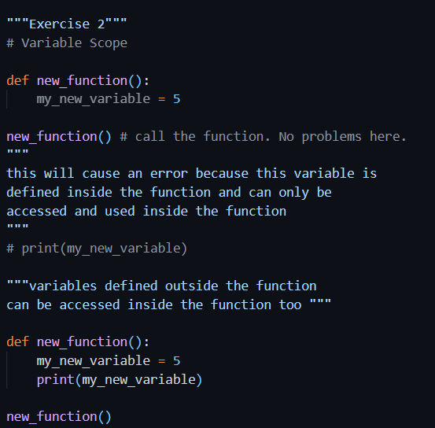

### Explanation

* The first part is where I define a variable called **my_new_variable** inside a function and try to access it outside the function; it gives me an error because it is known to exist only in local scope of the function.
* In the second part, I included a **print()** statement within the function just to access the same variable; it works perfectly. This is evidence that local variables are confined only to the function they are defined in.
* The code also states that **global variables**, which are defined outside function, can also be accessed into it but this example does not demonstrate it in action.

### Output

#### Error

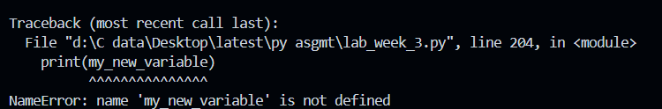

#### Corrected Code Output



# Section 2: Assertions and Errors

## Exercise 6: Assertions

### Understanding the Task

This task was about using assert statements in Python. An assert statement checks automatically whether a function gives a particular output or not. Assert statements are used for testing purposes.

### Source Code

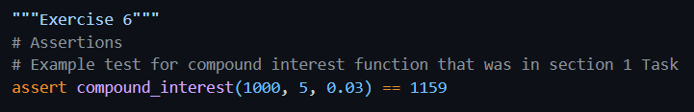

### Explanation

Using the assert keyword, the output of the compound_interest function was validated. If the result isn't 1159 exactly, the program would show an error. As the actual return is the same, the code executes without crashing.

### Output

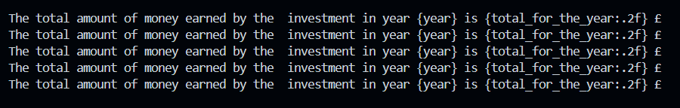

## Exercise 7: Identifying and Fixing Common Errors

### Understanding the Task

#### Syntax Error

This error occurs when Python code is written incorrectly with respect to its syntax and doesn't follow the proper rules, e.g., a typo like pritn() instead of print().

##### Source Code 1 – Has Error

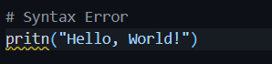

##### Output 1

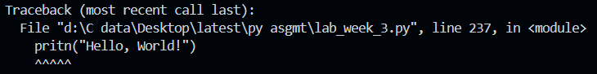

##### Source Code – Corrected

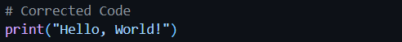

##### Output 2

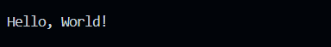

##### Explanation

The original line used pritn() which is incorrect. I fixed it by writing print("Hello, World!") correctly.

#### Name Error

Happens when you try to use a variable or function name that hasn’t been defined yet.

##### Source Code 1 - Has Error

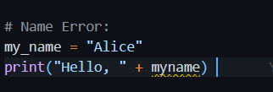

##### Output 1

##### 

##### Source Code 2 – Corrected Code

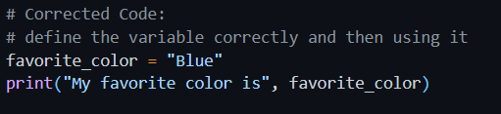

##### Output 2

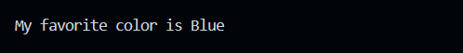

##### Explanation

Originally, myname was used without being defined. I fixed it by using a properly declared variable favorite_color and printed it correctly.

#### Value Error

Occurs when a function gets the right type of data but the value is not acceptable, like converting "abc" to an integer.

##### Source Code 1 – Has Error

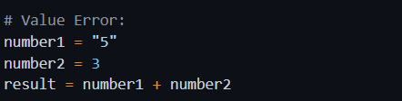

##### Output 1

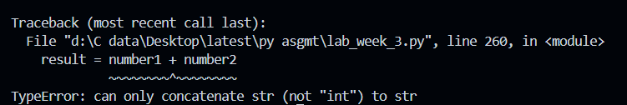

##### Source Code 2 – Corrected Code

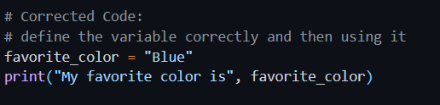

##### Output 2



##### Explanation

Python can’t add a string and an integer directly. I fixed it by converting "5" to int using int("5") before adding.

#### Index Error

Happens when you try to access an index in a list that doesn’t exist, like accessing index 3 in a 3-item list.

##### Source Code 1 – Has Error

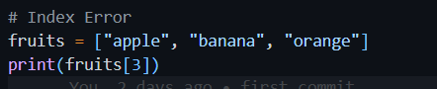

##### Output 1

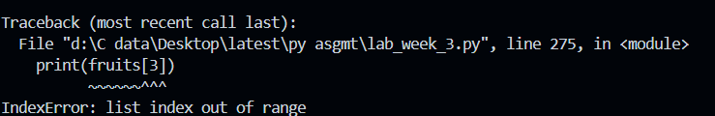

##### Source Code 2 – Corrected Code

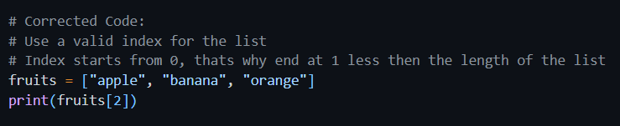

##### Output 2



##### Explanation

The list only had 3 elements (index 0 to 2), but index 3 was used. I corrected it by accessing index 2, which is valid.

##### Output

#### Indentation Error

Occurs when the code isn't properly spaced. Python uses indentation to know what code belongs in loops, functions, etc.

##### Source Code 1 – Has Error

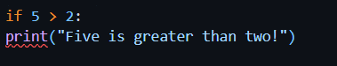

##### Output 1

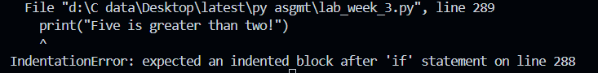

##### Source Code 2 – Corrected Code

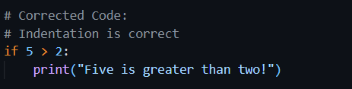

##### Output 2

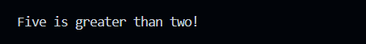

##### Explanation

Indentation is expected by Python in code blocks. The original code was not indented under if statement. I had corrected the code with an indentation in the print() line.

# Section 3. Larger scale python program

## Task: To-Do list manager:

### Understanding the Task

The purpose of this task was to create a simple To-Do List application using basic Python features like lists, functions, conditionals, and loops. The program allows the user to manage their tasks by adding a task, viewing the current list, removing any task, and therefore exiting the program using a menu system.

The focus was on writing clean and functional code and understanding of how to work with user input and list operations in Python.

### Source Code

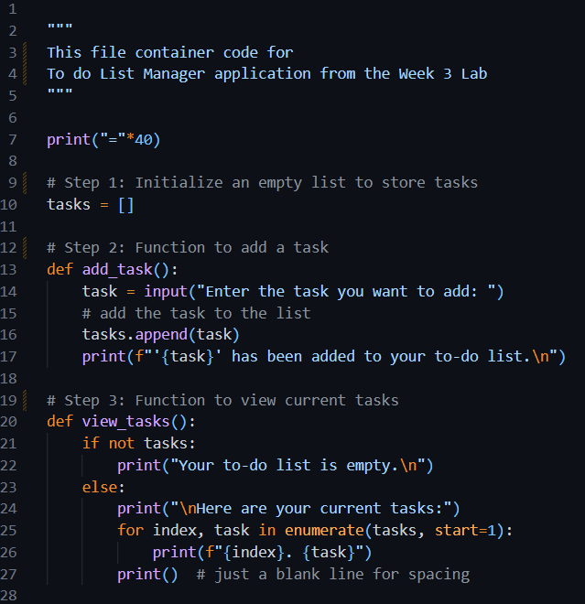

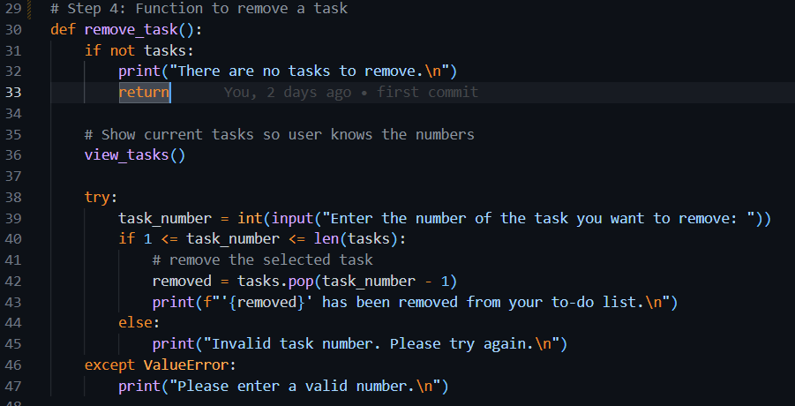

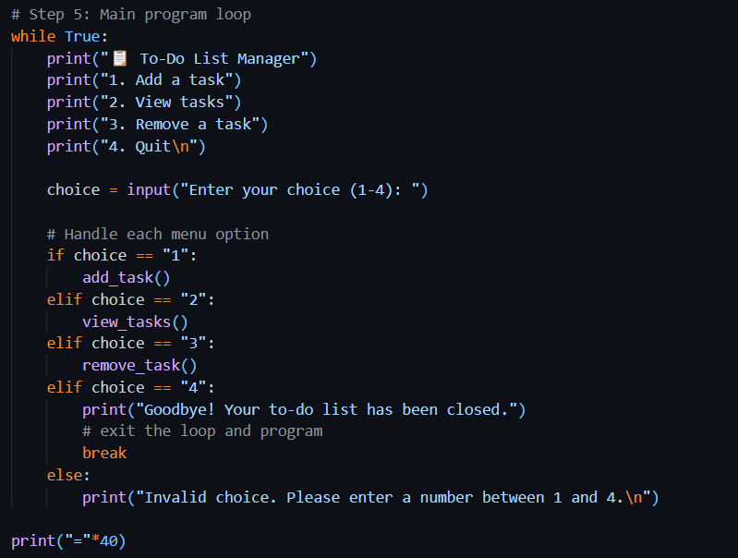

### Explanation

The program runs in a loop and offers four main options to the user:

#### 1. Initialize the Task List

At the top of the program, an empty list called tasks is created. The tasked created by user will be stored in this list.

#### 2. Adding a Task

The add_task() function asks the user to type in the details of task i.e. title, description, due date. Once entered, the task is added to the list, and a confirmation message is displayed.

#### 3. Viewing All Tasks

The view_tasks() function checks if the list is empty. If not, it shows all current tasks with numbers beside them for easy reference. This helps the user see what tasks they’ve added so far.

#### 4. Removing a Task

The remove_task() function lets the user delete a task by entering its number. The task list is displayed first so the user knows the correct number. The function also handles invalid input or if the list is empty.

#### 5. Menu and Loop

The program uses a while loop to repeatedly show the menu:

* 1 to Add a task
* 2 to View tasks
* 3 to Remove a task
* 4 to Quit

The user can perform any action, and the loop keeps running until the user selects the quit option.

### Output

###### Choice 1

Choosing 1 to add a task (one by one)

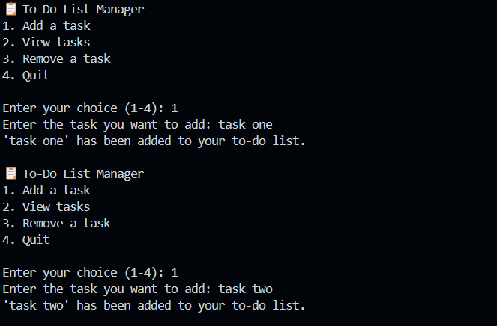

###### Choice 2

Choosing 2 to view tasks.

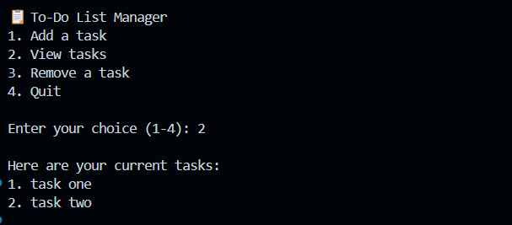

###### Choice 3

Choosing 3 to delete a task.

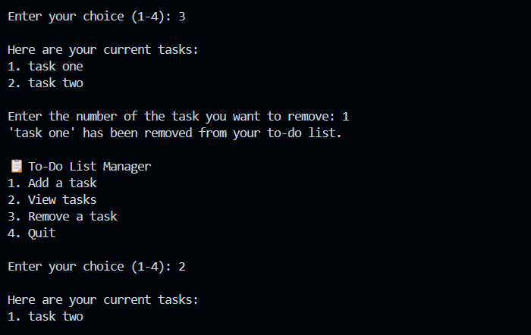

###### Choice 4

Quitting the program

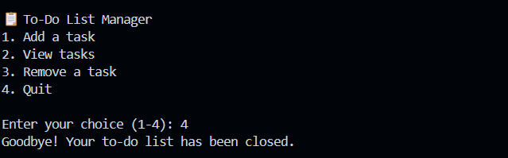

Week 4

# Section 1. Python Classes

## Exercise 1: Creating Classes and Initializing Objects

### Understanding the Task

In this exercise, I was asked to create Task class which will have task details. I was also asked to define a class called TaskList that holds a list of tasks which are the objects of Tasks from the Task class and stores the owner’s name. I learned how to use the __init__ method to initialize class attributes.

### Source Code

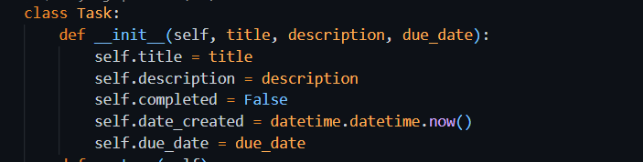

### Explanation

This class is used to represent a task in a to-do list. When a new Task object is created, it automatically stores:

* **title**: The name or heading of the task
* **description**: A short explanation about what the task is
* **completed**: A boolean value that shows whether the task is done (initially set to False)
* **date_created**: The current date and time when the task is created
* **due_date**: The deadline for the task

This helps organize all the important details of one task inside a single object.

### Source Code

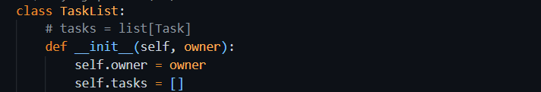

### Explanation

This class is used to manage a list of tasks for one user.

* **owner**: Stores the name of the person who owns the task list
* **tasks**: An empty list that will hold multiple Task objects

This class acts as a container for managing multiple tasks under one user.

#### Object Creation

##### For Task Class



##### And for Task List class

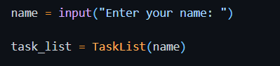

## Exercise 2: Adding Methods

### Understanding the Task

In this task, I was asked to further build upon the Task class by building effective functions that enable manipulation and interaction with task data. The objective was to practice instance methods for updating task attribute values, either marking a task as complete, changing its title, or altering the due date attributes. This was an exercise for me on learning how to define custom behaviors within a class.

### Source Code

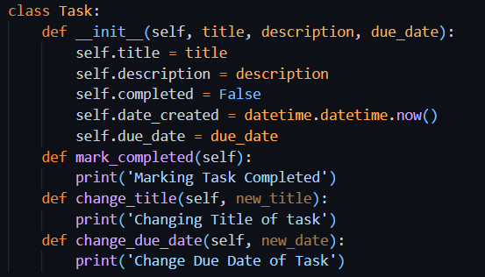

### Explanation

#### mark_completed() Method

* The purpose of this method is to mark the task as completed.
* It will update the ‘completed’ attribute of the class to True.

#### change_title(new_title) Method

* This method is created to change the title of the task.

#### change_due_date(new_date) Method

* This is meant to update the due date of the task.

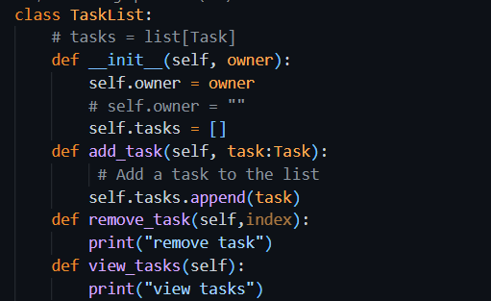

#### add_task(self, task: Task):

Adds a new **Task** object to the tasks list using the **append()** method.

*remove_task(self, index):*

This method is supposed to remove the task using an index provided by the user.   
To delete a task from your list, del self.tasks[index-1] is used.

*view_tasks(self):*

Displays all tasks in the list. If the list is empty, it shows a message saying there are no tasks. Otherwise, it iterates through the list and prints each task with a number.

This structure shows how methods can be added to a class to make it more dynamic and interactive.

## Task: Add logic to methods defined

In Task Class, I have implemented logic of functions e.g. mark_completed(), change_title(), change_due_date(). When any of these details will be required to be changed of specific task, these methods will be called respectively

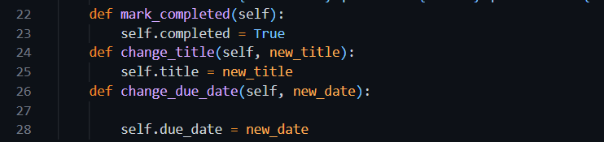

In TaskList Class, I have implemented logic of methods e.g. add_task(), view_tasks(), remove_task(). These methods will modify the tasks_list accordingly.

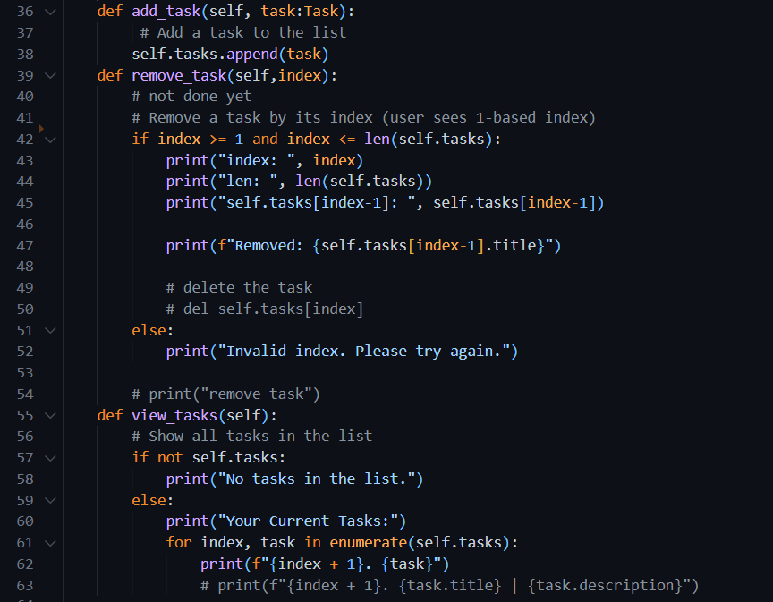

List_options() method will be calling for showing menu to the user and then calling the respective methods according to the choice.

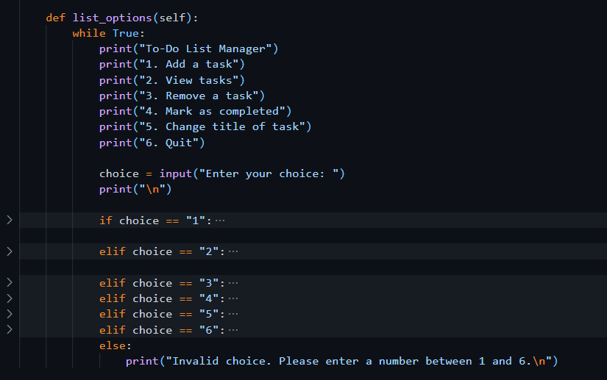

## Exercise 3: Testing the Functionality

Testing is done to check whether the code is working correctly or not.



### Output

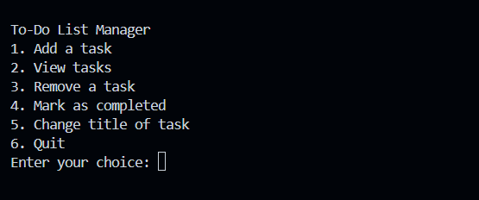

### Source code

Choosing one option lets us add one new task to the list at a time. Its working correctly

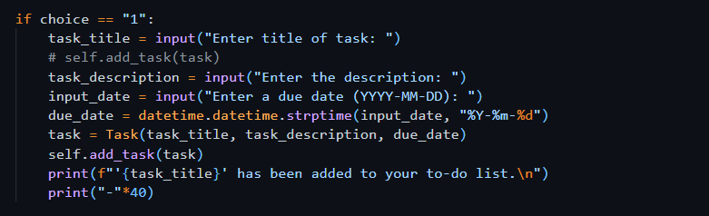

### Output

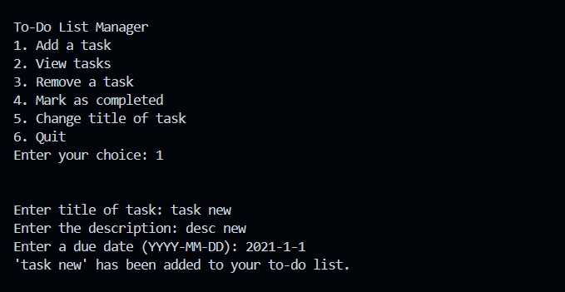

### Source code

Choosing option 2 to view all the tasks. It’s working correctly

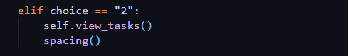

### Output

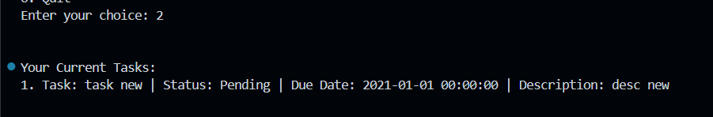

### Source code

Choosing option 3 to delete the task

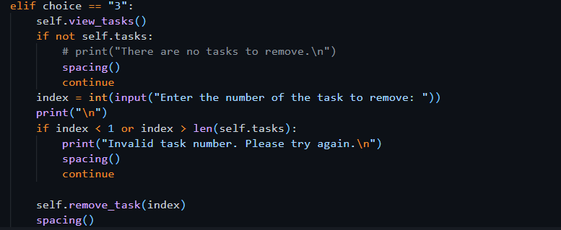

### Output

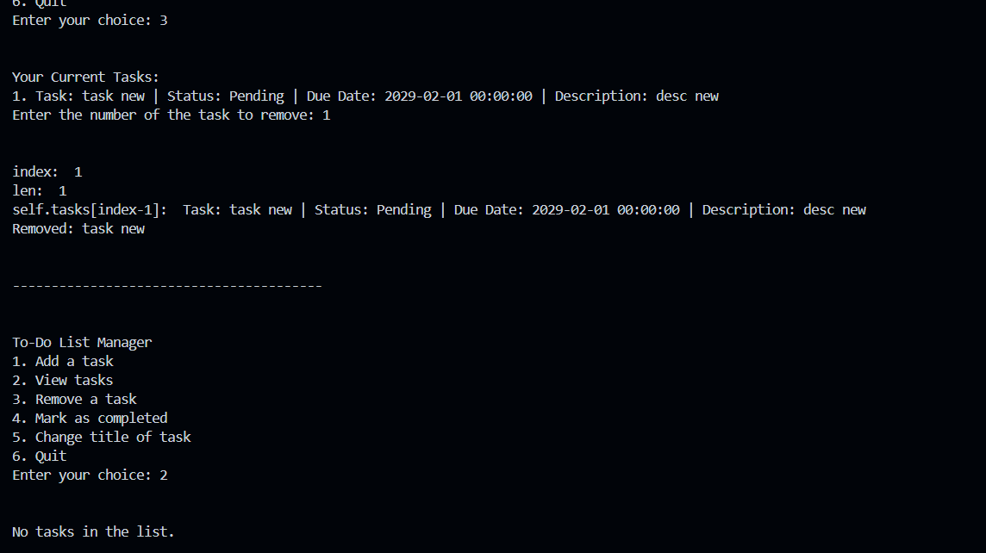

## Exercise 4: Composition

**Composition** is an object-oriented programming concept where one class is made up of or contains objects of another class.

### Source Code

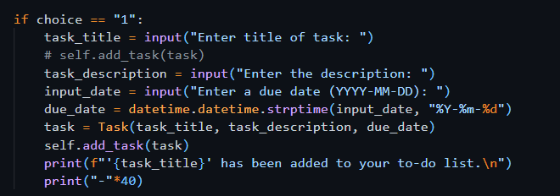

### Explanation

This code is taking title, desc and due date of a task as input from user. It then saves information using object of Task Class. It then adds that object to the Task List class using add_task() method. In this way TaskList can have many Tasks

## _str_ method

If we simply print the Task object , it will show something like



But we want to see the details of Task e.g. title, description, etc. For this purpose, we use _str_ method, which will convert the object into string and then will show it to user in readable format.



## Task: Change code in the Task Class

### Understanding the Task

‘**completed’** attribute is to be added to the class to mark the status of the task. First, it should be false to show that the task is not completed yet. There should be a function **mark_completed()** to update the status of the task. **change_title()** method will change the title of the respective task. All these details will be shown to the user by **_str_** method.

### Source Code

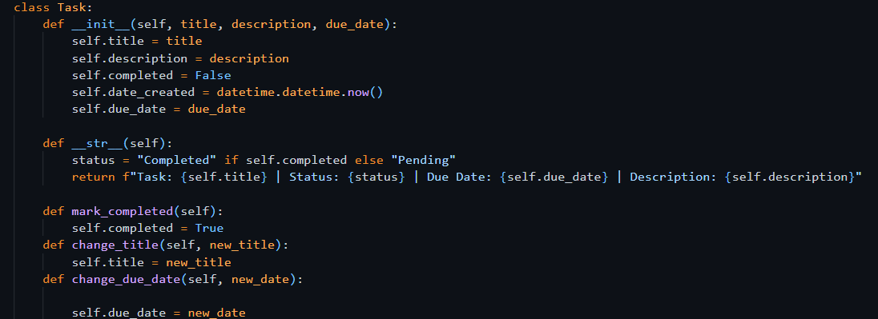

## Task: Update list_options() method

The options mark_completed(), change_title(), change_due_date() should be added to the menu items to show to the user to operate.

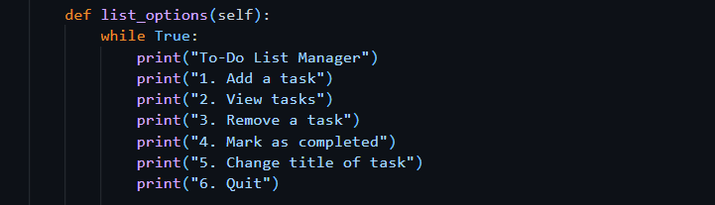

If Elif statements

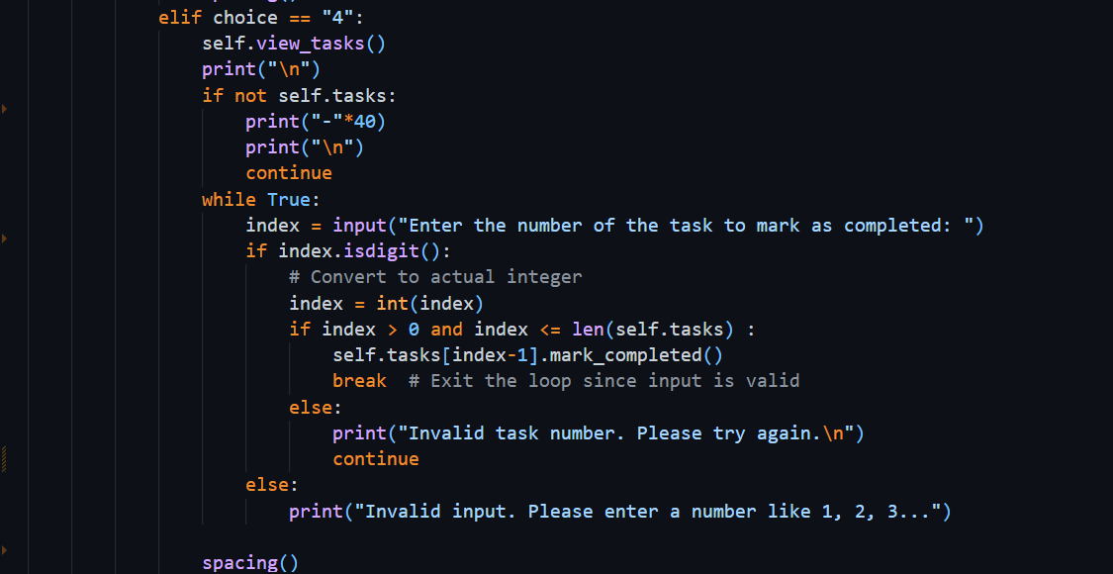

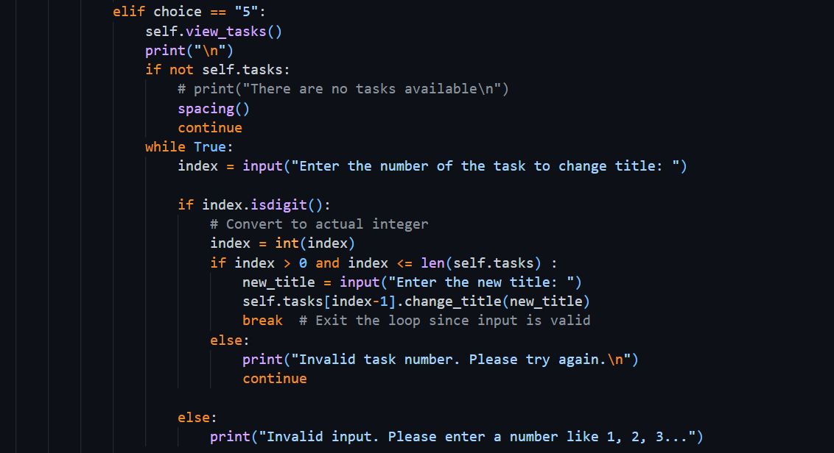

# Section 2. Python Libraries

Libraries are collections of functions and methods that allow you to perform actions, without having written the code yourself.

## Exercise 1: Adding Dates

### Understanding the Task

It is important for each task to have both the date it was created and the due date. To handle this, I used Python’s built-in **datetime** library. A method called **change_due_date** was also added so that the due date can be updated later if needed.

### Source Code

It is required to import the library, mostly at the top of the file.

**datetime** is the python library which is used to work with the dates and time. It lets us to :

* Get the current date and time
* Format dates in different ways
* Compare dates
* Add or subtract days, months, etc.
* Convert strings into date objects

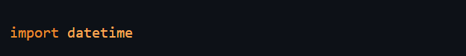

In this program, it is required to convert the string date (input from user) into datetime object and then save it to the Task. **strptime** also known as ‘String Parse Time’ is used to **convert a date string into a proper datetime object**, using a specific format. It takes 2 arguments, one is string and the other is format, in which the string has to be converted.

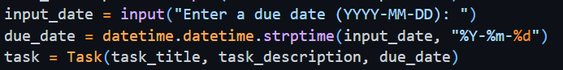

Or getting the present date and time



## Task: Add the due_date functionality

For changing due date of the task, I have created ‘change_due_date()’

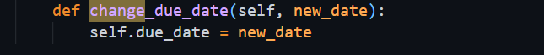

Modification of If-else statements in list_options() method for changing due date

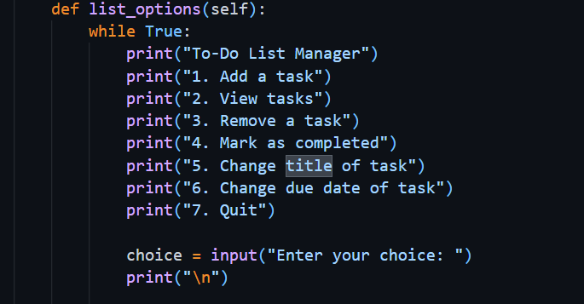

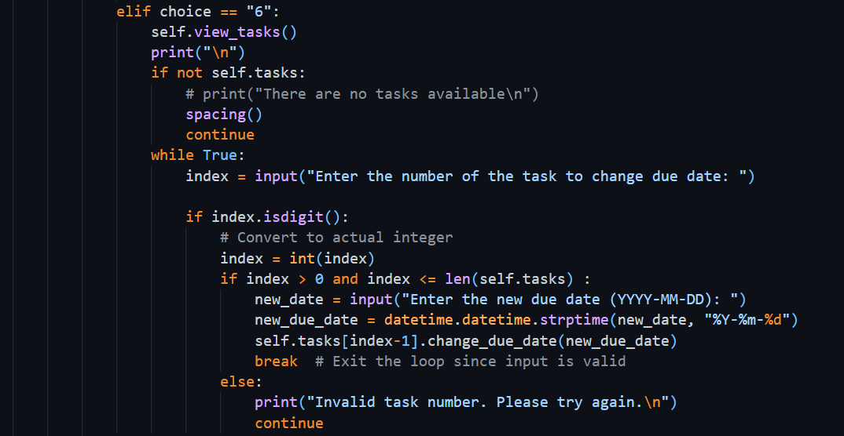

### Output

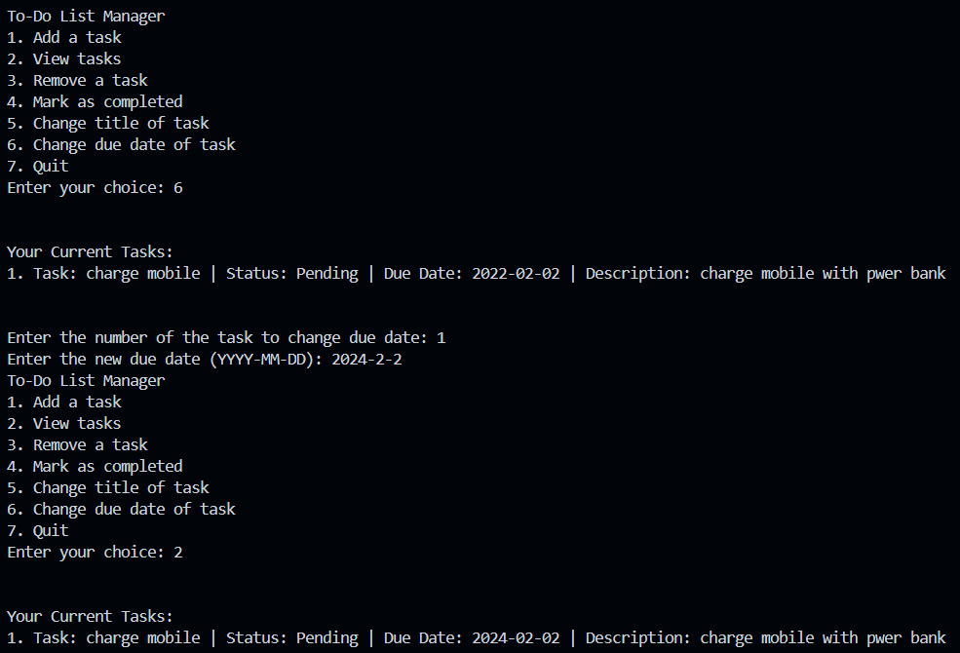

# Section 3. Modularizing the code

## Exercise 1: Restructuring

### Understanding the Task

In this task, I learned the importance of modularizing the code, ie., splitting the code into different files. I couldn’t simply write all in one big fat script, so I had to divide my code into modules that would take care of one and only one part of the things that needed doing.

I was asked to create a new folder called ToDoApp, then inside it:

* Create a main.py file to act as the **main.py entry point** of the application.
* Move the **Task** class into a new file called **task.py**.
* Now take the **TaskList** class and put it into a separate file name **task_list.py**.

This structure is used to stay organized, make code readable and maintainable, and is even more useful as the scale of the program grows. I also had to handle importing properly.

### Explanation

To make the code more organized, I divided it into three separate Python files:

#### main.py

This file is the starting point for the program. It includes the user interface (menu), prompts the user for input, and invokes functions that reside in other files. This is the file I use to run the application.

#### task.py

This module contains the **Task class**, which constains all the properties of a task, like title, description, due date, date on which task is created, and whether the task is completed. It also includes useful methods like:

* mark_completed()
* change_title()
* change_description()
* change_due_date()

#### task_list.py

This file contains the **TaskList class**, which manages a list of Task objects. It allows adding, removing, viewing, and checking overdue tasks.

### Output

* The program runs smoothly by calling everything from main.py, meanwhile keeping the logic separate in task. py and task_list. py..
* The output is unchanged and the user can add, display, update or remove tasks through the menu.
* The code is now cleaned up, more debuggable and easily extensible in the future..
* If I ever want to use the Task or TaskList classes in another project, I can, without having to rewrite the classes.
* It is a good programming practice of separating logic into modules, which is useful for teamwork and larger projects.

#### Import statement

When the contents of a file are needed in another file and will be used there, it must be imported into the second file at the top, otherwise it will give error.

### Source code

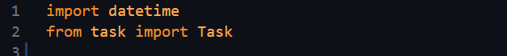

The second import statement says that I have imported Task class from task file. ‘task’ file is basically task.py file.

## Exercise 2: Main()

### Understanding the Task

In this task, I had to properly define a **main() function** that serves as the starting point of the program. The purpose was to cleanly separate the setup logic of program and make the code more structured and organized.

Instead of writing everything directly at the bottom of the file, I placed the core startup code inside main() and then called it safely using:

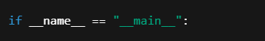

### Source Code

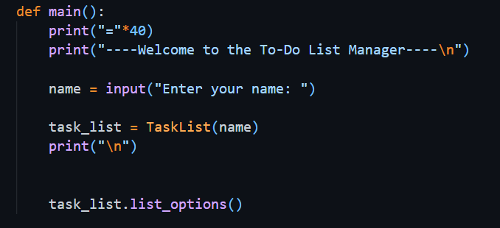

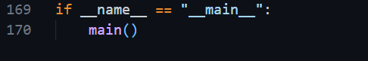

### Explanation

* Inside the main() program, I made an "object" of our TaskList, and inputted a name (my_firstname) as an argument..
* Then I called task_list. list_options(), this function shows us the menu and another fellow give the user the ability to play with the to-do list.
* The condition if __name__ == "__main__" makes sure the app runs only when executed directly, not when imported.

This structure is helpful for testing, modularity, and professional coding practices.

## Task: Move Menu Logic to main() in main.py

### Understanding the Task

In this task, I needed to take the list_options() method out of TaskList, and place its code in the main() function inside main. py. This is for trying to make the code more modular and structure better.

Since the menu and user interaction is not the TaskList class (which sole responsibility should be manage some tasks), it should belong to main.py where user executes the program.

### Explanation

Previously, the TaskList class had a function list_options() that did everything from displaying the menu to getting user input and executing things like adding or removing tasks. But that mixed two responsibilities into one class:

* Task management
* User interaction

To follow proper object-oriented design, I:

* Opened task_list.py and **copied the entire list_options() method’s content**
* Pasted the code inside the main() function in main.py
* Removed the list_options() method from TaskList class
* Deleted the line task_list.list_options() and replaced it with the actual menu logic now inside main()

Now, main py manages user input, and TaskList is just dealing with stuff for tasks. This separation makes the design cleaner, and future updates (EG: a menu that is replaced with a gui) much simpler.

## Task: Using task_list object instead of self

### Understanding the Task

When I take my menu logic out of the TaskList class into a main function in main. py, I had to change self with task_list at all places. This was required because I was not the inside of a class method anymore. I was currently working in a normal function (main()), and self is out of scope. I had already created object task_list in main() to refer user's task manager, so I tried to use it to call the tasklist class methods.

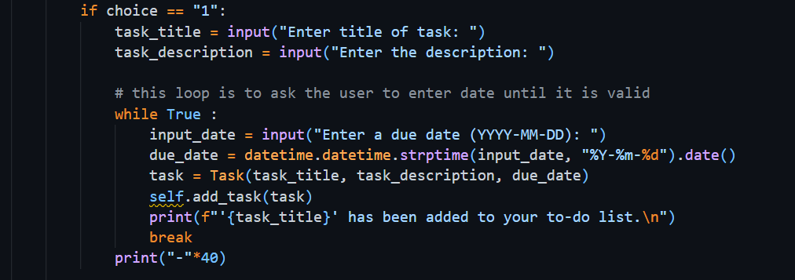

### Explanation

In the original list_options() method inside the TaskList class, all method calls used self, like this:

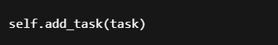

But after moving this logic to main.py, we’re no longer inside the TaskList class. So, we need to use the actual object created in main(), which is:



Now, to call methods on this object, I changed self to task_list, like:

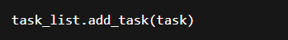

## Task: Add Helper function for test tasks

### Understanding the Task

In this task, I had to define a function called propagate_task_list that will automatically populate the task list with some sample tasks when the program begins. The primary reason why I did this was to simplify testing so that I wouldn’t have to add tasks manually each time I ran the program.

The function accepts a TaskList object and adds a few tasks to the task list, some with due dates set in the past, others in the future. Then it passes the updated list of tasks back to the main program.

### Source Code

#### Definition

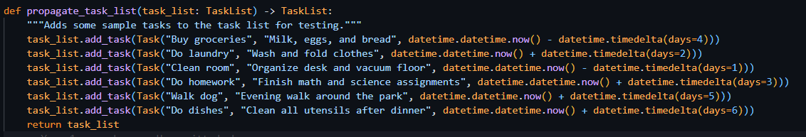

#### Usage

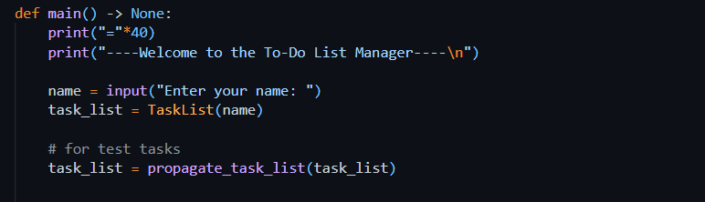

### Explanation

To complete this task, I followed these steps:

#### Defined the Function:

I placed a copy of the propagate_task_list() function in the top of my main. py file, at the beginning of the main() function. I then created six sample tasks with differing due dates inside that function..

#### Called It in main():

Inside my main() function, after creating the task list object.

This made sure that every time I run the program, the task list already includes some tasks.

#### Benefits: Testing Becomes Easier:

Now when I start up the app, I can instantly test features like the ability to view tasks, mark tasks as complete, delete tasks, and check for overdue tasks without repeatedly manually entering my list of tasks.

This didn’t affect the app as the user sees it, but it made my development and testing significantly faster and more pleasant.

### Output

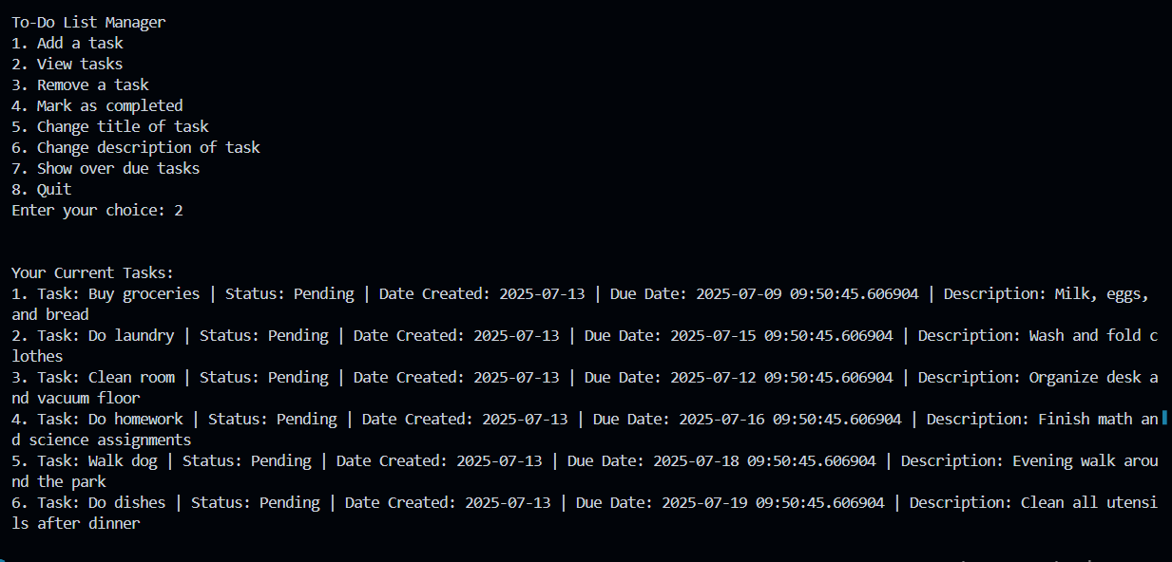

# Section 4. Type Checking and Documenting your Code

## Exercise 1: Type Checking

### Understanding the Task

In this exercise, I learned how to use **type hints** in Python to make my code cleaner, safer, and easier to understand. Although Python doesn't force you to declare variable types (like Java or C++), it's considered good practice to include them using the syntax variable_name: type.

Type hints help:

* Prevent bugs by catching type-related mistakes early.
* Improve code readability.
* Allow editors like VS Code to show helpful suggestions or warnings.

#### Type Hints for Method Parameters

This part showed me how to define what type of input (parameter) a method or function expects. For example:

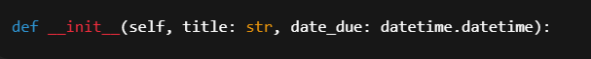

This means title should be a str and date_due should be a datetime object.  
It helps others (and me) understand what kind of values should be passed into the method.

Another example:

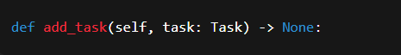

This method is expecting an object of type Task.

#### Type Hints for Return Values

“I also learned how to show what type of value a function returns by using the -> arrow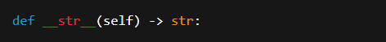

This means the __str__() method will return a string.  
It’s useful because when I call this method later, I’ll know exactly what kind of output to expect.

## Exercise 2: Docstrings and Comments

### Understanding the Task

In this task, I learned the importance of **documenting code** so that it becomes easier to understand, both for myself in the future and for others who may read it. I explored two main ways of doing this:

1. **Comments** – Used to explain parts of the code in plain language.
2. **Docstrings** – Used to describe what a class, method, or function does. These are written inside triple quotes right after the function or class definition.

The goal was to practice writing both, so the code becomes more readable and professional.

### Explanation

#### Comments:

I used # to add short notes inside my code to explain what each line or block is doing. For example:

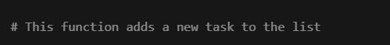

#### Docstrings:

These are placed inside triple quotes """ """ and written right below the function or class header. They explain what the method/class is for, what arguments it takes, and what it returns (if anything). For example:

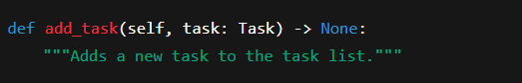

By adding docstrings and comments, my code became easier to read and work with. It also helped me stay organized and made it easier to review or debug things later.

## Portfolio Exercise 1: Adding Description Attribute to Task

### Understanding the Task

In this task, I was asked to improve the Task class by adding an optional **description** feature. This allows each task to have some extra details written about it, but it's not required.

I had to:

* Update the __init__ method so that the description can be passed when creating a task.
* Add a change_description() method to update the description later.
* Modify the __str__() method so that the description is included when printing the task.
* Lastly, I needed to update the main() function so that the user can change the task description through the menu (in the option where title and due date are already being updated).

### Explanation

* I started by updating the constructor like this:

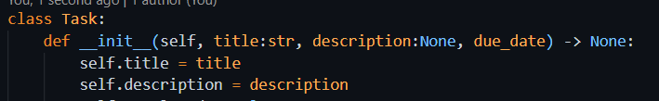

This made the description optional by setting its default value to None.

* Then I added a method:

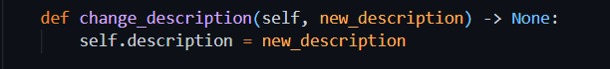

This allowed the user to change the description any time they want.

* In the __str__() method, I added the description to the return string so that whenever a task is displayed, its description shows up too.
* Finally, in main.py, I added an input option for the user to update the task’s description in the menu that also handles updating title and due date.

## Portfolio Exercise 2: View overdue tasks

### Understanding the Task

In this task, I had to add a feature that lets the user see all the **overdue tasks**, meaning tasks whose due date has already passed. For this, I needed to:

* Create a method called view_overdue_tasks() inside the TaskList class.
* Update the main() function and add a new menu option that calls this method.

This helps users easily track which tasks they’ve missed or need urgent attention.

### Explanation

In the TaskList class, I wrote a new method called view_overdue_tasks() which:

* Loops through all tasks.
* Checks if the due_date is **less than today’s date** using datetime.date.today().
* Prints those tasks as overdue.

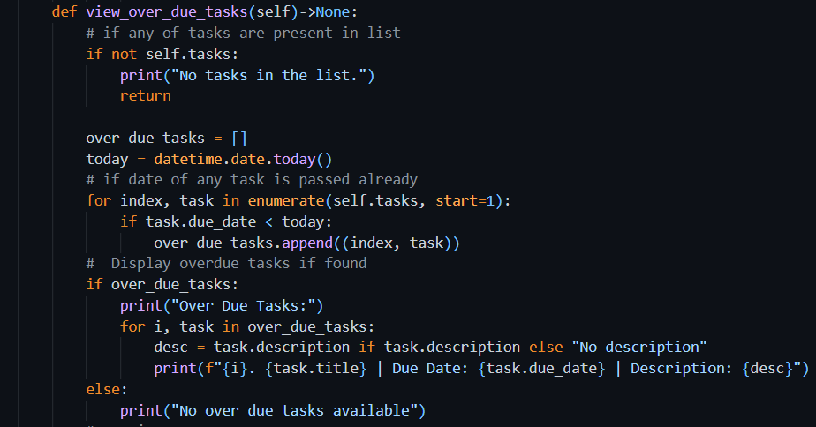

Then, in main.py, I added a new choice in the menu, that calls this method when selected.

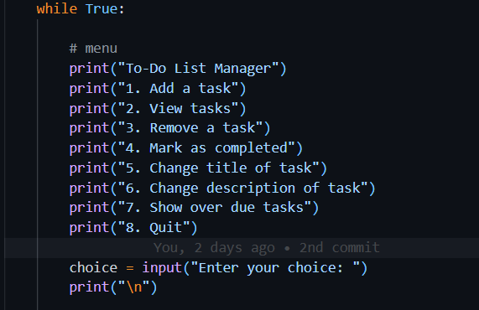

### Output

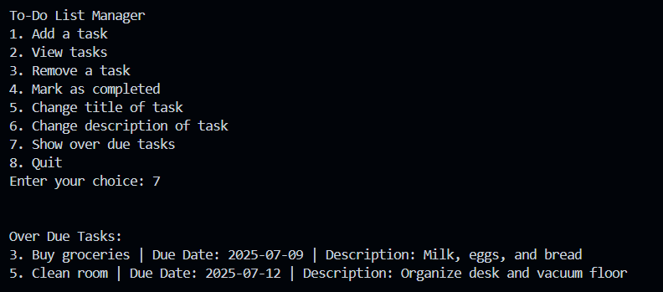

Week 5

# Section 1. Inheritance

## Exercise 1: Simple Inheritance

### Understanding the Task

I learned about inheritance in OOP from this exercise. The main aim was to learn how a child class can reuse and extend the members of a parent class. For instance, since a Car is-a Vehicle, we can derive a Car class from a Vehicle base class.

### The general idea is not to write the same code repeatedly. We are telling the computer that colour, weight and max_speed are common attributes (features) which only needs to be defined once in the parent class(Vehicle) and not for every child class i.e Plane or Car gets to use those features as it is. And each child can also have its own separate attributes (such as wingspan for a plane).

### Explanation

* I started by creating a base class **Vehicle** with common properties.
* Then I made a child class (like Plane or Car) using inheritance like this:

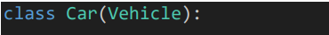

This means Car will automatically inherit everything from Vehicle.

* I also practiced **method overriding**, where I redefined the move() method inside the child class to generate a different output. For example:

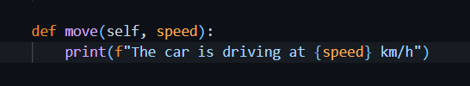

Even though the Vehicle parent class also had a move(), this allowed me to do custom handling per vehicle.

This exercise helped me understand how inheritance helps reduce code repetition. It makes programs easier to organize and supports flexible custom behavior in child classes.

#### Object Creation

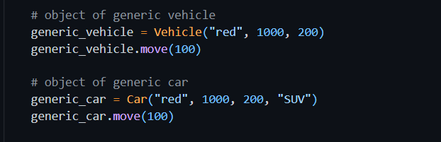

##### Output

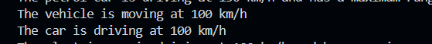

#### Adding more attributes to child class

All the factors of parent class are there in child class, but sometimes we require to add new attributes to child classes. For instance, in this case with Car as an example, one needs to add the form_factor.

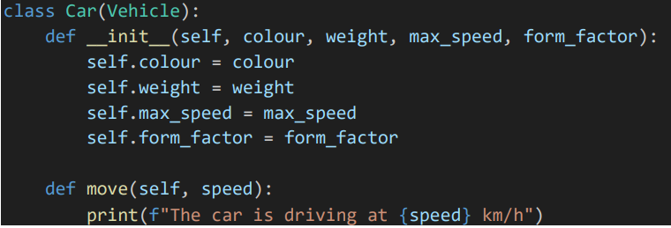

Creating the object with form factor:

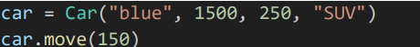

## Exercise 2: Super () function

super() is a special function used inside a **child class** to call a method from its **parent class**.

It's mostly used in **constructors (__init__)** to make sure the parent class is properly initialized before the child class adds more functionality.

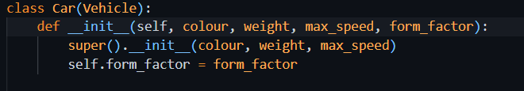

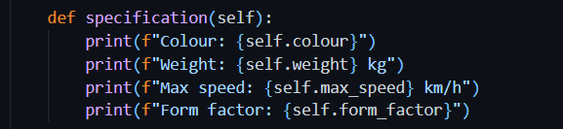

### Output

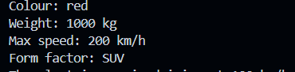

## Task: Create ElectricCar and the PetrolCar class.

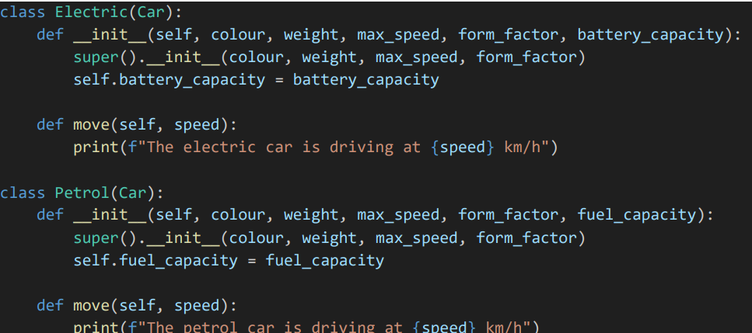

#### Test

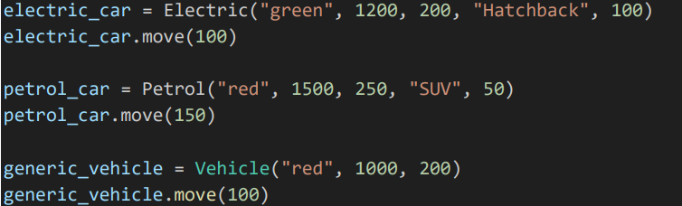

##### Output

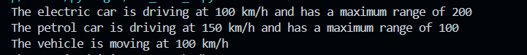

## Task: Adding max range parameter

Some vehicles have max range, but some don’t. That’s why max_range attribute is set to be None on default. If any vehicle has this value, it will be used.

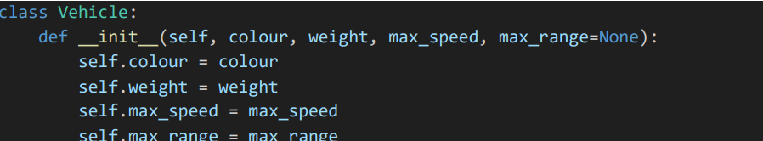

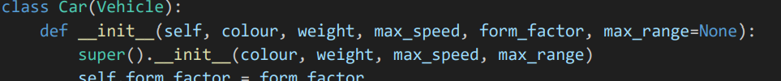

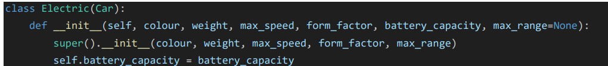

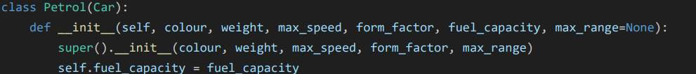

Using max range in electric car move method

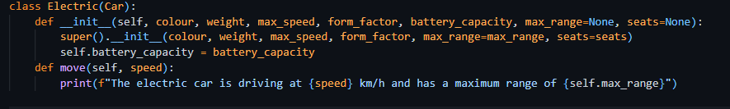

## Exercise 2: kwargs**

By using kwargs**, we can pass as many keyword arguments as possible. These are stored in dictionary data structure  
To use kwargs**, add this keyword as a parameter to any child class that is derived from Vehicle. Then pass this keyword to the parent class using super() function.

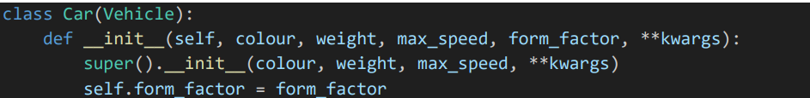

### Understanding the Task

In this task, I learned how to use **kwargs in a function or constructor.  
The purpose of **kwargs is to allow a function or method to accept **any number of keyword arguments** (like seats=4, max_range=200) even if they aren’t explicitly listed in the parameter list.

This is helpful when working with **inheritance** because sometimes a child’s class needs to pass extra arguments to the parent class without knowing exactly what those arguments are.

### Explanation

* **kwargs stands for **"keyword arguments"**
* It collects any extra named arguments as a dictionary

### Source Code

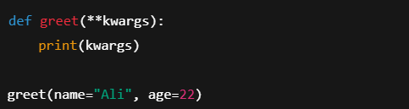

### Output

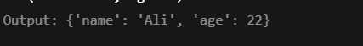

## Task: Adding seats attribute

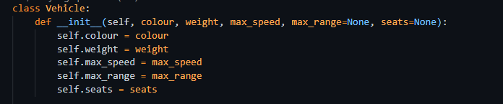

### Test

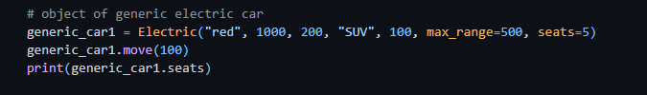

### Output



## Task: Creating Multilevel Inheritance

### Understanding the Task

In this task, I was asked to extend the Vehicle class by adding a new child class called Plane, and two more specific child classes from that, Propeller and Jet. This type of inheritance is called **multilevel inheritance.**

Each of these subclasses should:

* Inherit common vehicle features like colour, weight, and max_speed
* Add their own unique attribute:
  + Plane → wingspan
  + Propeller → propeller_diameter
  + Jet → engine_thrust

Also, each class should have its own version of the move() method, and since they are all flying machines, their output should say **"flying"** instead of "**driving**" or "**moving**".

### Explanation

* The Plane class was created extending the Vehicle class.
* An additional attribute wingspan was added in Plane, and the move() method was overridden to say the respective text:

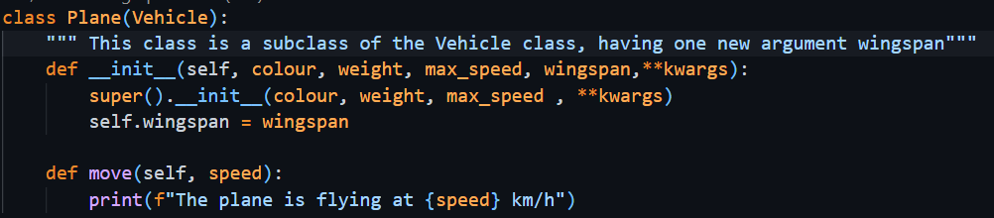

* Then, I created two more child classes:
  + Propeller(Plane) → adds propeller_diameter
  + Jet(Plane) → adds engine_thrust

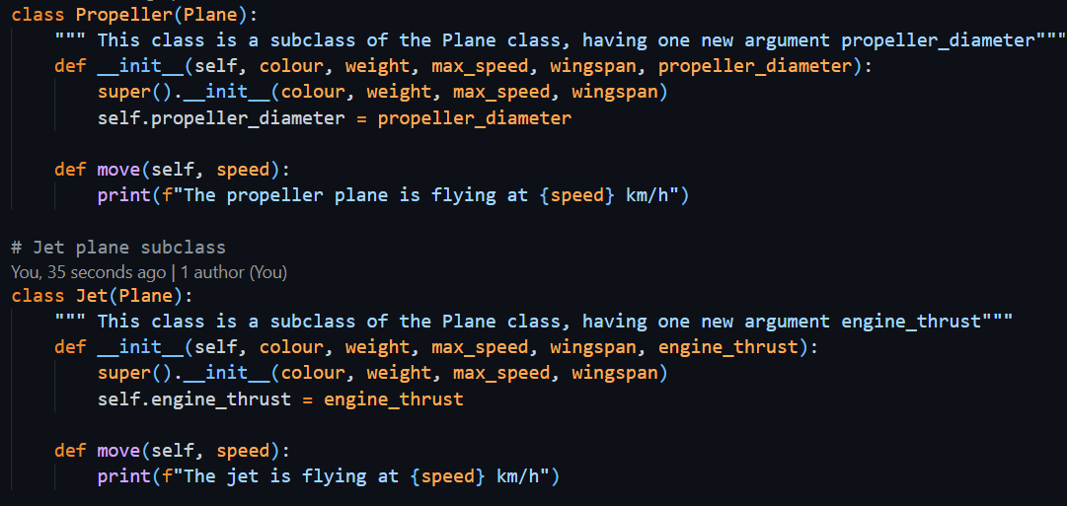

* Each subclass also has its own custom move() method for its type.
* I created an object of each class and printed its attributes to see if everything is working as expected.

# Section 3. Multiple Inheritance

### Understanding the Task

In this task, I had to create a class called FlyingCar that inherits from **both** the Car class and the Plane class. This is a good example of **multiple inheritance**, where a child’s class gets features from more than one parent’s class.

Since a flying car has the properties of both a car (like wheels and form factors) and a plane (like wingspan), it makes sense to inherit from both.

### Explanation

* I created the FlyingCar class.

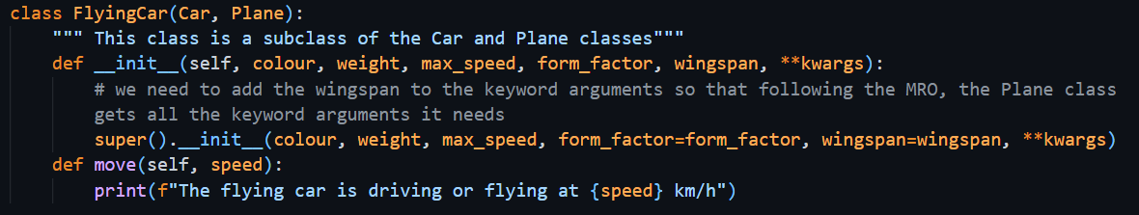

* Inside the constructor (__**init**__): calls to parent class constructors using super() and among them passes arguments like form_factor and wingspan. As Car and Plane both are derived from Vehicle, I preferred all the extra arguments being passed using **kwargs.
* I also overrode the move()
* I have created an object of **FlyingCar** to see if the properties such as form_factor, wingspan, and seats are properly set for both car and plane.

This task helped me understand how multiple inheritance works in Python, and how to combine behaviors from different classes into one.

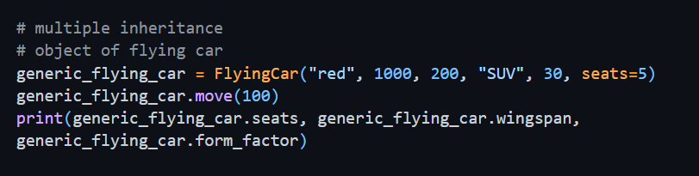

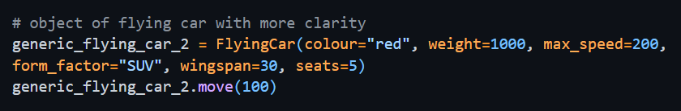

### Output

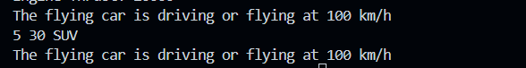

# Section 4. Polymorphism

Polymorphism allows different classes to have a **common method name** (like move()), but each class can perform **its own version** of that method.

### Understanding the Task

In this case, we don't want to care what sort of object we're working with; if it has the method, we can just call it, and Python will run the correct version. This becomes very powerful when we loop over objects of different types and do something to each of them.

### Explanation

The most common example of polymorphism is when a **parent class has a method**, and each **child class overrides** it with its own behavior. It means every child class also has the method with same name and same arguments but with different implementation

Let’s say we have:

* A Vehicle class → has a move() method
* Car, Plane, and FlyingCar subclasses → each with their own version of move()

Even though the method name move() is the same, the **output will depend on which object** is calling it. This is known as **method overriding**, and it’s a core part of polymorphism.

### Source Code

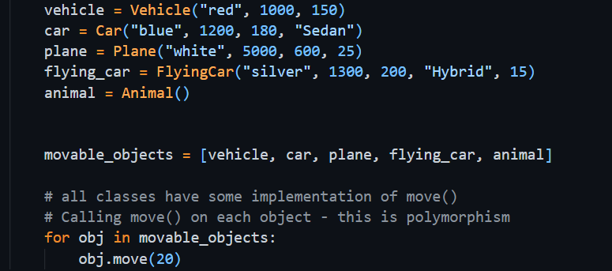

### Explanation

### The task was to create these different classes with their corresponding arguments in a sequential manner. All objects were then stored in a list, and subsequently, each object's move() method was called, displaying the concept of polymorphism.

### Output

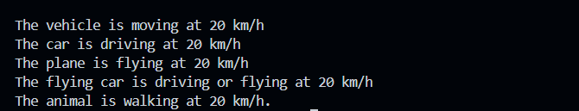

# Section 6. ToDo

## Task: Add Recurring Task functionality

### Understanding the Task

The task was to improve the ToDo Application to allow using it with Recurring tasks, those that are repeated over time (for example, doing laundry every week or cleaning every 2 weeks). Instead of adding these tasks every time manually, the app should be smart enough to add them by itself. To accomplish this, I was to do the following:

* Create a new class called RecurringTask that **inherits from** Task.
* Add new features:
  + interval: a timedelta object that stores how often the task repeats.
  + completed_dates: a list to store **all dates** on which the task was marked as done.
  + _compute_next_due_date(): a method to **automatically calculate the next due date** based on the interval.
* Override the __str__() method to include the **interval** and **completed history**, so we can tell which tasks are recurring when we list them.
* Modify the logic in **option "1"** of the main() function to:
  + Ask the user if they want to add a recurring task or not.
  + If yes → ask for the interval in days, convert it using timedelta, and create a RecurringTask object.
  + If no → create a normal Task as before.

### Explanation

* I created the RecurringTask
* In the constructor, I added:
  + self.interval = interval
  + self.completed_dates = [] → to store completion history
* I added a private method _compute_next_due_date() which calculates the next deadline based on the last completion date or the current due date:
* I overrode the __str__() method to show:
  + Title, due date, status (completed/pending)
  + Interval (like "every 7 days")
  + Completed history

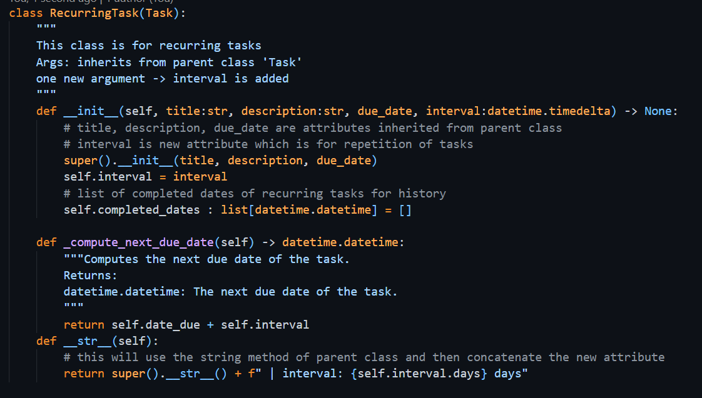

* Then in main.py, I updated the **task-adding flow**:
  + The user is asked: “Add a one time task or a recurring task?”
  + If recurring task, they enter an interval like "7"
  + I converted it using:

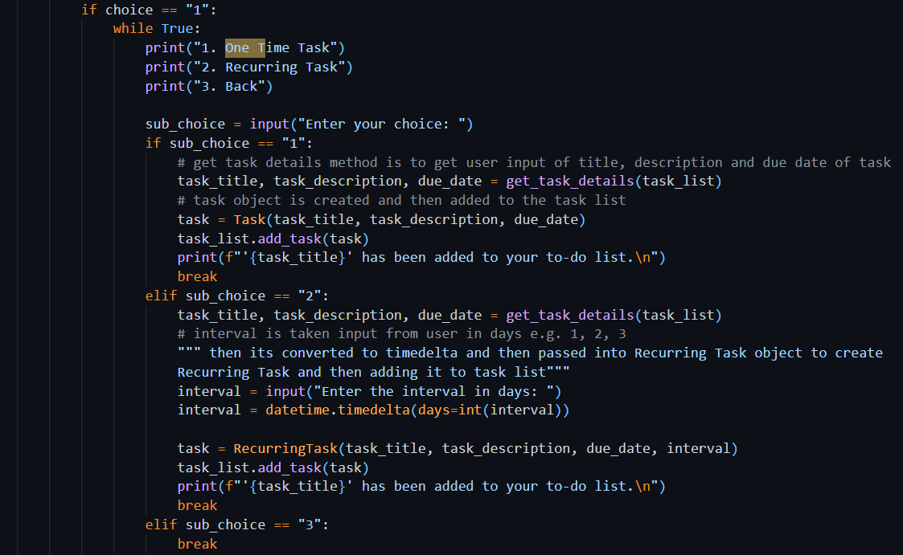

### Explanation

In this code, if user enters option 1 to add a task, it then asks him to enter the choice whether he wants to add a one-time task or a recurring one. In both cases, Program will ask the user to enter task details by get_task_details() method. If the option was to add a recurring task, then program will ask the user to enter number of days for interval. The program will then convert the string number of days into timedelta object using the datetime library. It will then create an object of Recurring Task by passing task details in it.   
Whether the Task created is a one-time task or a recurring task, it will be added into Task List.

### Output

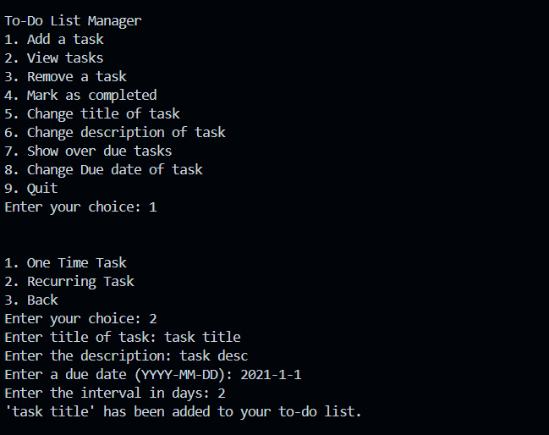

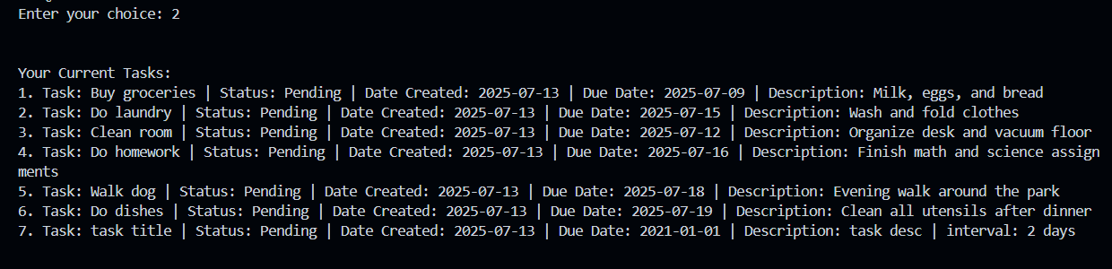

## Task: Add Recurring Task in Propagate Task List

### Understanding the Task

It is asked to add a recurring task in tasks list with all its required attributes, by using the method propagate_task_list

### Source Code

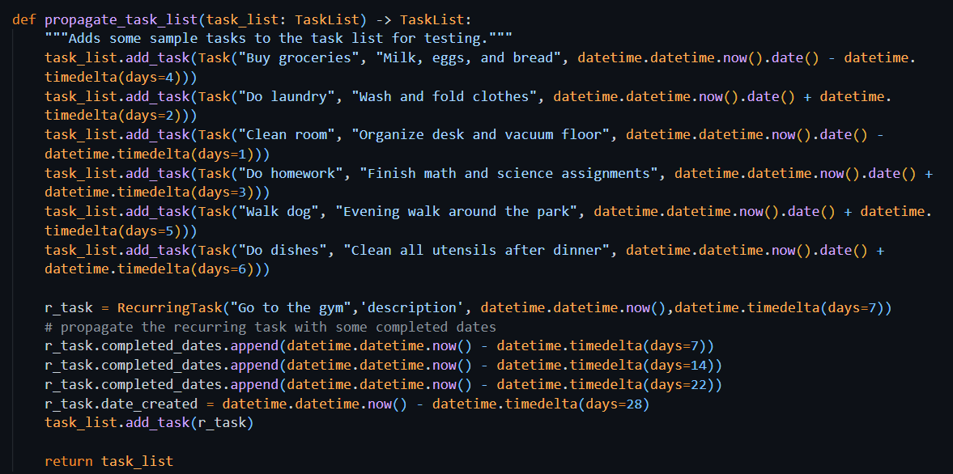

### Explanation

This code is getting a task list object. It then adds 6 objects of tasks into the task list. It also creates an object of Recurring task, then adding it to the task list with completed dates attribute. At the end it is returning a list back. The list returned is the one which we got empty in the start.

### Output

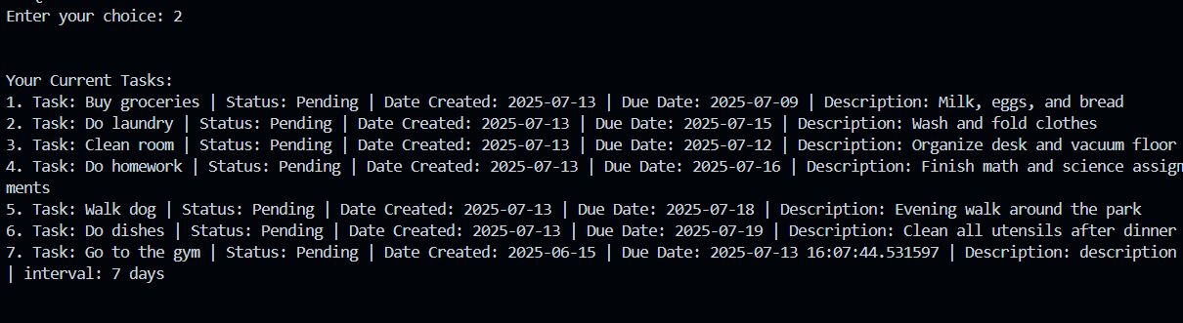

### Explanation

The first 6 tasks are normal one-time tasks and the ls tine is recurring task because of the interval attribute.

## Task: Mark Recurring Task Completed

### Understanding the Task

In the previous ToDoApp version, when we marked a task completed (choice 5), it would only change the status of that task to completed=True. This, however, does not enough for recurring tasks. This improvement required me to update the behavior of recurring tasks. Instead of simply marking it complete, the app should:

This task asked me to improve the behavior of recurring tasks. Instead of just marking them as completed, the app should:

* Keep a **record** of the date when it was completed
* Automatically change the due date for the next cycle (for example, next week)

This required me to override the mark_completed() method in the RecurringTask class by using **polymorphism**.

### Source Code

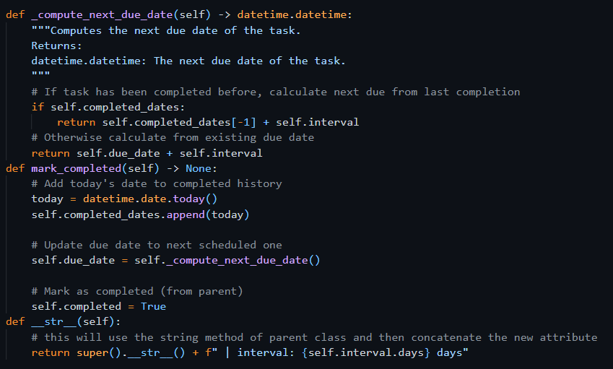

### Explanation

* I created a new version of mark_completed() inside the RecurringTask class.
* Inside that method:
  + I first added today’s date to the completed_dates list:
  + Then, I updated the due_date using the private method compute_next_due_date():
  + This calculates the next due date based on the task’s repeat interval.
  + Finally, I marked the task as completed using:

Here, polymorphism is shown, where both Task and RecurringTask have a method with the same name (mark_completed), but the behavior is different based on the object type.

### Output

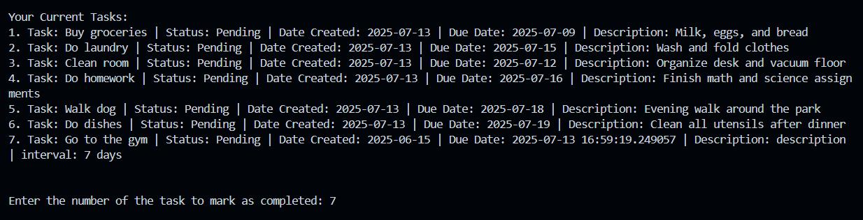

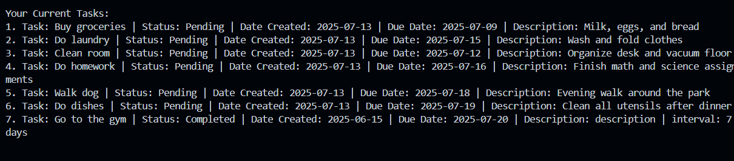

## Exercise 4 – Encapsulation

### Understanding the Task

This task is all about improving how tasks are accessed from the TaskList class. At present, the code accesses the task list through the method task_list.tasks[index]. This is counterproductive since it exposes the internal structure.

The objective was to apply encapsulation: to hide most internal details and expose whatever was necessary. I had to do things like:

* Create a method called get_task(index) inside the TaskList class.
* Replace direct access to task_list.tasks[...] in the main() function with this method.
* Make sure everything still works the same from a user’s point of view.

### Source Code

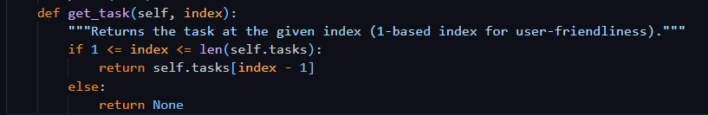

### Example Usage

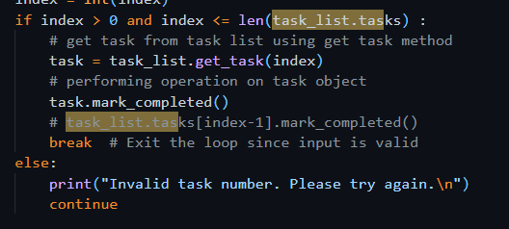

### Explanation

Encapsulation is about protecting the data and only allowing controlled access. So instead of exposing the task list to external components, I created a method called get_task() in TaskList. This will verify whether the index is valid before returning the task.   
By using this method

* The internal list (self.tasks) stays hidden and protected
* Any future changes in how tasks are stored won’t affect the rest of the app
* It keeps the code clean, safe, and easier to maintain

## Portfolio Exercise 3: Add User and Owner Functionalities

### Source Code

#### user.py

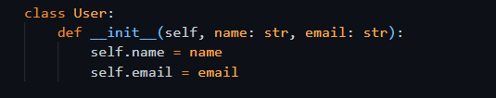

#### owner.py

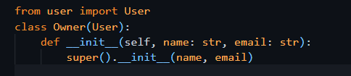

#### Accept owner object in TaskList class

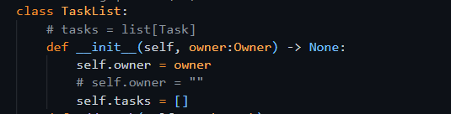

#### Usage in main function

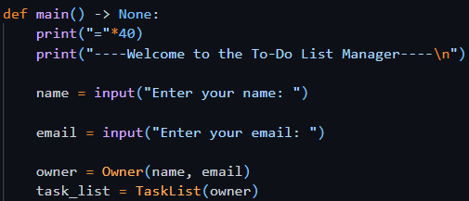

### Understanding the Task (UIT)

This task was about applying **inheritance** and **composition** together in the ToDoApp. I had to implement a new user system, which involves:

* Creating a User class with basic info like name and email
* Creating an Owner class that inherits from User
* Modifying the TaskList class to include an owner attribute, which should be of type Owner

This helps structure the app more professionally and adds a clear connection between a task list and its owner.

### Explanation

* I created a **base class User** that stores a person's name and email.
* Then I made another class, Owner class that **inherits from User**, meaning it automatically gets the name and email attributes.
* In the TaskList class, I added an attribute owner, which accepts an Owner object.
* This shows a **composition** relationship: a TaskList "has-an" Owner, while Owner "is-a" User.

This structure follows good OOP design and keeps responsibilities clear. If we want to expand later (e.g., add Admin or Guest users), this structure will make it much easier.

### Output

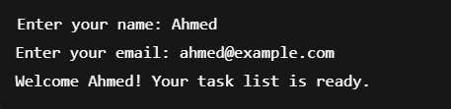

## Portfolio Exercise 4

### Understanding the Task (UIT)

This task was focused on structuring the code better by using **modularization** and **OOP concepts**:

* I had to create two new files users.py and owner.py that contains two classes: User and Owner respectively
* Each class has a __str__() method to print user details nicely
* Then, I updated the TaskList class to accept an Owner object when initializing
* Finally, in main.py, I asked the user for their name and email, created an Owner object, and used that to create a personalized TaskList

### Source Code

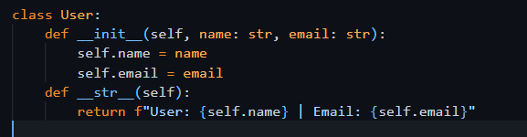

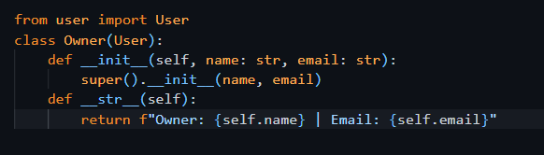

### Usage Example

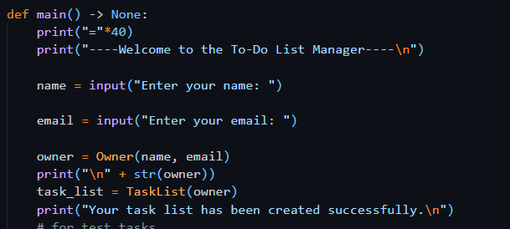

### Output

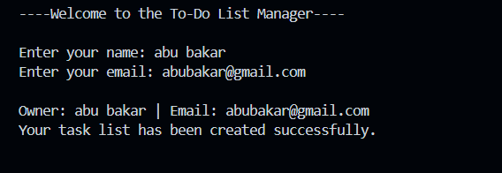

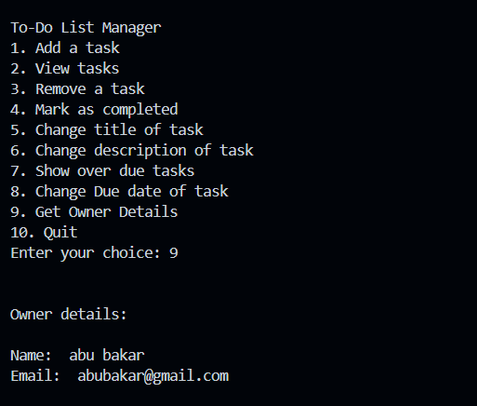

Week 6

# Section 1. Debugging

The debugging process is an important part of programming. It allows you to find and fix errors in your code. A debugger is a tool that allows you to step through your code and see what is happening at each step.

## Exercise 1: Finding the Problem

### Problem Statement:

I was given a Python program that simulates a car’s actions like accelerating, braking, and tracking distance (odometer) and average speed. When I ran the program and selected the following actions:

A (Accelerate), B (Brake), B (Brake), O (Show Odometer)

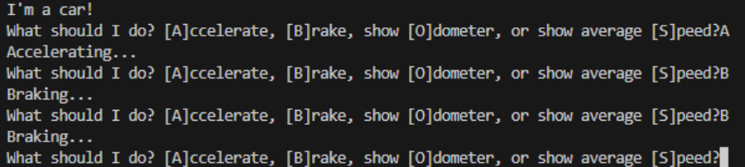

#### Output

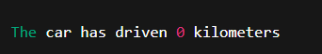

This was incorrect, because I expected the car to have traveled at least some distance after accelerating. However, the odometer stayed at 0.

### Understanding the Issue

### This was tested on the car simulation with the A →B →B →O sequence, which claimed the car had covered a distance of 0 kilometers. This did not seem right to me because I had accelerated the car, and I thought it should have gone forward. When I examined the code further, I understood the speed of the car would increase under acceleration, but the odometer would be updated only when the step() method was called. Thereafter, there appears no simulation time passing, hence the car doesn’t move. So, without letting the car really move before braking and within this time frame, the odometer read 0 records from the beginning. It was not this kind of issue that was a syntactical or crash one- it was a logical error in the usability of the simulation.

### Type of Error: Logical Error

This was not a syntax error. The code ran without crashing, and thus it was a logical error. The code executed in a way that simply did not fit with my logical expectations. Yes, the car's speed increased, but it did not go forward unless I called the step() method to simulate time passing with an update of the odometer.

Also, I noticed that after applying brake() repeatedly, the speed could go negative, which is ridiculous for a real car.

### What I Learned About Debugging

From this task, I have realized that debugging involves not only fixing broken code but also an assurance that the logic and behavior follow the user's expectation. The code in this case did run without throwing any errors, but the sequence of operations did not represent realistic car behavior.

Simulating this behavior taught me that state changes such as speed influence movement only if combined with a progression of time: namely, the step(). The debugging process encouraged me to think about how method calls are ordered and what interaction methods should exhibit with one another. I also learned how to carefully follow how each piece of code alters the status of the car, namely speed, distance, and time. These are a crucial set of checks to guarantee the expected output, whilst missing one of them may lead to erroneous behavior.

## Task: Fixing the Problem

The purpose of the brake() method is to slow the car down by reducing its speed.  
Originally, the code just subtracted 5 from the speed every time brake() was called. But this could make the speed go below 0, which doesn't make sense — a car can't go at negative speed. The new version of the method adds a check:

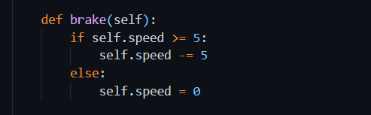

Here’s what it does:

* If the current speed is **5 or more**, it safely reduces the speed by 5.
* If the speed is **less than 5**, instead of going negative, it simply sets the speed to **0**.

This way, the speed will **never drop below zero**, and the simulation behaves more realistically, just like a real car that stops but doesn't go into reverse unless explicitly told to.

### Output

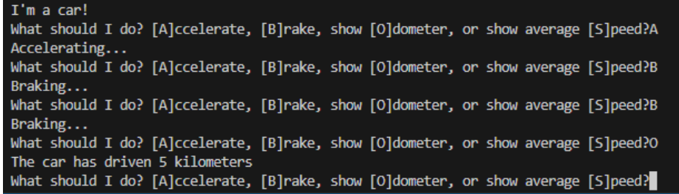

## Exercise 3: Stepping Through the Code

I learned in this exercise how to step line by line through the code using the debugger without having to set a breakpoint on every single line. Hence, I observed and realize how the program executed in real-time along with knowing more about how the flow of control moves through loops and functions.

So, the first thing I did was restart the debugger and while it was running, I typed in the console the command a so that the car would accelerate. Immediately, the debugger paused right on my first breakpoint, and from that point, I used the **Step Over** button to move me to the next line of code without stepping into the function. I kept clicking it until I reached the line my_car.accelerate(). At that point, I was interested in understanding how exactly the accelerate method worked internally. So, I clicked the Step Into button instead of stepping Over and was taken directly inside the method itself, where I was virtually able to see how the speed had increased. This will help me visualize what the function is doing under the hood.

According to what I have learned, when I make use of "**Step Over**", the program will then go to the next top level line without delving into function bodies. But if I really want to look at what a method does, "**Step Into**" must be used. For getting very deep into functions and then finding that I want to return back, I can also easily make use of "Step Out" command.

This experience taught me that **stepping through code is a powerful way to debug**. It allowed me to:

* Follow the logic step by step.
* Choose when to explore functions deeply.
* Better understand how loops and conditionals are executed.

Using this approach, I was able to pinpoint exactly where and how my code updated the car’s speed, odometer, and time. It gave me much more control and insight than just relying on print statements

## Exercise 4: Watching Variables or Expressions

In this exercise I tried out the watch feature in vs code’s debugger it’s used for keeping an eye on certain variables or expressions while your code runs which honestly feels way better than using print statements all over. So, I added my_car.speed in the watch panel and while i was stepping through the code it kept showing the speed live i didn’t have to look through the variables section or spam my code with print lines anymore.

I also tried putting stuff like my_car.speed > 0 just to see if that condition is true while it runs and yeah it showed me that too which was actually helpful.

The watch view just gave me a clean look at the stuff i actually needed to see no distractions or extra code everything was right there while debugging.

Once I was done i just clicked that red stop button on the top corner and it brought me back to the normal code view.

Overall, this task really showed me how useful the debugger is instead of printing stuff and guessing what’s going on i can just use watch and understand my code better and save time too.

# Section 2. Properties using the @property decorator

In Python, the @property decorator is used to turn a method into an **attribute-like property**. It makes a function exactly like a variable. This allows us to **call methods without parentheses** and treat them like variables, making code cleaner and more readable.

Instead of calling object.get_value(), you can just use object.value

### Understanding the Task

In this task, I was asked to use the @property decorator to filter and return **uncompleted tasks** from a to-do list.

The goal was:

* To define a method uncompleted_tasks() in the TaskList class.
* Use @property so that I can access task_list.uncompleted_tasks like a variable, even though it's a method behind the scenes.
* Update the view_tasks() method to use this property and only show tasks that are **not yet completed**.

### Source Code

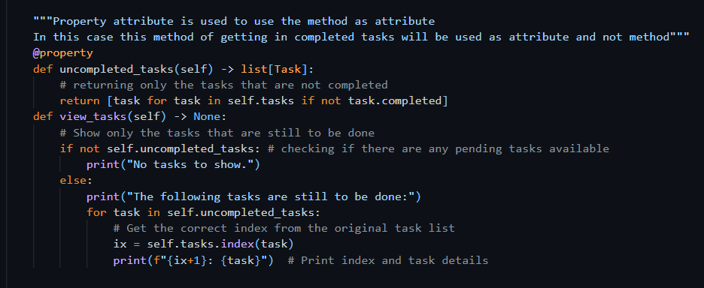

### Explanation

The uncompleted_tasks() method:

* Is now used like a variable (self.uncompleted_tasks) instead of self.uncompleted_tasks().
* This makes code inside view_tasks() cleaner and easier to read.

In the view_tasks() method, this property is used to:

* Check if there are any uncompleted tasks
* Loop through them and print only the tasks that are still pending

The index is retrieved from the original self.tasks list to keep numbering consistent.

### Why Is This Useful?

* It hides logic behind a simple interface
* Improves readability
* Maintains proper encapsulation
* Make code easier to maintain and extend later

### Output

Choosing 2 to view the tasks

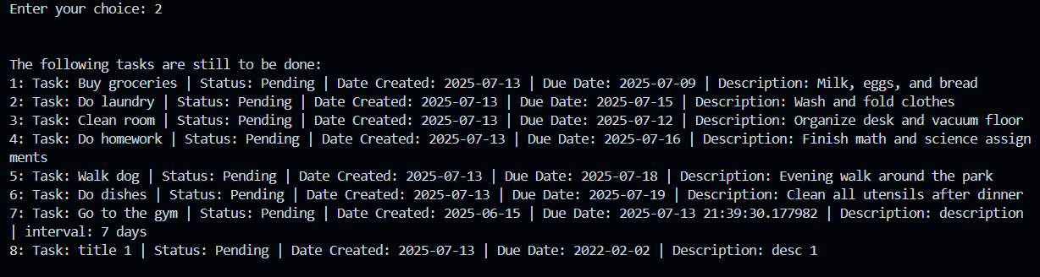

All pending tasks are shown only

# Section 3. Implementing Persistence

**Persistence** basically means saving your data so it doesn’t disappear when the program ends like the data stays there even if you close the app and run it later it’s still gonna be there

like for example:  
If you make a task list and then close the app normally it would just be gone but with persistence that list gets saved and when you open the app again boom it shows up again just like you left it

In python there’s a bunch of ways to do this depending on how your data looks and what your app needs here’s some of the common ways people do it

1. **Text Files (.txt)**  
   Plain text data is saved in these types of files. This method is simple and useful for basic lists or logs.
2. **CSV Files (.csv)**  
   Ideal for tabular data: Every row holds a record, and every column a field. It is usually employed in structured data like tasks, scores, or tables.
3. **JSON Files (.json)**  
   Here you may save data in key-value pairs/dictionaries or lists. This is great for such cases as saving complex objects, e.g., lists of tasks with many attributes, like title, due date, and whether the task is completed.
4. **Databases (e.g., SQLite, MySQL)**  
   For larger or more complex applications, using a database is a better approach. Databases include such nice and advanced features as searching, filtering, sorting, and relationships between different data types.

## Exercise 1: DAO

### Understanding the Task

The above task states to modularize the part of the code that is responsible for creating sample tasks by separating it into an individual class leveraging the DAO design pattern. In this way, data logic is kept separate from the rest of the application. Instead of putting the function propagate_task_list() in the main.py it is removed and a new class TaskTestDAO has been created. The purpose of the class is to mimic the loading of tasks from a file while no actual file-saving is being conducted. Then, I updated the main function to:

* Allow the user to decide when the tasks must be loaded/saved.
* Ask for a file path (just for simulation)
* Create an object of TaskTestDAO
* Use get_all_tasks() to load predefined tasks and add them to the current task list

### Source Code

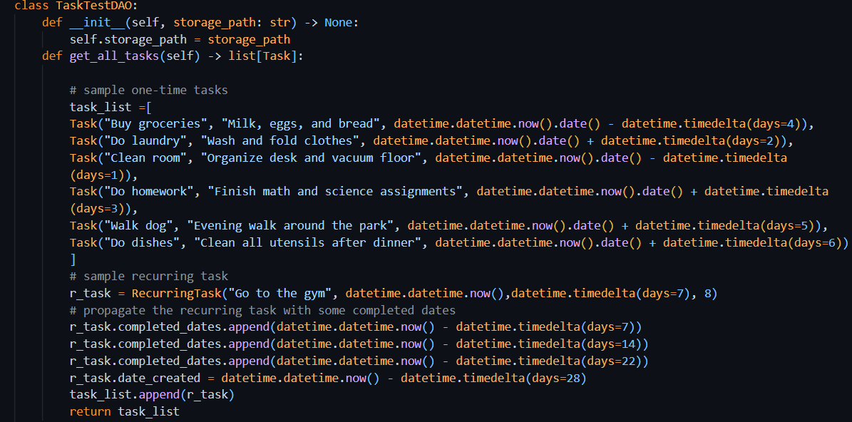

### Explanation

The DAO design pattern separates data access logic (like loading and saving) from the rest of the application. This helps in:

* Keeping the main.py file clean
* Making future updates easier (e.g., connecting to a real database or CSV file)
* Improving **code maintainability** and **testability**

In the TaskTestDAO class:

* The get_all_tasks() method simulates loading data by returning a list of sample Task and RecurringTask objects.
* The save_all_tasks() method is empty for now, just a placeholder for future saving functionality.

By moving task-loading logic here, I made the application more **organized** and **realistic**, like how professional apps are built.

### Output

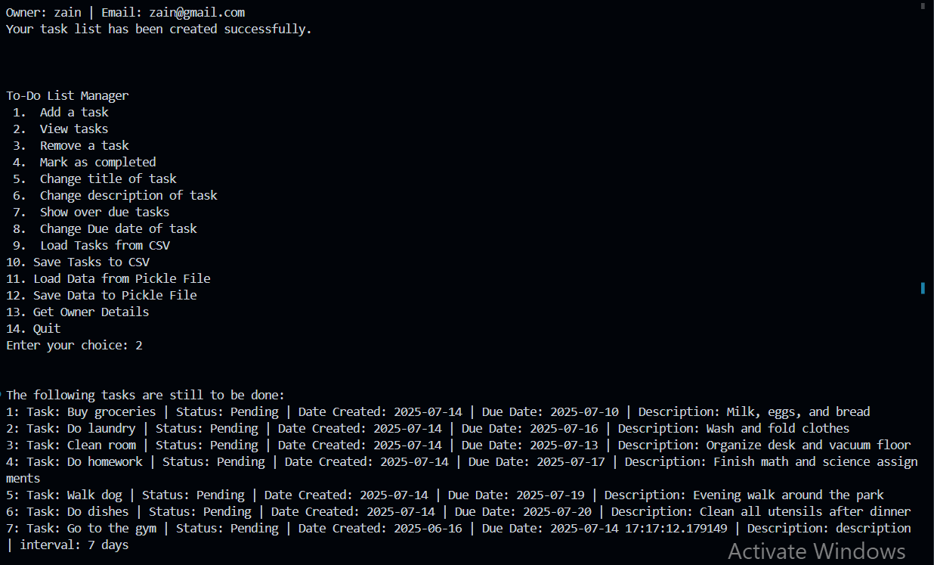

Thesen are the test tasks, as no new task is added.

## Exercise 2: CSV Persistence

### Serialization

In simpler words, object serialization means converting the object into bytes stream so that it can be stored or transferred to memory or a database or file. The serialization of any object can be done with the express purpose of reconstructing it at some future date.   
In this case, I intend to use serialization for the purpose of writing tasks to a CSV file.  
So I created a file called TaskCsvDAO.py. Its __init__ method constructs the appropriate path to the CSV file by concatenating the current Python file's folder with the specified filename so that the appropriate place can be accessed from or saved to. It also initializes the expected column headers (fieldnames) that make up the structure of the task data, namely title, type, due date and status of completeness. So this prepares the class for any future activity to read from or write to the CSV file.

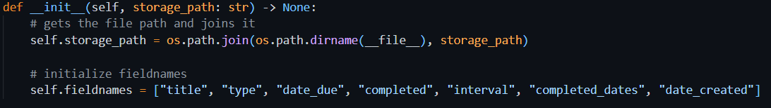

## Task A: Complete get_all_tasks() functionality

### Understanding the Task

So, for this task i had to load all the saved tasks from a csv file and turn them back into proper Task or RecurringTask objects this is kinda like real-life persistence where whatever tasks you saved before get loaded back into the app when you run it again.

instead of just hardcoding tasks like we did before with TaskTestDAO now i’m using TaskCsvDAO which does stuff like:

* Open the .csv file,
* Read each row
  + Get the type of the task
  + Get the title, due date, date created, interval (if present)
  + Convert the string format of the date into datetime object to be used further
* Check if the row is a normal task or a recurring one,
* Rebuild the appropriate object using the row's data (like title, due date, etc.),
* Do the same processing for all the rows present in file
* And finally, return a list of all such tasks.

### Source Code

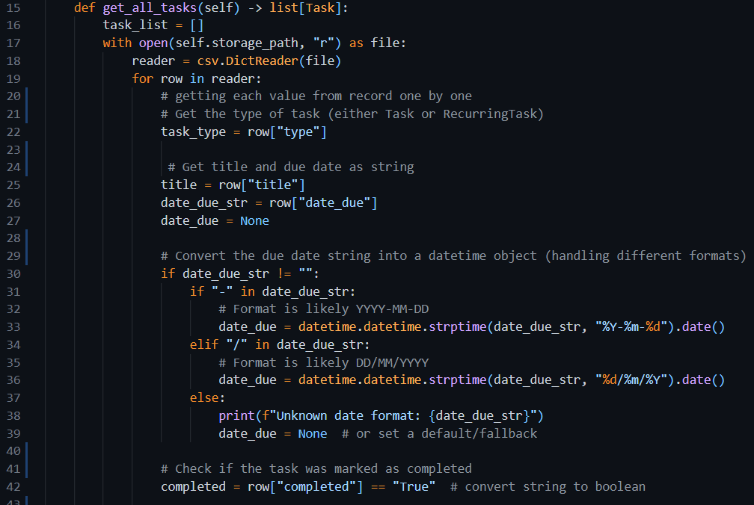

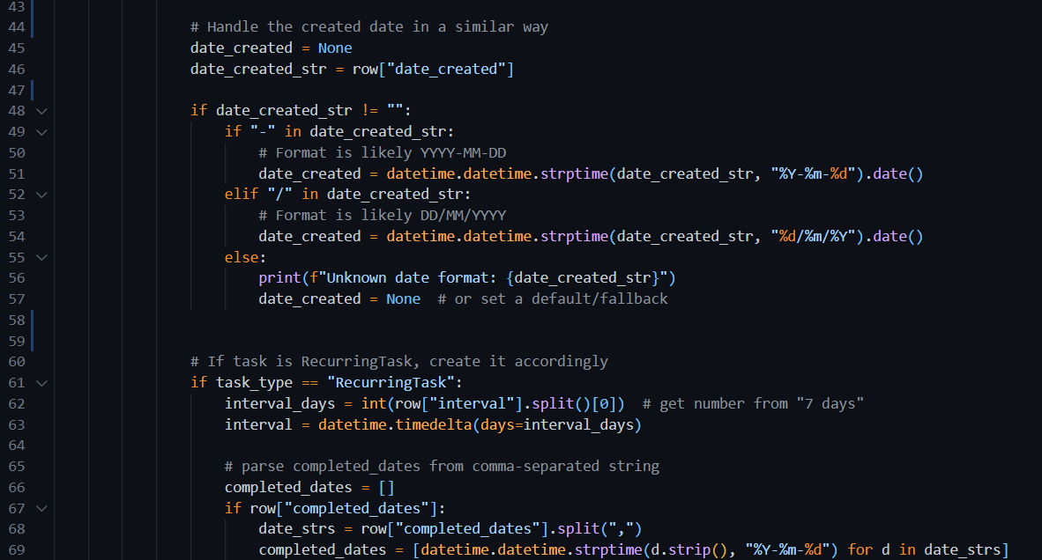

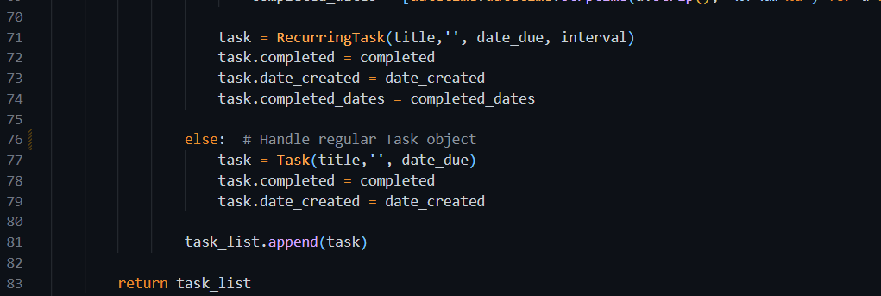

### Explanation

The get_all_tasks() method does the following:

* Opens the CSV file and reads it using csv.DictReader, so each row becomes a dictionary.
* Check the type column to decide if it's a regular Task or a RecurringTask.
* Parses important values like:
  + date_due and date_created using two possible formats (YYYY-MM-DD or DD/MM/YYYY).
  + Converts the completed value from string to Boolean.
  + Extracts and parses the interval (for recurring tasks).
  + Splits and parses multiple completed_dates into a list of datetime objects.
* Build the task object (Task or RecurringTask) and adds it to a list.

This way, all task data from the CSV file is restored exactly as it was, making the program **persistent and usable across sessions.**

### CSV file

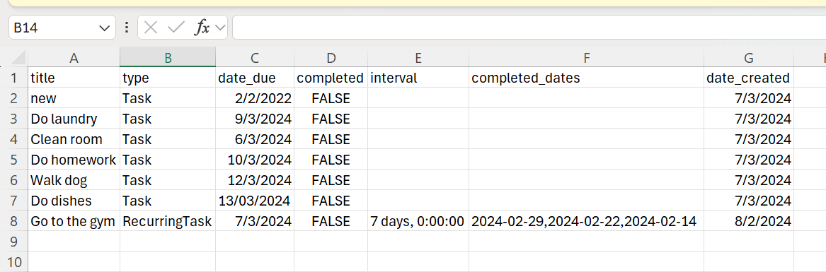

First, there are no tasks present in the program

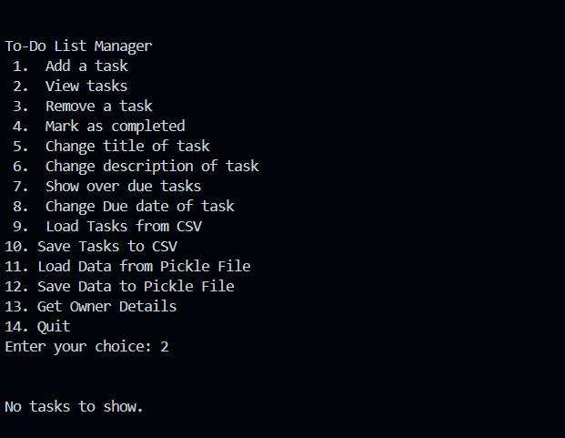

Choosing 9 to load data from csv file. Then entering the path of the file e.g. tasks.csv

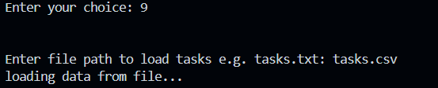

Choosing 2 to view tasks which are loaded from the file

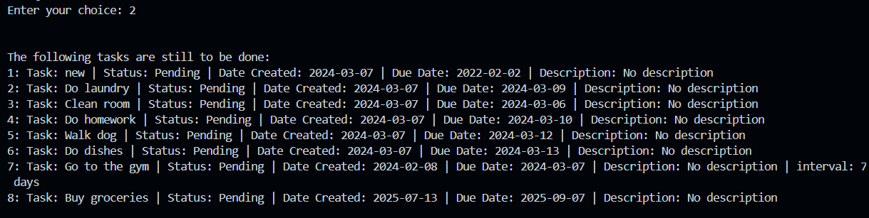

## Task B: Complete save_all_tasks() functionality

### Understanding the Task

so for this task we had to add the part where tasks get saved into a csv file the idea was to make sure user’s tasks don’t disappear and can be stored and opened again later even after closing the app this includes both normal tasks and recurring ones. The function needed to do few things:

* write all the task details into the csv in a proper clean format.
* check for duplicates by using something unique like the task title so we don’t save the same task again.
* tell the difference between a regular Task and a RecurringTask by using a type column.
* also handle different attributes properly like changing date objects into strings and turning lists like completed_dates into string format so they can be stored in the file.

### Source Code

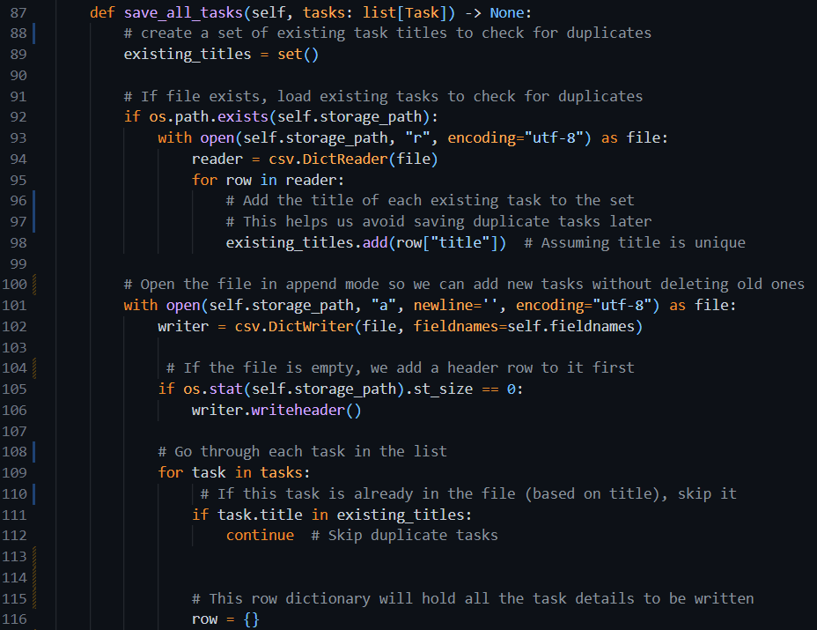

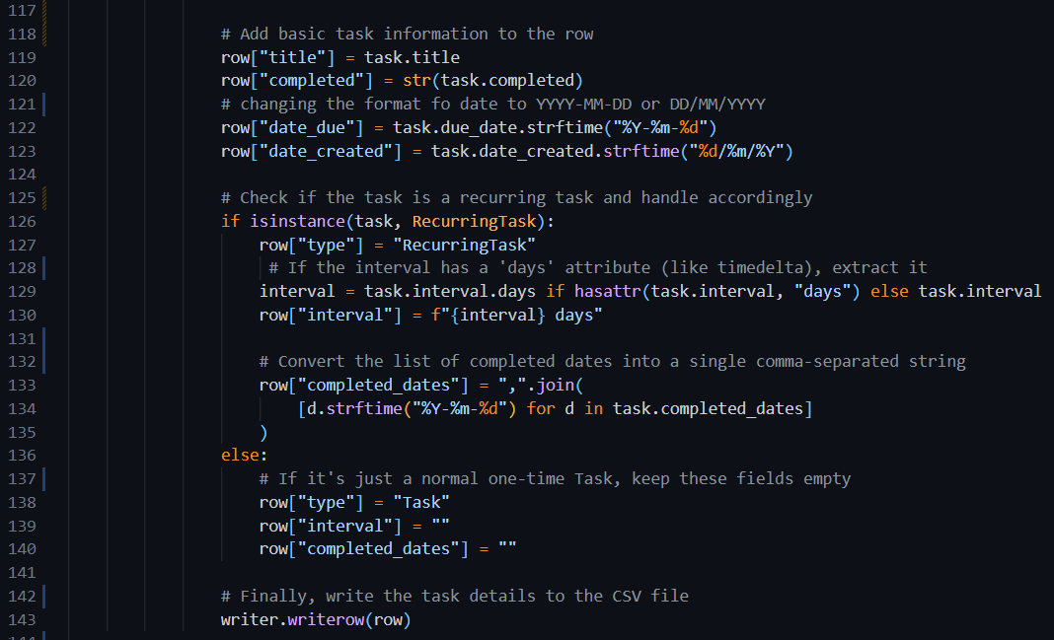

### Explanation

So, this save_all_tasks method is made to save all your tasks into a csv file without saving duplicates first it checks if the file already exists and grabs all the task titles that are already there that way it doesn’t save the same task again by mistake.

Then it opens the file in append mode and if the file’s still empty it adds the header row before anything else after that it goes through each task in the list and skips the ones that already exist based on the title.

for every new task it gets the info ready to be saved like converting due_date and date_created into strings using strftime if the task is a RecurringTask it also adds stuff like the interval and completed dates as a comma-separated list but if it’s just a normal task those extra fields stay empty.

Once all the info’s set up it writes the task as a new row in the csv file all clean and organized this way all your tasks are saved and you can reuse them later too even after closing the app.

### Output

#### CSV

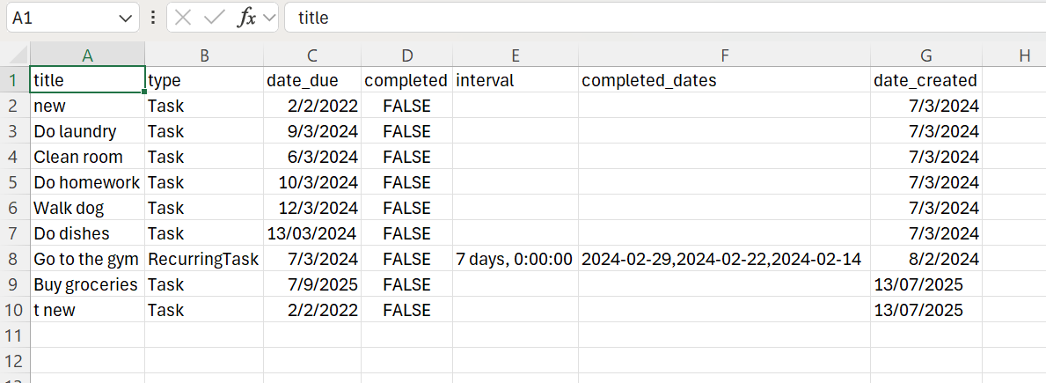

Choosing opt 1 to add a task, then choosing 1 to add a one time task.

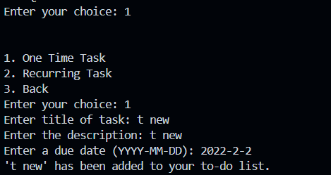

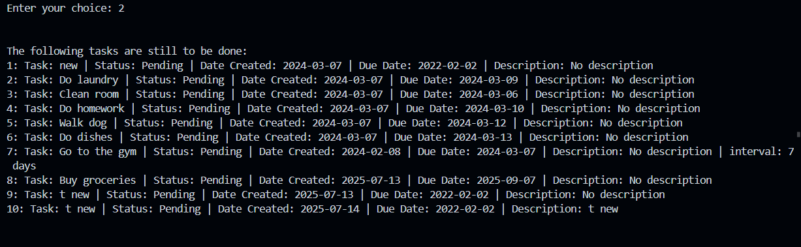

We can see the duplicate of task with title ‘t new’. This output is from the tasks saved in program, not the file.

Choose 10 to save data to file. After that the tasks in the csv are:

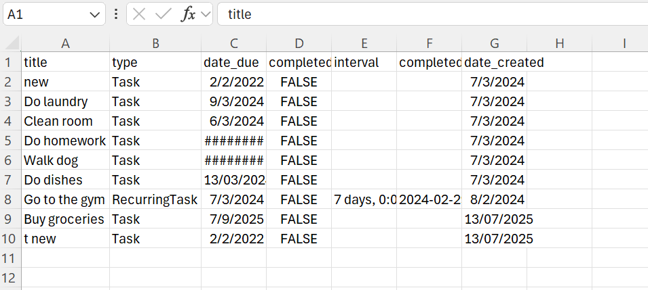

Which shows that duplicate is not saved.

#### Example 2

Choosing 1 and then 1 to add a one time task.

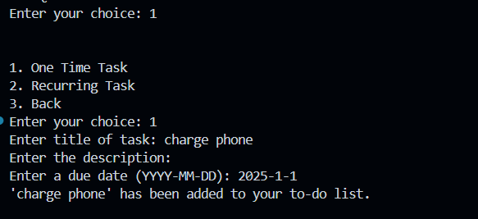

Choosing 10 to save data to file

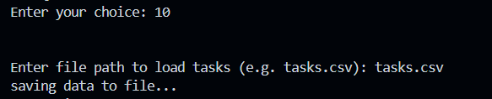

Output in csv

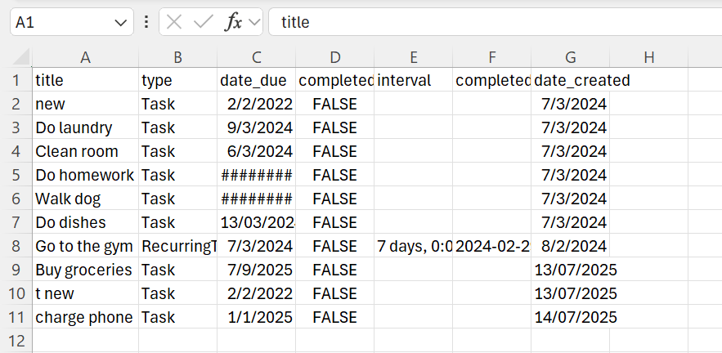

We can see that the task ‘charge phone’ is saved in the file

### Summary

This method ensures that:

* Tasks are written to a file in a clean, structured way.
* Duplicates are avoided.
* Both Task and RecurringTask objects are properly handled.
* Dates and lists are converted into formats suitable for CSV storage.

## Task C: Update single record in the file

### Understanding the Task

The goal of this task is to enable updating a single task record in the CSV file. When a user updates a task (like marking it completed, changing the title, or editing the due date), the change has to be saved persistently. The update is supposed to overwrite that record in the file properly without affecting the others. This is to ensure that the CSV file will always represent the latest state of all tasks.

### Source Code

### Explanation

* The method takes two arguments:
  + updated_task: the modified task object (with new values)
  + old_title: the title used to find the original task in the CSV
* First, it opens the CSV file and reads all rows.
* It checks each row’s title to find the task that matches old_title.
* When found:
  + It builds a new row with the updated task data (including type, dates, etc.).
  + Adds this new row to a temporary list.
* All other rows are added to the list unchanged.
* After iterating through loop, it writes the entire list back to the CSV file, replacing the original file with the updated content.
* A success message is printed if the update is completed; otherwise, it alerts the user that the task wasn’t found.

The method also properly handles different task types:

* Regular Task
* RecurringTask

#### Usage

##### Marking a Task as Completed (Choice 4)

* Displays all tasks
* Takes task number from user
* Marks the task as completed
* Calls update_task() to save the updated task status in the CSV

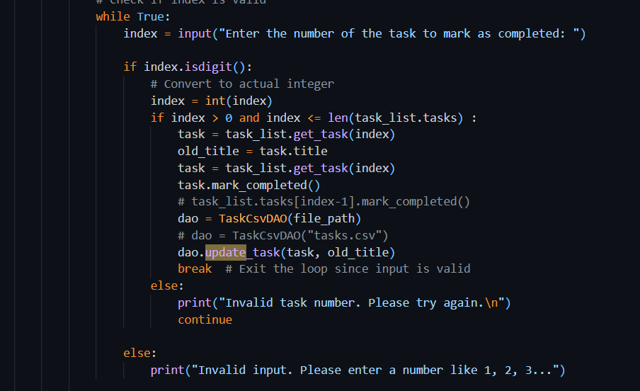

##### Changing Task Title (Choice 5)

* Displays all tasks
* Asks user to enter a task number and a new title
* Updates the task's title
* Calls update_task() to save the new title to the CSV

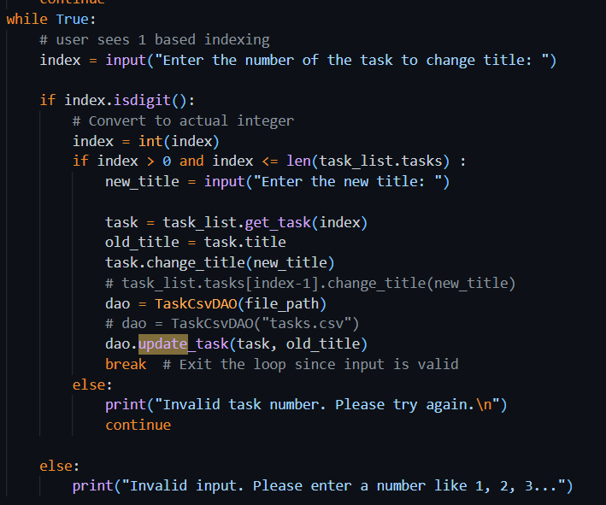

##### Changing Description

* Prompts for task number and new description
* Updates the description
* Calls update_task() with the changed task

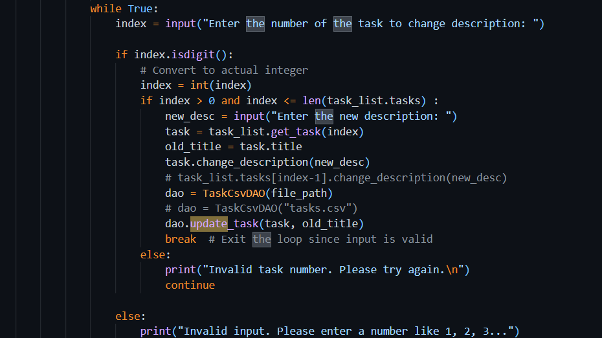

##### Changing Due Date

* Prompts for task number and new due date
* Updates the due date
* Calls update_task() to persist changes

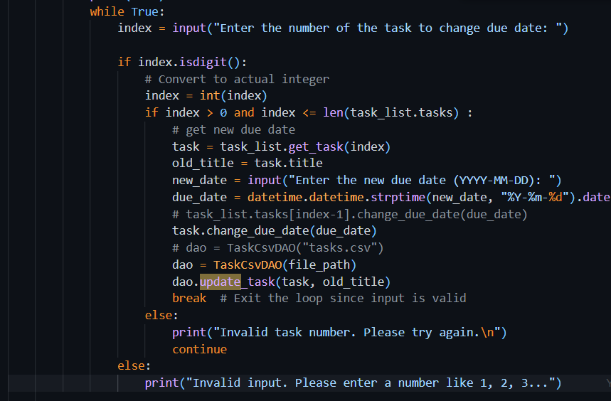

### Explanation

## Exercise 3: Serialization using Pickle

The Pickle Module is one of the binary libraries that comes along natively with Python to help the programmer with serialization and deserialization operations that convert Python objects into byte streams and back to object form. It usually aids whenever you want to save complex objects, such as a class of your own design or other lists of such objects, to a file for later use. Unlike CSV or JSON, which call for manual handling of every attribute, Pickle does this handling for the whole object and so preserves the rest of its structure, type, and value.

The format of pickle file looks like this:

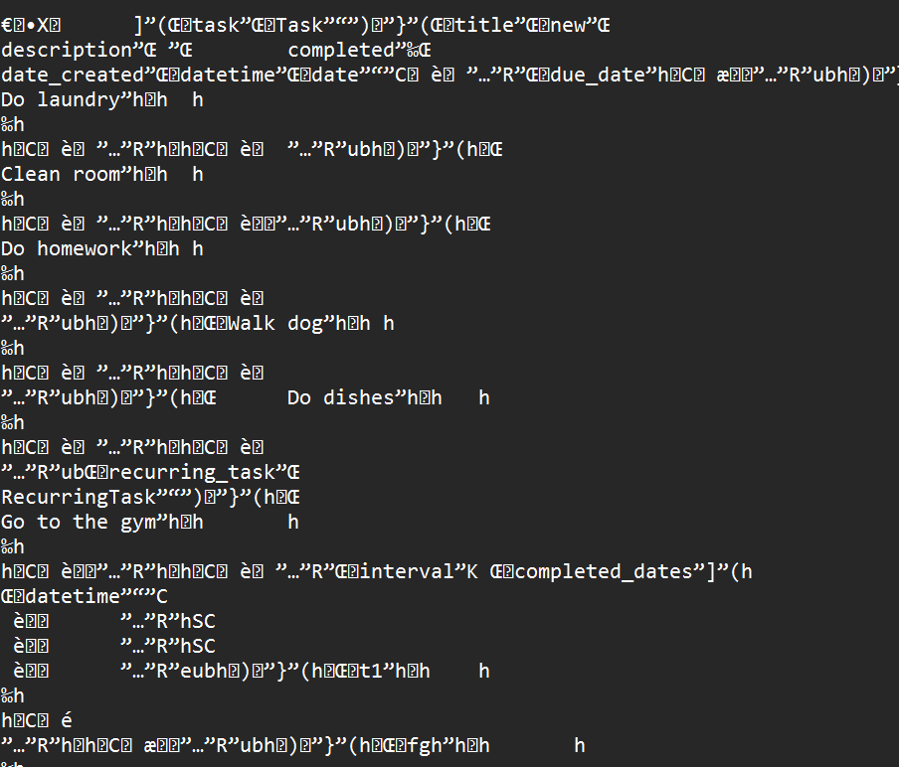

In a **pickle file**, data is saved in **binary format**, specifically, as a stream of bytes that represents Python objects.

### Understanding the Task

This assignment is to implement saving and loading tasks using a pickle instead of CSV. A file TaskPickleDAO.py is defined to put the logic of loading and saving data from pickle file. This makes it much easier to interface with more complex objects, such as tasks potentially having several nested attributes or classes, especially as the code evolves. Thus, this exercise lends itself toward enhancing the data persistence in a more flexible and Pythonic way.

### Source Code

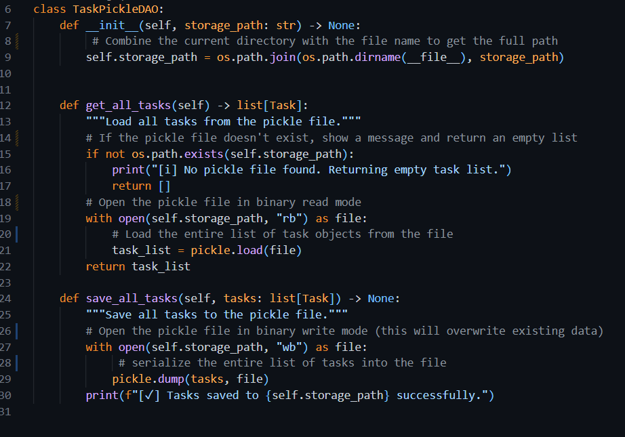

### Explanation

The TaskPickleDAO class is built to handle saving and loading of task data from the pickle file. In the constructor, it sets the path where the pickle file will be saved, this path is kept kind of local like relative to where your code file is just to keep things neat and organized  
so everything stays in one place and it’s easier to manage the files later. The get_all_tasks method checks whether the pickle file exists; if it doesn't, an empty list is returned, while if it does, it proceeds to load and return the saved tasks via pickle.load(). The save_all_tasks method accepts the list of tasks and writes it to the appropriate file using pickle.dump(). In this manner, all task information, including objects such as RecurringTask, are safely stored and can easily be restored without much hassle of reading or writing each attribute. This is going to be especially useful as the complexity of the task structure increases.

### Output

Choosing 11 to load data from pickle file

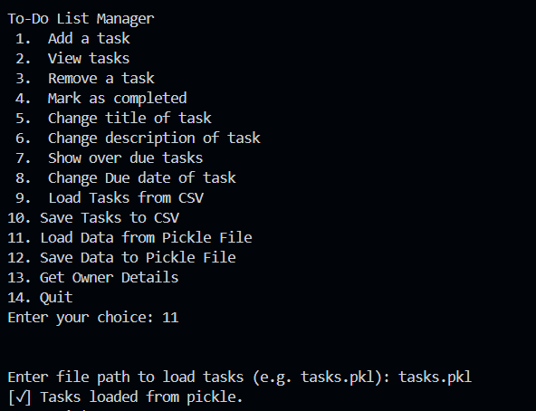

Choosing 2 to view tasks

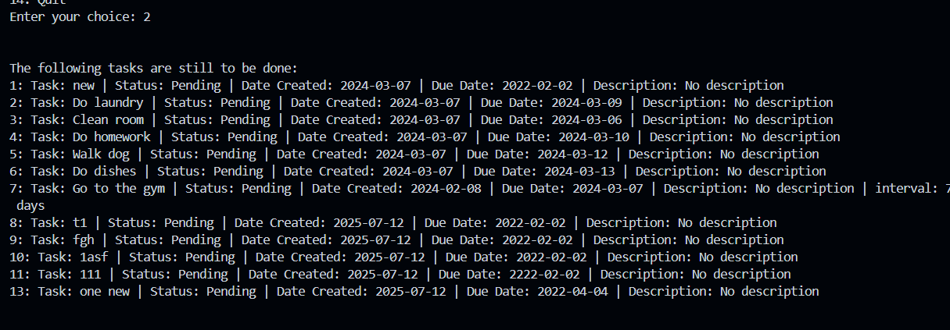

Choosing 1 and 2 to add a recurring task

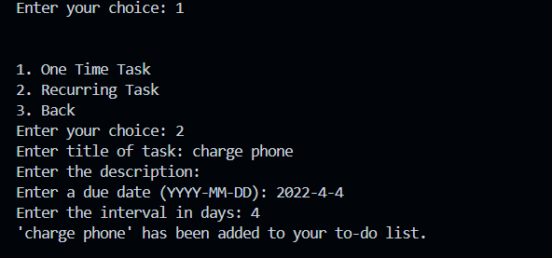

Choosing 12 to save data to pickle file 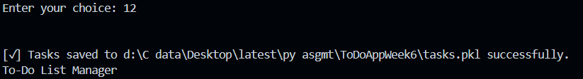

Choosing 2 to see whether the task is saved in pickle file or not

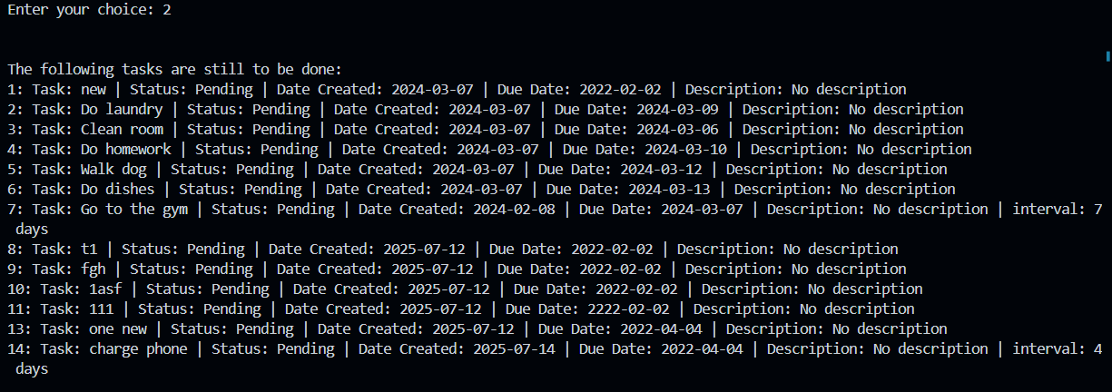

It is saved in the file

Week 7

# Section 1. SOLID Principles

There are several OOP principles that, if followed, can help you to write better OO code. A commonly used set of principles follows the SOLID acronym. These principles are:

* S: Single Responsibility Principle. This principle ensures that every class should have only one function to perform. This is to increase modularity of application.
* O: Open/Closed Principle. It puts forth that classes should be open for extension but closed for modification.
* L: Liskov Substitution Principle. It says that a subclass should substitute its superclass without a change in behavior.
* I: Interface Segregation Principle. Maintain modularity, as clients should only depend upon interfaces that they use.
* D: D: Dependency Inversion Principle. It states that high-level modules should depend on abstractions and not on low-level details.

## Exercise 1. Single Responsibility Principle

### Understanding the Task

With this exercise, I understood the concept of the Single Responsibility Principle (SRP), which basically states that any class ought to do one job, and only one job. The main idea of the task is that if a class has too many responsibilities, it becomes quite difficult to maintain, reuse or extend. So, I had to keep an eye on whether or not each part of my ToDoApp respects **SRP**. I reviewed classes like Task, TaskList, TaskCsvDAO, and main.py to verify whether any of them were handling more than one responsibility or were overburdened. I found out that most of the classes obeyed SRP - however, the main.py file got mixed with **UI logic** and **business logic**, hence violating the rule.

### Source Code

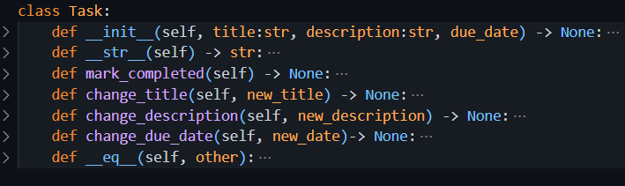

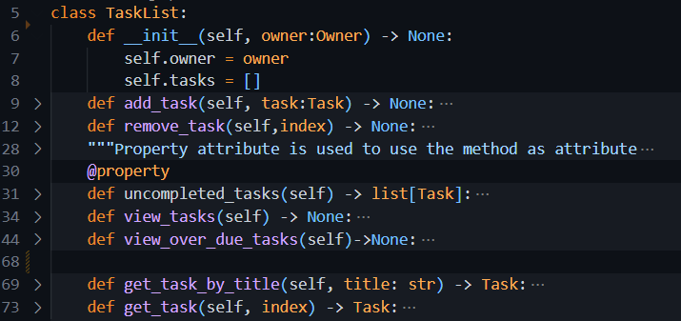

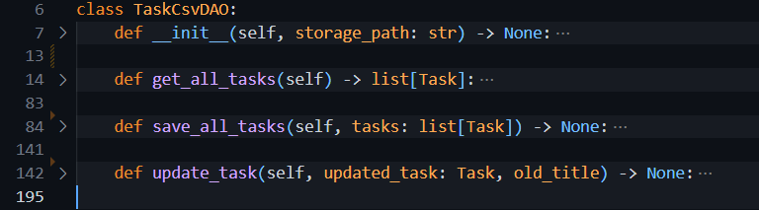

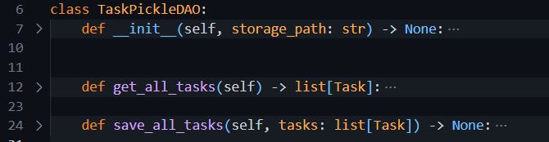

In the source code, it is seen that every class is serving one purpose only using its methods.

### Explanation

The Single Responsibility Principle SRP is part of clean code and good software design. In the context of my ToDoApp, each class mostly follows SRP:

* **Task and RecurringTask** handle storing task data of respective types.
* **TaskList** is responsible for managing the list of tasks (like adding, removing, or viewing them).
* **DAO classes** (TaskCsvDAO, TaskPickleDAO, etc.) deal only with saving and loading tasks from files.

The main violation with SRP happens in main.py, where it is responsible for asking user input, displaying menus, performing logic, and calling other classes' methods. Such a file becomes increasingly hard to manage or change later into new requirements. Therefore, to keep SRP, any input printing should be performed by a separate **CommandLineUI** class and keep the business logic in the controller or model classes.

### Benefits of SRP in My ToDoApp

* Make the code **cleaner and easier to understand**.
* If I want to update one feature (like how tasks are saved), I don’t have to dig through unrelated code.
* Make **testing** easier since each class can be tested in isolation.
* Help reduce **bugs** and confusion when the codebase grows.
* **Improves reusability** – I can reuse the same Task logic in other apps, without copying extra unrelated stuff.

## Exercise 2. Open/Closed Principle

### Understanding the Task

In this exercise, I had to learn to be able to apply the Open/Closed Principle (OCP) in my ToDoApp. The OCP states that a class should be open for extension and closed for modification. What this clearly means is that when adding new features to a class, it should not be changed but instead created a new class for extension. This idea has already been applied in building the RecurringTask class that inherits global attributes and functionality like interval and completed_dates but does not modify the original Task class. Similar to this exercise I am supposed to think of improving other areas of code (like DAO classes) using inheritance and abstraction to ease future changes.

### Explanation

The Open/Closed Principle helps make code more maintainable by encouraging extensions instead of changes. In my ToDoApp:

* The **Task class** is the base for all task-related functionality.
* The **RecurringTask class** extends Task and adds features like automatic due date updates and recurring intervals. I didn’t touch the Task class while adding this, which means I followed OCP.

The same reasoning can be applied to the DAO layer. Instead of editing TaskCsvDAO or TaskPickleDAO every time I want to add a new storage type, I can create an abstract BaseTaskDAO class and make each DAO subclass inherit from it. This ensures consistent structure (interface) and allows me to add new behavior without touching the old code.

### Benefits of Using OCP

* Avoid **breaking existing functionality** while adding new features.
* Keeps the original class **stable and reliable**.
* Supports **scalable** design, new features can be plugged in easily.
* Promotes **reuse of existing code** and reduces duplication.
* Encourages use of **polymorphism**, making the design more flexible and cleaner.

## Exercise 3: Liskov Substitution Principle (LSP)

### Understanding the Task

The goal was to ensure that wherever a Task object is being used in the app, it is possible to replace that with a RecurringTask without crashing the app. This clearly falls under LSP, which states in short that subclasses should be able to stand in place of their parent classes without any problem.

### Explanation:

In the ToDoApp, RecurringTask extends from Task and follows similar structure in terms of attributes like title, due_date, and methods like mark_completed(). RecurringTask overrides some behavior, such as automatic due date updates, but the subclass acts as required in every situation where a normal task is expected. Therefore, this indicates app compliance with LSP since, in replacing Task with RecurringTask, everything continues to work just fine.

### Benefits:

* Enables **flexible code reusability** with safe subclassing
* Reduces the chance of **bugs due to substitution**
* Keeps the **interface consistent** across the app

## Exercise 4: Interface Segregation Principle (ISP)

### Understanding the Task

The focus was to avoid writing large, all-purpose classes with random sets of methods opposing their roles; rather keep the class interface small to have only methods that are relevant to its role.

### Explanation

Even though Python doesn’t use formal interfaces, ISP is followed by keeping our Task and RecurringTask classes clean and focused. Task has only necessary methods like change_title() or mark_completed(). RecurringTask builds on that by adding specific logic for recurrence. There are no unrelated or unused methods in either class. This helps ensure that each class is lightweight, specific, and easier to maintain.

### Benefits

* Keeps each class **easier to understand**
* Prevents **overloading classes with unnecessary responsibilities**
* Makes future **testing and extension cleaner and faster**

## Exercise 5: Dependency Inversion Principle (DIP)

### Understanding the Task

This exercise is to ensure that higher-level modules (like TaskList) don’t depend on the concrete details of file formats or storage logic (like CSV or Pickle). . Instead, they are supposed to rely on abstract interactions via a DAO.

### Explanation

### The TaskList within the ToDoApp does not save to a file but delegates it to a DAO for example TaskCsvDAO or TaskPickleDAO. If we would ever change how we save a task against a database, API, or what else, the TaskList logic doesn't break, as it is never tightly coupled with any implementation. In Python, we don't have built-in interfaces, but in the end, we can achieve DIP in writing code that communicates through well-structured, abstract method contracts, i.e., get_all_tasks(), save_all_tasks().

### Benefits

* Improves **maintainability and testability**
* Allows for **easy swapping of data sources** (e.g. CSV to Pickle)
* Keeps higher-level logic **clean and isolated from low-level details**

# Section 2. Exception Handling

## Task: ToDoApp Modification by adding exception handling

### Understanding the Task

This task is to improve the user experience by making the application more robust and error tolerant. Currently, the application crashes when the user attempts to delete or modify a task with an invalid index (e.g. a number that does not exist in the task list). We shall be adding the exception handling feature using the try, except, and raise keywords in the application with a view to preventing these crashes and providing useful messages to the user instead.

#### Example 1

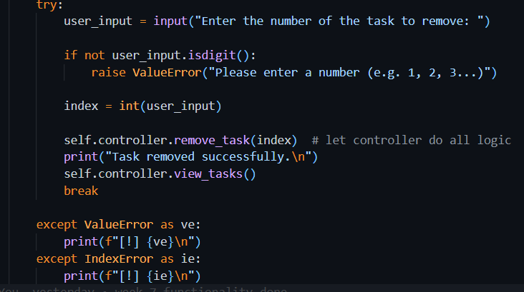

##### Explanation

The provided code uses a try-except block around user input and task manipulation logic. Here’s what happens:

* First, the app **asks the user for a task number** to remove.
* If the input is **not a digit**, a ValueError is manually raised using raise ValueError(...).
* The string input is then converted to an integer and passed to self.controller.remove_task(index).
* If this index is **not valid** (e.g., it's out of range), the controller will raise an IndexError.
* Both are caught and shown a friendly error message instead of crashing
* If everything goes well, the task is removed, and the updated task list is shown.

This structure allows the app to **continue running smoothly**, even if the user makes a mistake.

#### Example 2

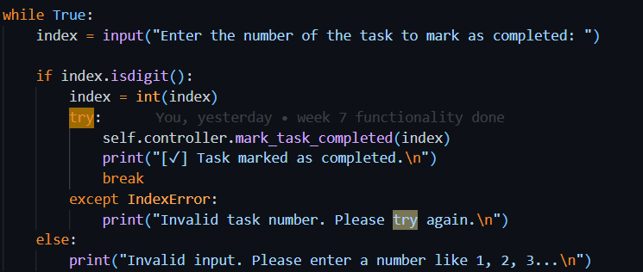

##### Explanation

* The user is asked to enter a number of the respective that they want to mark as completed.
* isdigit() checks if the input is a number. If not, a clear error message is shown.
* If input is valid, the program will try to mark that task as completed via the controller.
* If the task number is **out of range or invalid**, the program catches the IndexError and informs the user that the task number is incorrect.
* If the task is marked successfully, a success message is shown.

This logic keeps the app from crashing when the user enters wrong or text unordered list of task numbers.

#### Example 3

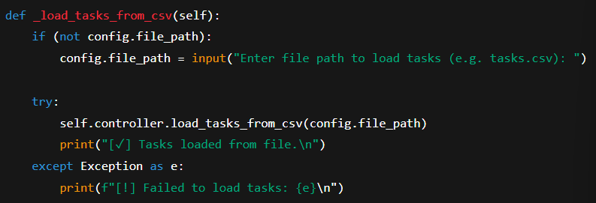

##### Explanation

* This function checks whether the CSV file path (config.file_path) is already stored. If not, it asks the user to provide it.
* Then it tries to load tasks from the file using the controller’s load_tasks_from_csv() method.
* If something goes wrong (like the file doesn’t exist or is incorrectly formatted), it catches the error and prints a clear message.
* The use of Exception as e helps catch **any kind of error**, not just specific ones like FileNotFoundError.

### Benefits of Exception Handling

* Prevents the program from crashing unexpectedly.
* Provides better user experience by giving clear instructions when input is incorrect.
* Makes the code more maintainable and easier to debug.
* Helps isolate bugs and ensures the app behaves reliably under edge cases.

# Section 3. Improving ToDoApp according to SOLID Principles

## Task: Modification of main module to separate the user interface from the business logic

### Understanding the Task

In this task, I was required to **restructure my ToDoApp** to improve its design by clearly separating **user interface logic from business logic**. The idea was to make the code more modular, easier to maintain, and better aligned with **Object-Oriented Programming principles** like **Separation of Concerns**, **Single Responsibility Principle**, and **Low Coupling**.

I had to:

* Create a new class CommandLineUI in a separate ui module. This class is responsible for everything the user sees or interacts with: menus, inputs, and printed messages.
* Create another class TaskManagerController in a controllers module. This class handles the logic of how the app behaves, adding tasks, marking them complete, checking valid indexes, loading/saving data, etc.
* Introduce and use the TaskFactory class whenever a new task is created. This pattern helps me avoid hardcoding logic in the UI or controller and makes task creation more flexible.
* Optionally, if I had portfolio tasks (like user login or overdue filtering), I could plug them in as well without disrupting existing logic.

### Explanation

The idea behind this task is to **fully separate concerns** in the app. The main.py file is now very lightweight and simply acts as an entry point that runs CommandLineUI.

The **CommandLineUI** class handles:

* Showing the menu
* Taking input from the user
* Deciding what action to take based on the input
* Sending user requests to the controller class (TaskManagerController)

The **TaskManagerController** class handles:

* Adding, deleting, editing, completing tasks
* Saving or loading data via the appropriate DAO (CSV or Pickle)
* Validating task indexes
* Communicating with the TaskFactory and TaskList

The **TaskFactory** decides what kind of task to create (normal or recurring) based on the given data. It acts like a helper tool to keep that logic out of both UI and controller.

This design pattern makes the app easier to extend in the future e.g., adding a GUI interface later won't require changing the task logic.

### Benefits of This Restructure

* **Easier to maintain and modify**: UI changes don’t affect task logic, and vice versa.
* **Modular structure**: Each class has a clear responsibility, following **SRP** (Single Responsibility Principle).
* **No code duplication**: By centralizing task creation in TaskFactory, and task validation in TaskList, we follow the **DRY** (Don't Repeat Yourself) principle.
* **Easier to test**: Business logic and UI are separate, so we can write unit tests for the controller and tasks without dealing with print/input.
* **Extensible**: Adding features like login, filtering, exporting can be done without touching all parts of the app.

### Source Code

Main.py

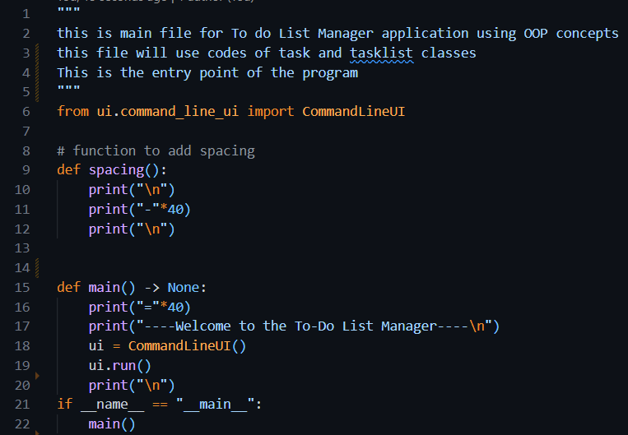

command_line_ui.py

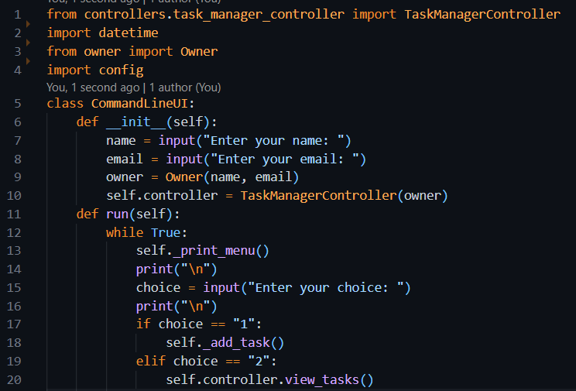

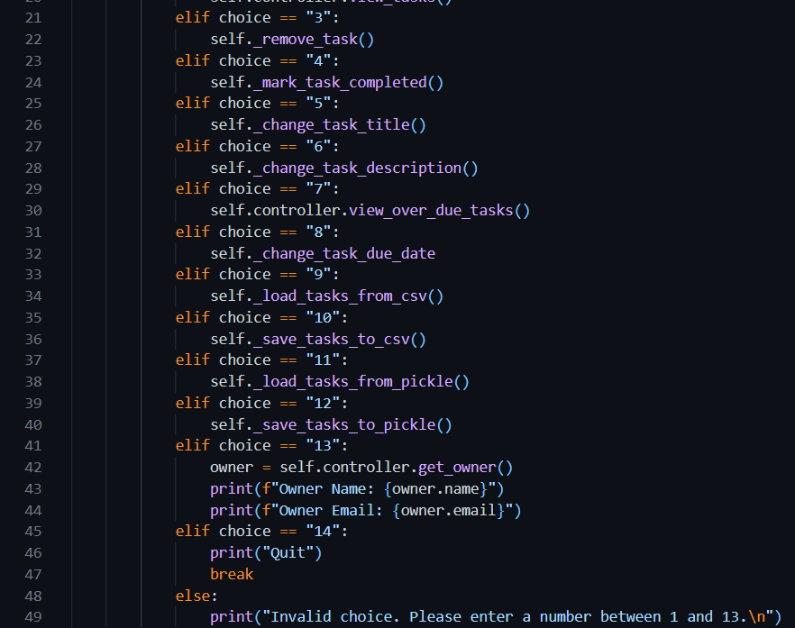

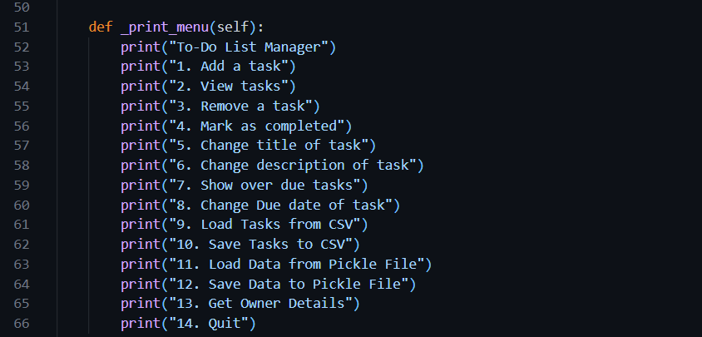

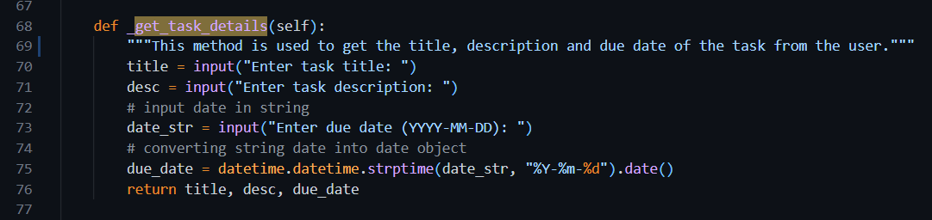

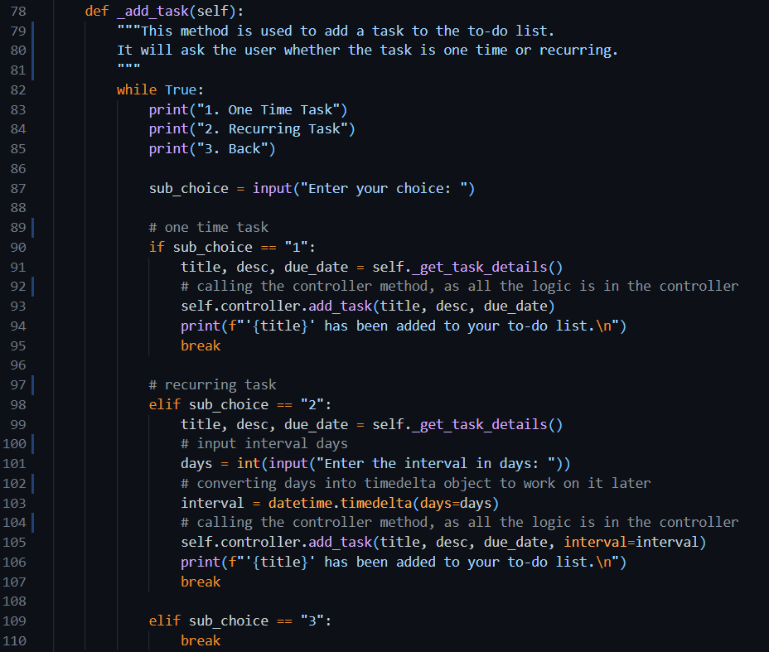

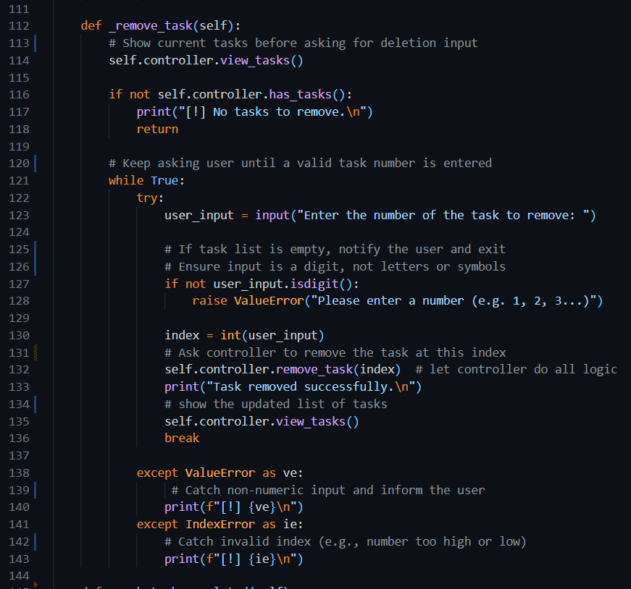

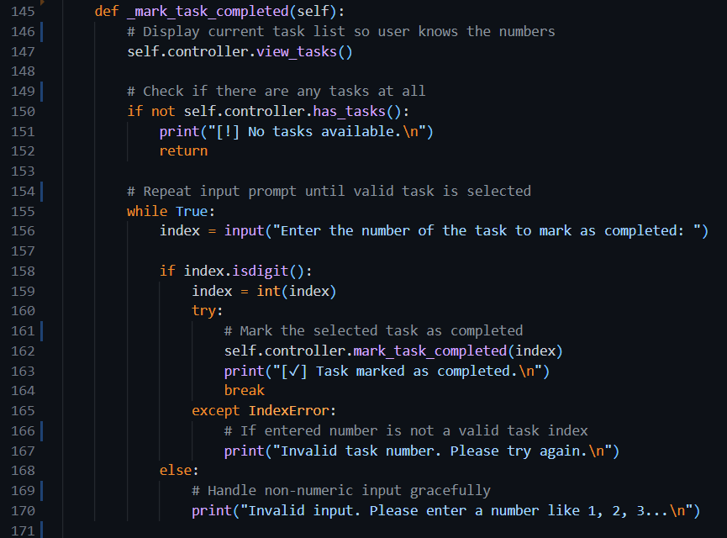

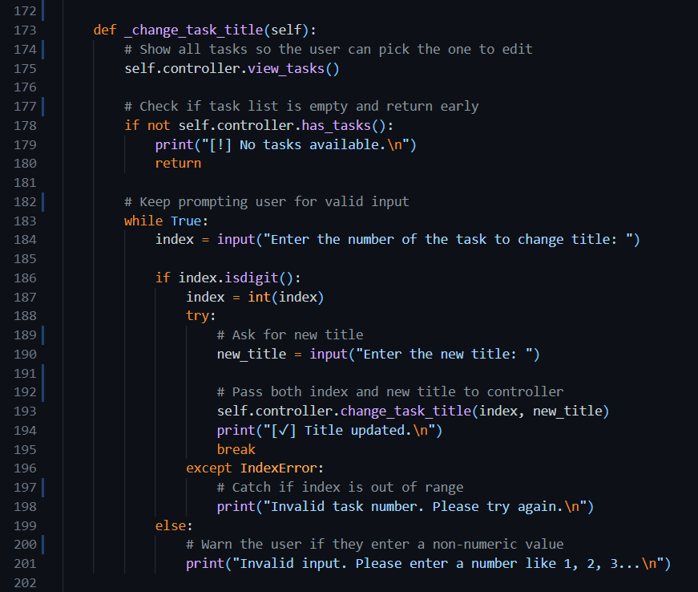

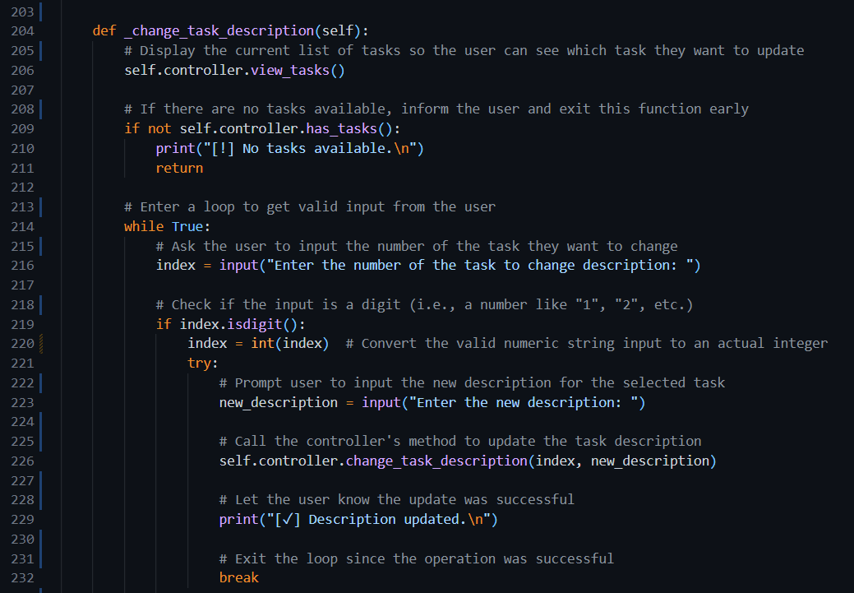

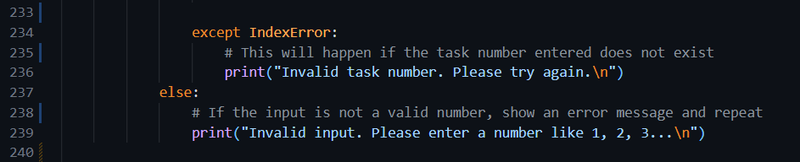

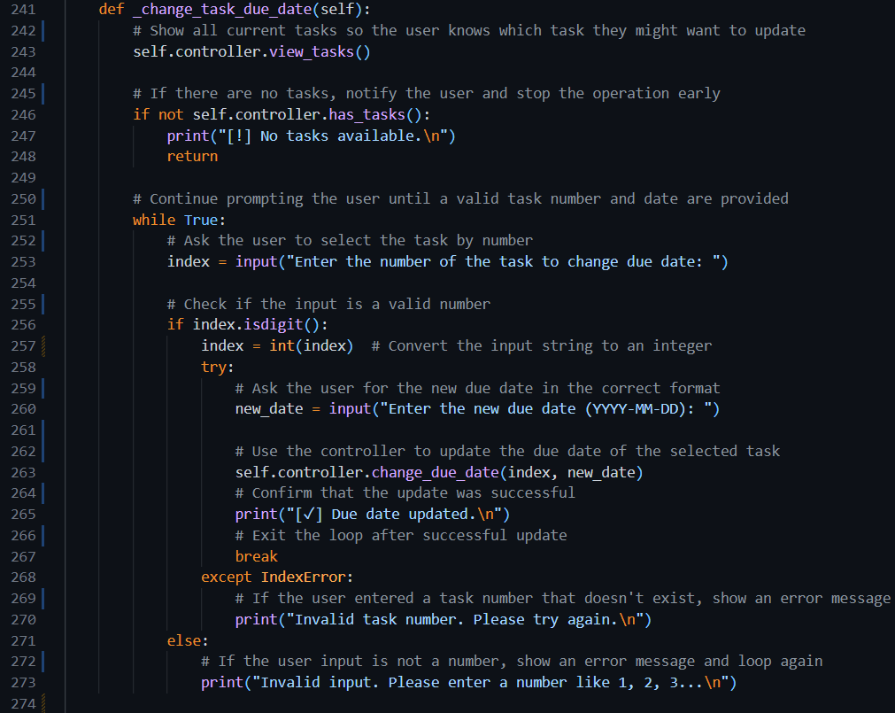

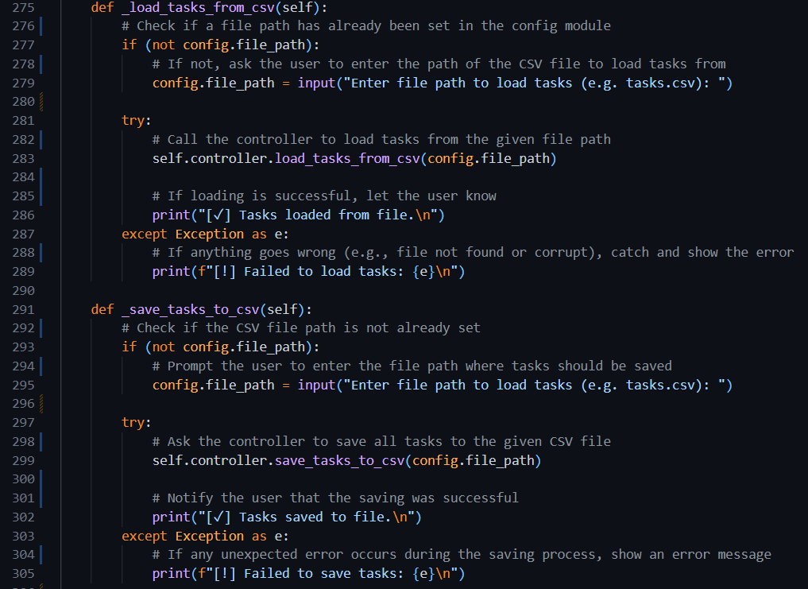

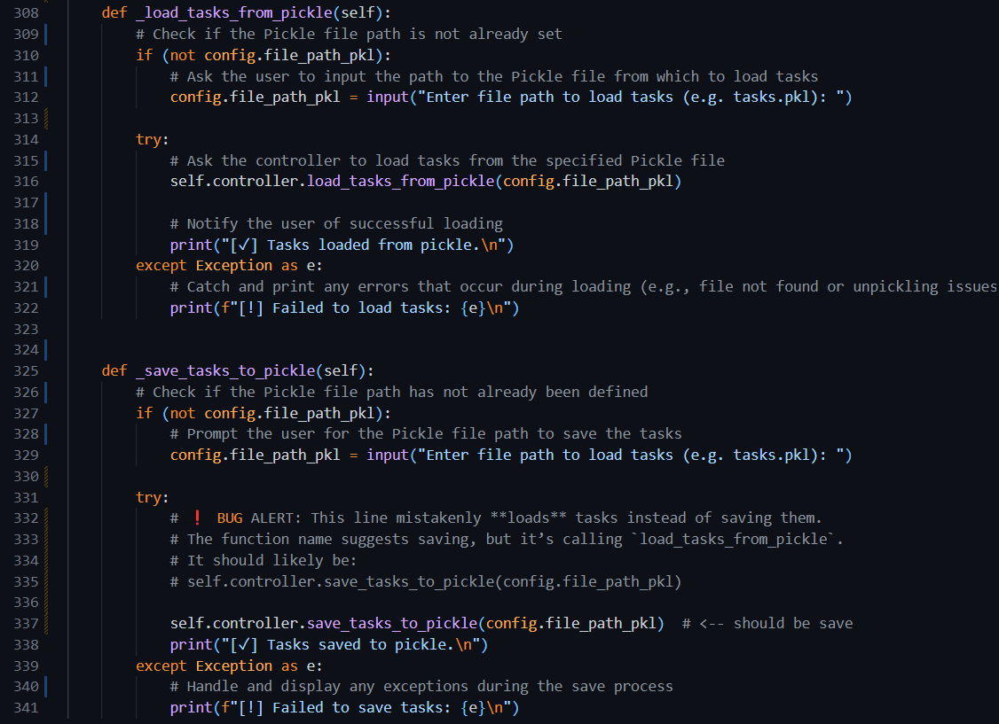

#### task_list.py

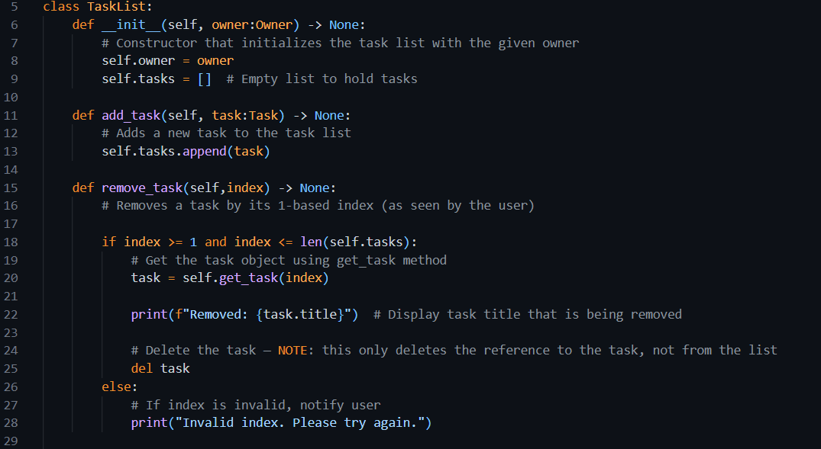

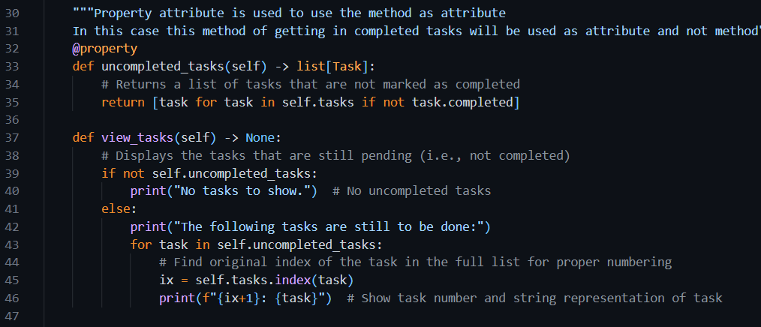

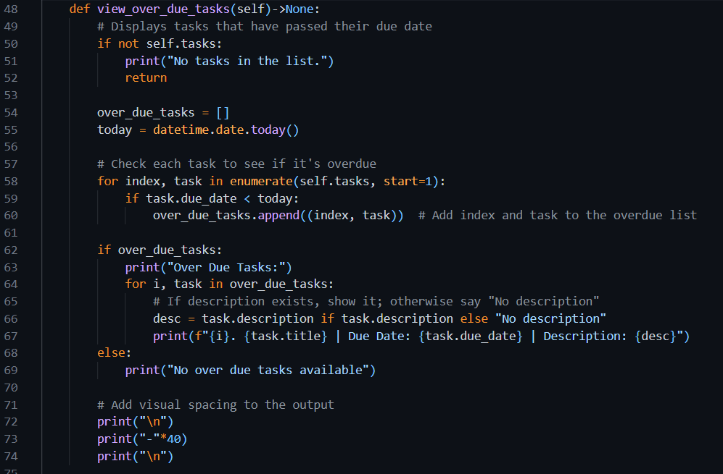

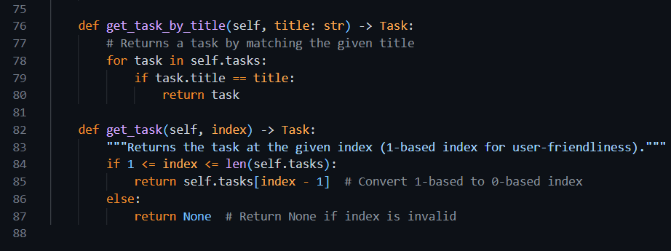

#### task_factory.py

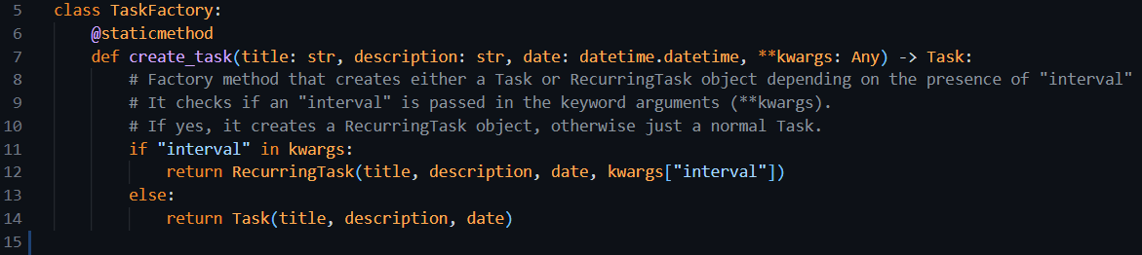

#### task.py

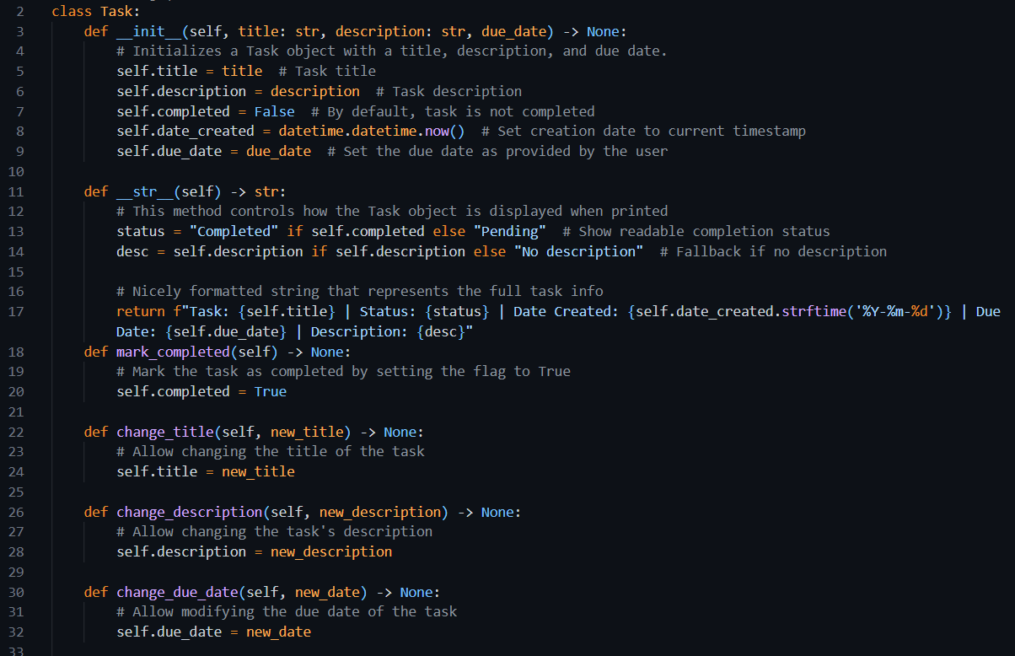

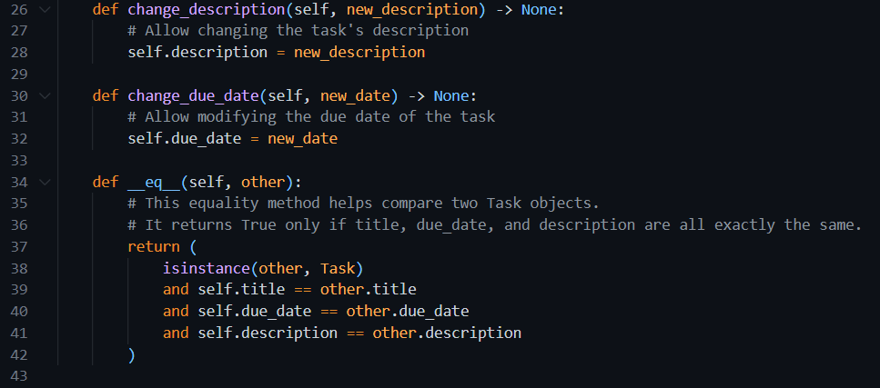

#### task_manager_controller.py

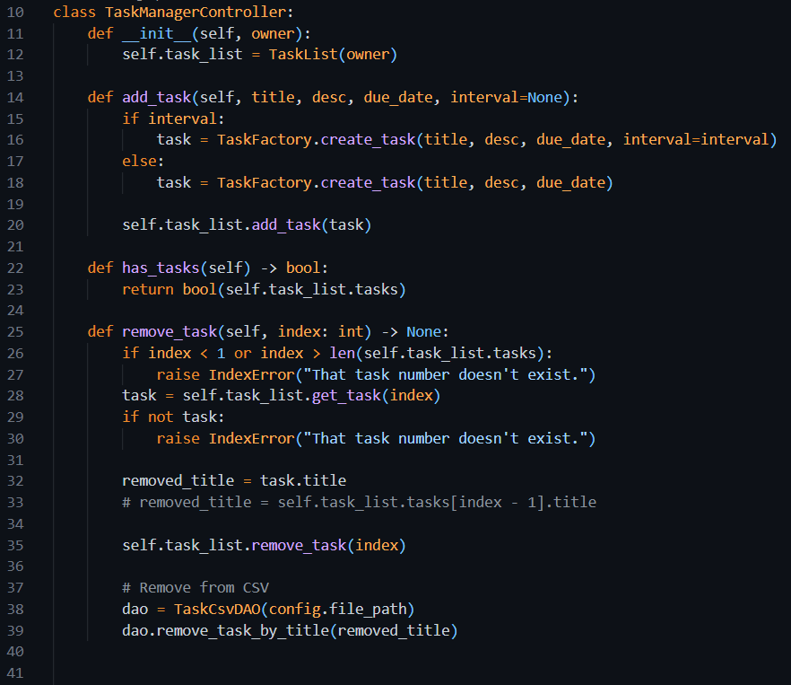

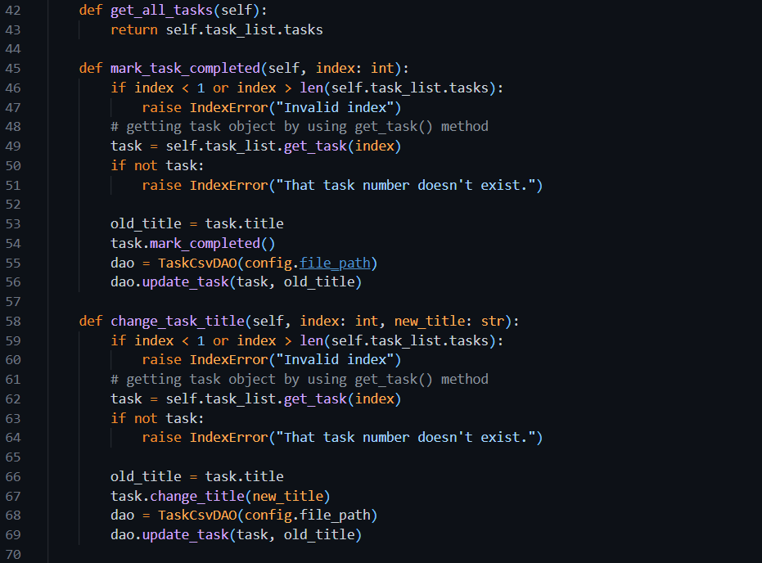

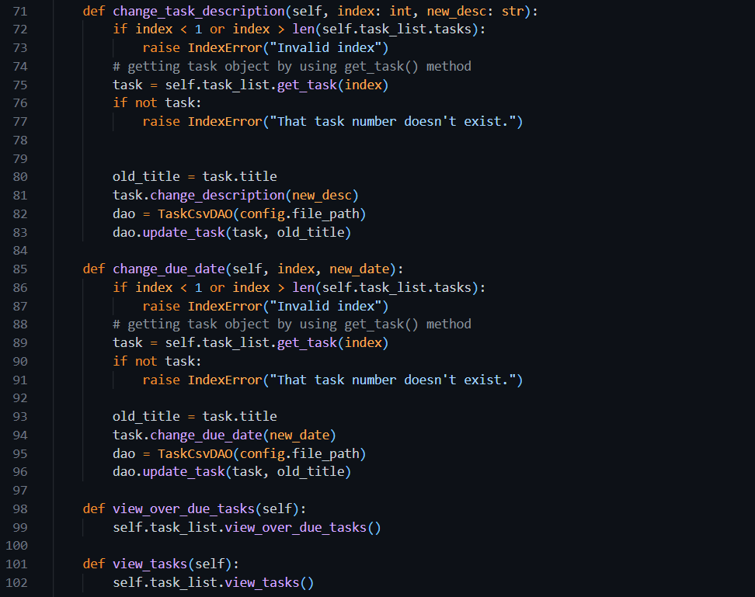

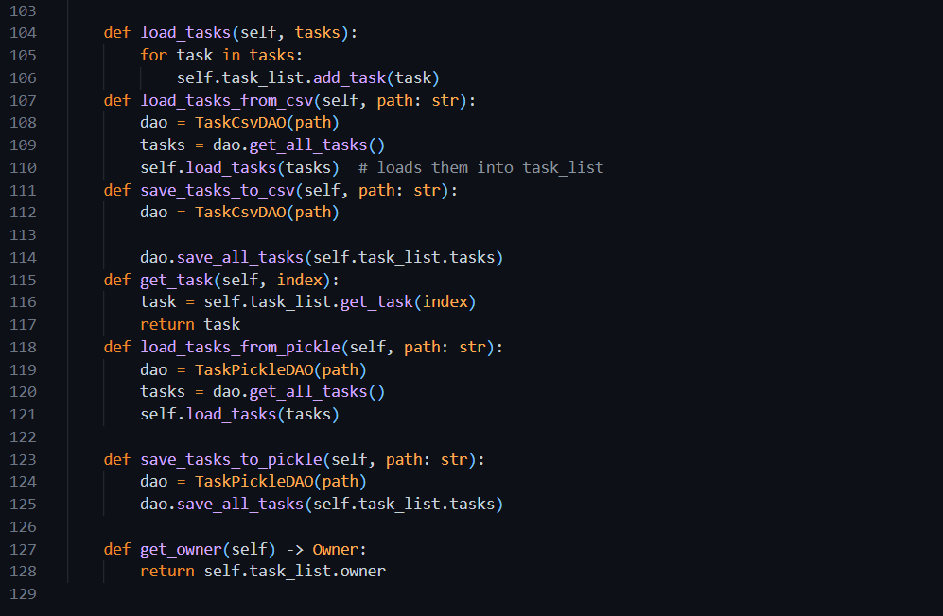

Week 8

# Section 1. Data Structures

In programming, **data structures** are different ways of organizing and storing data so it can be used efficiently. Python offers several built-in data structures like **lists**, **tuples**, **sets**, and **dictionaries**, each with unique behaviors and use cases.

In this exercise, we’ll focus on:

1. Tuples
2. Sets
3. Dictionaries

## **Exercise 1: Tuples**

### Understanding the Task:

A **tuple** is a collection of items that are **ordered and immutable**, meaning once you create it, you cannot change its values. It's great for storing data that shouldn’t be modified, like coordinates or RGB color values.

### Source Code

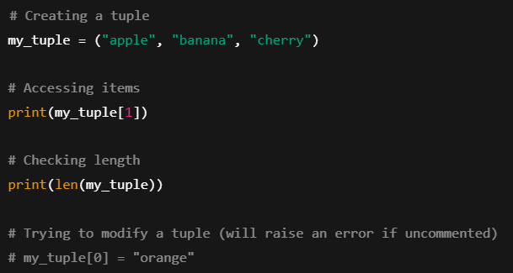

### Explanation:

* my_tuple is created with three fruits.
* We access the second item using indexing (my_tuple[1]).
* We check the total number of items using len().
* Tuples are **immutable**, so trying to modify an item will raise an error.

### Output

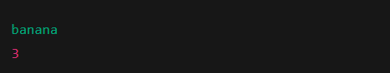

## Exercise 2: Sets

### Understanding the Task:

A **set** is an **unordered collection** of **unique elements**. It’s useful when you want to remove duplicates or perform operations like union or intersection.

### Source Code

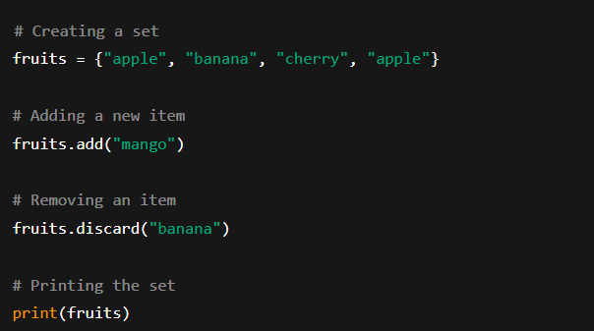

### Explanation:

* The set removes the **duplicate "apple"** automatically.
* We add "mango" and remove "banana" using add() and discard() respectively.
* Sets do not maintain any order, so the printed result can appear in any sequence.

### Output

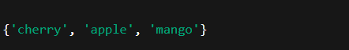

## Exercise 3: Dictionaries

### Understanding the Task:

A **dictionary** is a collection of **key-value pairs**. It’s used when you want to map a value to a specific label or key, like storing student names with their grades.

### Source Code

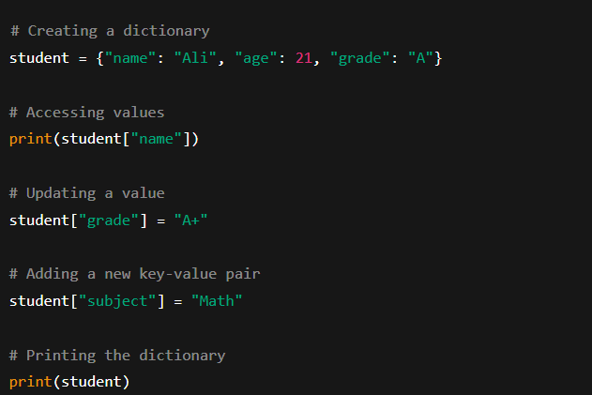

### Explanation:

* A dictionary student is created with keys: "name", "age", and "grade".
* We access and update values using square brackets.
* New key-value pairs can be added anytime.
* Dictionaries are **unordered** in Python versions before 3.7, but now they preserve insertion order.

### Output

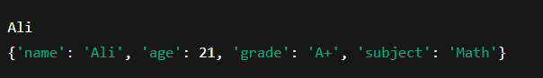

## Task: Swap a and b using tuple

### Source Code

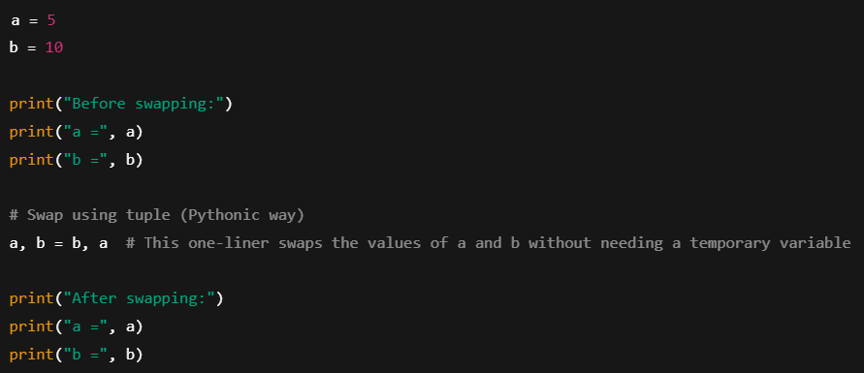

### Explanation

* We first define two variables a and b with values 5 and 10.
* Python allows us to **swap** values in a very clean way using tuple unpacking: a, b = b, a.
* No need for a temporary variable (like in other languages).
* The values are now swapped.

### Output

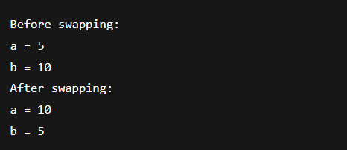

## Task: Comparing two sets to find common values

### Source Code

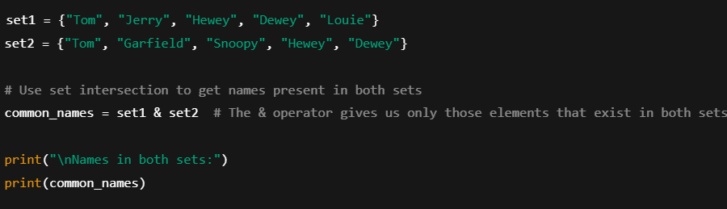

### Explanation:

* We define two sets with cartoon character names.
* The & operator performs a **set intersection**, returning only elements found in both sets.
* This helps us quickly compare and find common entries.
* The result is printed as a Python set.

### Output

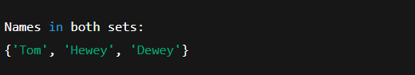

## Task: Histogram

### Source Code

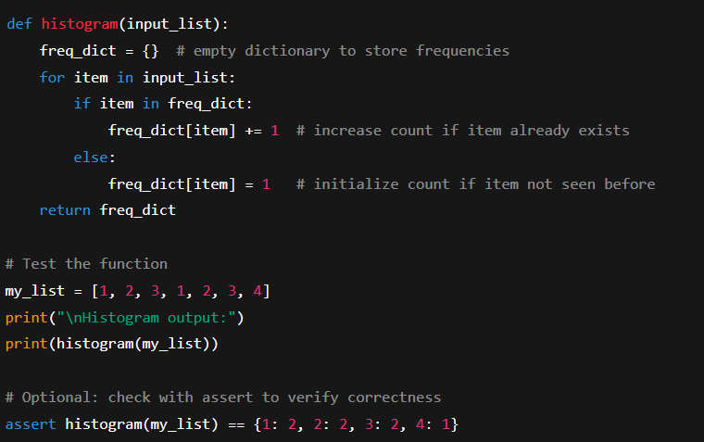

### Explanation:

* A function histogram is defined to count how many times each number appears in a list.
* It uses a **dictionary** to store numbers as keys and their count as values.
* For each item in the list:
  + If the number is already in the dictionary, we increase its count.
  + If not, we add it with a count of 1.
* We then test the function with a sample list: [1, 2, 3, 1, 2, 3, 4].
* The assert statement is used for **automated verification**, ensuring the result matches the expected dictionary.

### Output

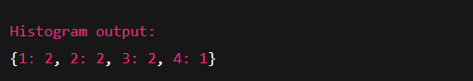

# Section 2. Abstract Classes

It is the concept of hiding the complex implementation of an object and only showing the necessary features of the object. Abstract classes enable this as all we do is define the methods that must be implemented by the child classes. Once those child classes have been created, we can use them without needing to know the details of their implementation but can be sure that those methods (and attributes) will be available.

To use abstract classes in python, it is required to import the **ABC** and **abstractmethod** modules from the **abc** **package**. Then you can create an abstract class by inheriting from the ABC class and using the **@abstractmethod** decorator to define the abstract methods.



## Task: Dice class and abstract method in it

### Source Code

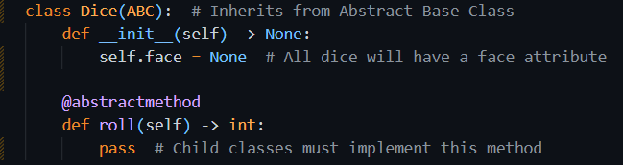

### Explanation

In this task, we are introduced to **abstract classes** in Python using a simple and relatable example, a dice. The main goal here is to design a **base class** that defines the **essential structure** and **common interface** for all dice, without actually implementing how the dice rolls. That behavior will be defined by the **child classes**.

The Dice class is created as an **abstract class** using Python’s ABC module. This class sets a foundation that all dice must follow. It includes:

* A face attribute, which will hold the current value shown on the dice after a roll.
* An abstract method roll(), which is meant to be implemented by any class that inherits from Dice. This method will define how the dice is rolled (e.g., random number generation for 6-sided dice).

The key takeaway is that the Dice class **cannot be used directly to create objects** because it lacks a working implementation of roll(). It’s just a **blueprint** meant to be extended.

## Task: Six Sided Dice

### Understanding the Task

Now that we have an abstract base class Dice, the next step is to **implement a specific type of dice**, in this case, a standard **six-sided dice** (like the one used in most board games). The idea is to **inherit** from the Dice class and provide the missing roll() method.

### Source Code

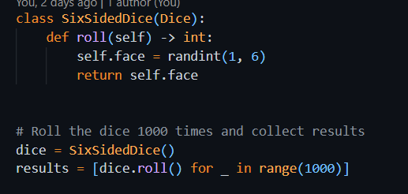

### Explanation

* This class SixSidedDice **inherits** from the abstract Dice class.
* It **implements** the roll() method that was declared as abstract in Dice.
* Inside roll(), it uses randint(1, 6) to simulate rolling a real dice, generating a random number between 1 and 6.
* The result is stored in the face attribute (inherited from Dice) and returned.

The class is now **concrete** and can be instantiated since all abstract methods are implemented.

### Rolling the Dice 1000 Times:

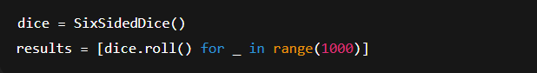

* An instance of SixSidedDice is created.
* The roll() method is called **1000 times** using a list comprehension.
* Each result is stored in the results list, so we can analyze frequencies, simulate outcomes, or plot distributions.

## Task: Ten-Sided Dice

### Understanding the Task

This task focuses on building a **concrete subclass** of an abstract Dice class. Specifically, we are implementing a TenSidedDice that simulates the behavior of a dice with 10 faces. The core idea is to show how inheritance and abstraction work together, and then simulate the dice to see how random values are distributed. Finally, we visualize the outcome using a histogram to check how balanced the results are.

### Source Code and Explanation

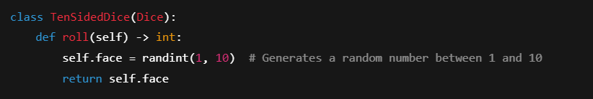

* This class **inherits from** the abstract Dice class.
* It **implements** the required roll() method.
* Each roll gives a value from **1 to 10**, and the result is stored in the face attribute.

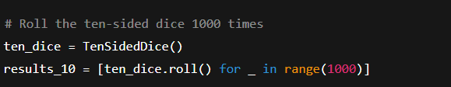

* An instance of TenSidedDice is created.
* A list comprehension is used to **simulate 1000 rolls** and collect the outcomes.

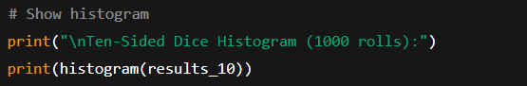

* he histogram() function counts how many times each number (1–10) appeared.
* This is used to **visually inspect randomness**, ideally, each number should appear around 100 times.

### Output

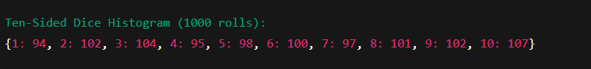

## Task: Implement Abstraction in ToDoApp

### Understanding the Task

This task is about **applying abstraction** in your ToDo application by introducing **abstract base classes** (ABCs) using Python’s abc module. The main goal is to enforce **a common structure** for classes that are similar in purpose but differ in implementation, such as the DAO classes and Task-related classes. This makes the application more **scalable, maintainable, and robust**.

### Source Code

#### TaskDAO.py – Abstract class for DAO classes

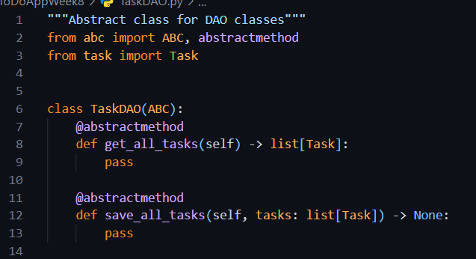

### Using Abstract class

#### TaskCsvDAO.py

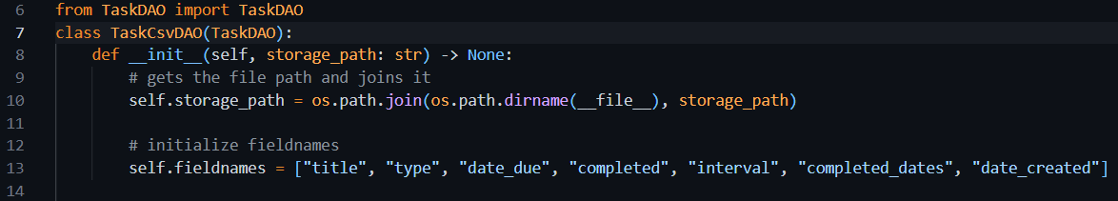

#### TaskPickleDAO.py

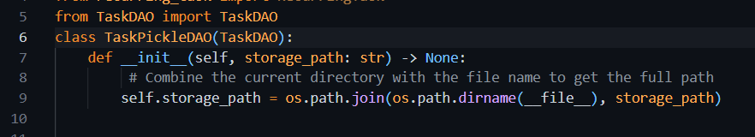

#### AbstractTask.py – Abstract class for Task classes

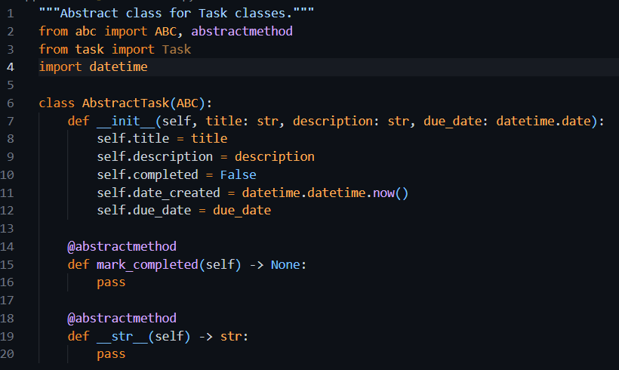

### Using Abstract class

#### task.py

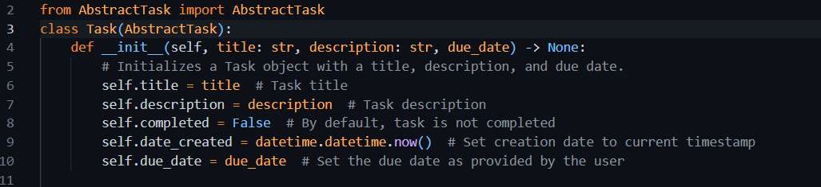

#### recurring_task.py

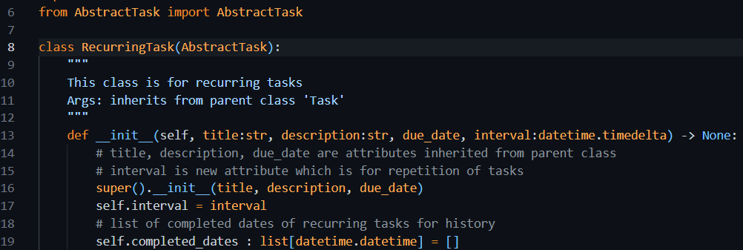

## Portfolio Exercise 5: Priority Task

### Understanding the Task

This exercise expands the ToDo app's functionality by introducing a new task type called **PriorityTask**. Just like we have Task and RecurringTask, the PriorityTask adds an extra layer of importance by associating tasks with a **priority level** (1 to 3).

* Priority will be stored as an **integer** (1, 2, 3) representing **low**, **medium**, and **high**.
* A **mapping dictionary** will convert those numeric values into user-friendly strings ("low", "medium", "high").
* The class should include:
  + type hints,
  + validation (to restrict values outside 1–3),
  + and a readable string representation via __str__.

### Source Code

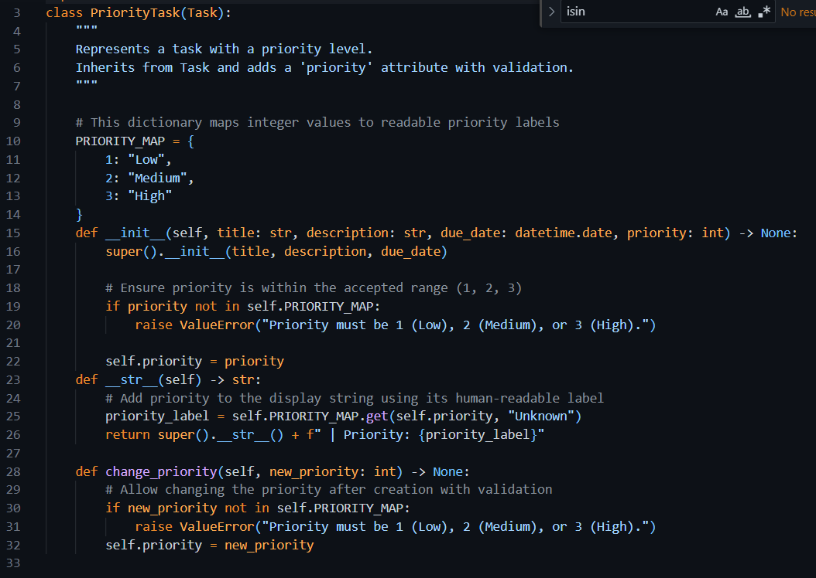

### Explanation

* PriorityTask is a specialized type of task that builds on the regular task features.
* It includes a priority level to show how important the task is.
* The priority is stored as a number: 1 (Low), 2 (Medium), or 3 (High).
* When creating a task, the program checks that the priority is valid (only 1, 2, or 3 are allowed).
* If an invalid number is given, the task won't be created, and an error is shown.
* The task can display priority in words using a built-in mapping from numbers to labels.
* When printed or displayed, the task shows its usual details plus the priority label.
* The priority can be changed later, and the new value is also validated to be one of the allowed numbers.

## Portfolio Exercise: Integrate Priority Task in ToDoApp

### Understanding the Task

In this exercise, I was asked to fully integrate the PriorityTask class into the existing To-Do application. The goal was to make sure that all parts of the application are aware of and can handle this new type of task that includes a priority level (Low, Medium, High).

Specifically, I was required to update three main components:

* **TaskFactory**: So it can create PriorityTask objects when a priority is provided.
* **CommandLineUI**: So the user can interactively create a PriorityTask through the terminal.
* **DAO (Data Access Objects)**: So PriorityTask can be saved and loaded correctly from files (especially CSV), including the priority value.

What I understood from the question is that this is not just about creating a new class, it’s about making sure it works throughout the whole system just like other task types (e.g., standard and recurring tasks). This includes making sure it can be added, saved, loaded, and displayed properly within the existing app structure.

### Source Code

#### Task_factory

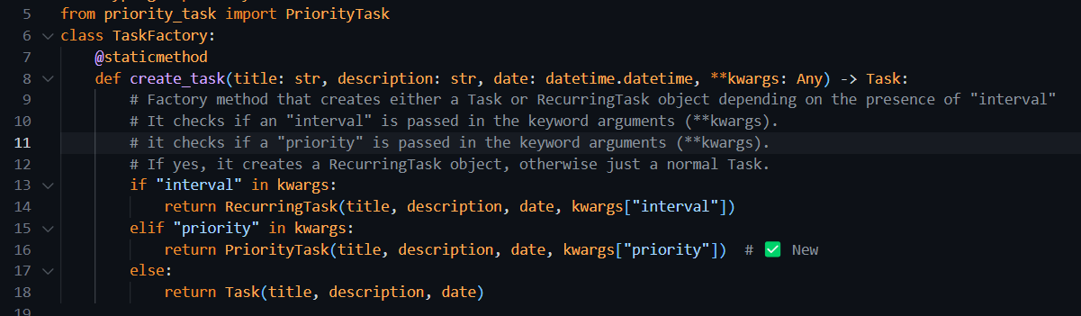

#### Comman_line_ui.py

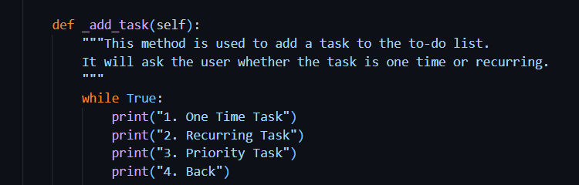

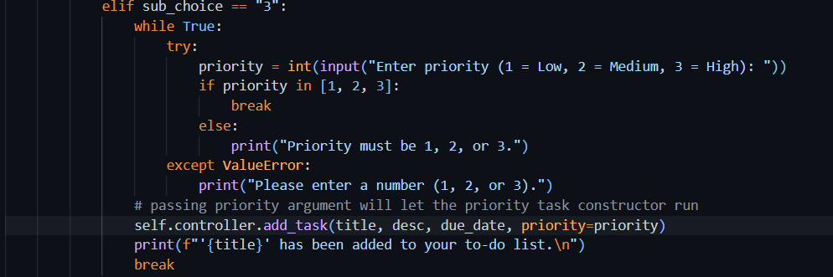

#### TaskCsvDAO.py

#### Init function

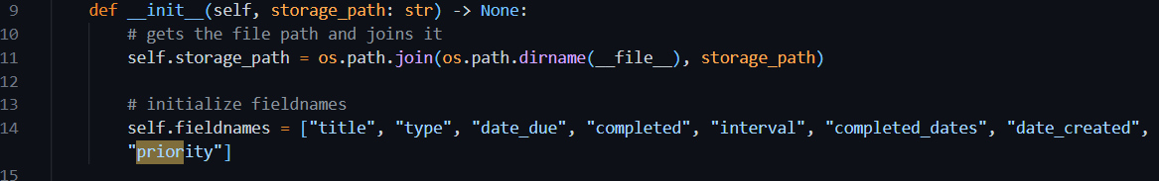

#### Get_all_tasks()



#### save_all_tasks()



### Output

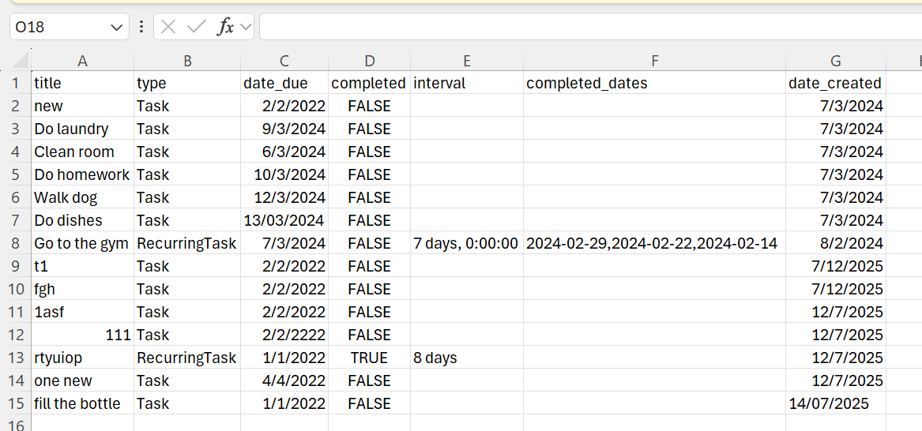

Choosing 1 and then 3 to add a priority task to the list

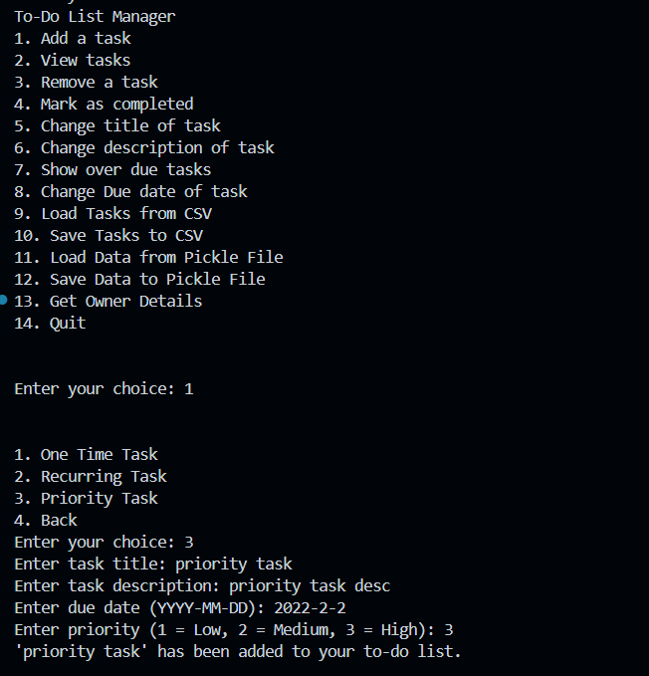

Choosing 10 to save data to file

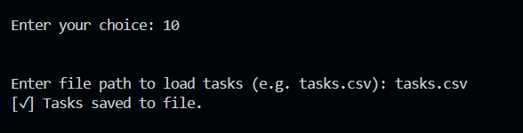

### CSV

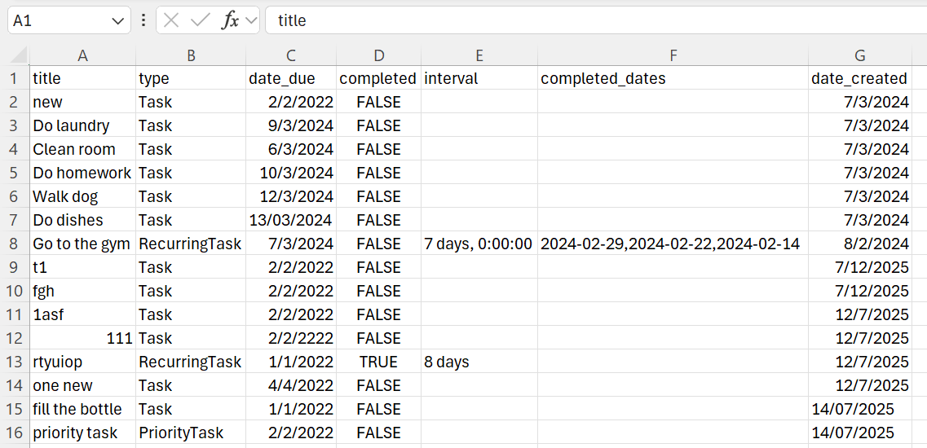

We can see from this picture that the priority task is added to the file